

**CAPSTONE PROJECT REPORT**

**Report 4 – Software Design Document**

– Hanoi, June 2021 –

**Table of Contents**

I. Project Report **25**

1. Status Report 25

2. Team Involvements 25

3. Issues/Suggestions 25

II. Software Design Document **26**

1 Introduction 26

1.1 Purpose 26

1.2 Definitions, Acronyms and Abbreviations 26

1.3 References 27

2 Overall Description 28

2.1 System Overview 28

2.2 Assumptions 28

2.3 Design Constraints 29

3 Architecture Design 29

3.1 Software Architecture 29

3.1.1 Process View 29

3.1.1.1 View Restaurant Process 29

3.1.1.2 Registration Process 31

3.1.1.3 Login Process 32

3.1.1.4 Create Feast Order Process 33

3.1.1.5 Cancel Feast Order Process 35

3.1.1.6 Accept Order Process 37

3.1.1.7 Cancel Order Process 38

3.1.1.8 Complete Order Process 40

3.1.1.9 Add Restaurant Process 41

3.1.1.10 Restaurant Review Process 43

3.1.2 Logical View 45

3.1.3 Development View 45

3.1.3.1 Package Diagram 45

3.1.3.2 Component Diagram [optional] 47

3.1.4 Deployment View 48

4 Detailed Component Design 50

4.1 Guest 50

4.1.1 Search Restaurants 50

4.1.1.1 Screen design 50

4.1.1.2 Class diagram 51

4.1.1.2.1 Back end 51

4.1.1.2.2 Front end 52

4.1.1.3 Class Description 52

4.1.1.3.1 home 52

4.1.1.3.2 searchResult 53

4.1.1.3.3 RestaurantController 55

4.1.1.3.4 RestaurantServiceImpl 56

4.1.1.3.4 RestaurantRepository 58

4.1.1.3.4 User 59

4.1.1.3.5 Restaurant 60

4.1.1.3.6 ProviderType 61

4.1.1.3.6 Status 62

4.1.1.4 Sequence Diagram 63

4.1.2 View Restaurant Services 63

4.1.2.1 Screen design 63

4.1.2.2 Class diagram 64

4.1.2.2.1 Back end 64

4.1.2.2.2 Front end 65

4.1.2.3 Class Description 65

4.1.2.3.1 restaurantDetail 65

4.1.2.3.2 service 66

4.1.2.3.3 ServiceController 67

4.1.2.3.4 ServiceServiceImpl 68

4.1.2.3.5 ServiceRepository 69

4.1.2.3.6 ServiceCategory 70

4.1.2.3.7 Services 71

4.1.2.4 Sequence Diagram 72

4.1.3 View Restaurant Infor 73

4.1.3.1 Screen design 73

4.1.3.2 Class diagram 74

4.1.3.2.1 Back end 74

4.1.3.2.2 Front end 75

4.1.3.3 Class Description 75

4.1.3.4 Sequence Diagram 75

4.1.4 View Restaurant Combo 76

4.1.4.1 Screen design 76

4.1.4.2 Class diagram 76

4.1.4.2.1 Back end 77

4.1.4.2.2 Front end 78

4.1.4.3 Class Description 78

4.1.4.3.1 combo 78

4.1.4.3.2 ComboController 79

4.1.4.3.3 ComboServiceImpl 80

4.1.4.3.4 ComboRepository 80

4.1.4.3.5 Combo 81

4.1.4.4 Sequence Diagram 82

4.1.5 Search Restaurant Dishes 82

4.1.5.1 Screen design 82

4.1.5.2 Class diagram 82

4.1.5.2.1 Back end 83

4.1.5.2.2 Front end 84

4.1.5.3 Class Description 84

4.1.5.3.1 menu 84

4.1.5.3.2 DishController 85

4.1.5.3.3 DishServiceImpl 86

4.1.5.3.4 DishRepository 87

4.1.5.4 Sequence Diagram 88

4.1.6 View Restaurant Dishes 89

4.1.6.1 Screen design 89

4.1.6.2 Class diagram 89

4.1.6.2.1 Back End 90

4.1.6.2.2 Front End 91

4.1.6.3 Class Description 91

4.1.6.4 Sequence Diagram 91

4.1.7 View Detail Item 92

4.1.7.1 Screen design 92

4.1.7.2 Class diagram 92

4.1.7.2.1 Back End 92

4.1.7.2.2 Front End 93

4.1.7.3 Class Description 93

4.1.7.3.1 RestaurantComboItem 93

4.1.7.3.2 RestaurantDishItem 94

4.1.7.3.2 RestaurantServiceItem 95

4.1.7.4 Sequence Diagram 96

4.1.8 View All Promotions 96

4.1.8.1 Screen design 96

4.1.8.2 Class diagram 96

4.1.8.2.1 Back End 97

4.1.8.2.2 Front End 98

4.1.8.3 Class Description 98

4.1.8.3.1 TopMenu 98

4.1.8.3.2 promotion 99

4.1.8.4 Sequence Diagram 100

4.1.9 Register Account 100

4.1.9.1 Screen design 100

4.1.9.2 Class diagram 100

4.1.9.2.1 Back End 101

4.1.9.2.2 Front End 103

4.1.9.3 Class Description 103

4.1.9.3.1 register 103

4.1.9.3.2 validate 104

4.1.9.3.2 UserController 106

4.1.9.3.3 UserServiceImpl 107

4.1.9.3.4 UserRepository 108

4.1.9.3.5 Role 109

4.1.9.4 Sequence Diagram 110

4.1.9 Chat With System 111

4.1.9.1 Screen design 111

4.2 Customer 111

4.2.1 Reset Password 112

4.2.1.1 Screen design 112

4.2.1.2 Class diagram 113

4.2.1.2.1 Back End 113

4.2.1.2.2 Front End 114

4.2.1.3 Class Description 114

4.2.1.3.1 forget-password 114

4.2.1.4 Sequence Diagram 116

4.2.2 Sign In 116

4.2.2.1 Screen design 116

4.2.2.2 Class diagram 117

4.2.2.2.1 Back End 117

4.2.2.2.2 Front End 118

4.2.2.3 Class Description 118

4.2.2.3 login 118

4.2.2.4 Sequence Diagram 119

4.2.3 View Profile 120

4.2.3.1 Screen design 120

4.2.3.2 Class diagram 121

4.2.3.2.1 Back End 121

4.2.3.2.2 Front End 121

4.2.3.3 Class Description 122

4.2.3.3.1 checkAuthen 122

4.2.3.3.2 userProfile 123

4.2.3.4 Sequence Diagram 126

4.2.4 Update Profile 127

4.2.4.1 Screen design 127

4.2.4.2 Class diagram 128

4.2.4.2.1 Back end 128

4.2.4.2.2 Front end 129

4.2.4.3 Class Description 129

4.2.4.4 Sequence Diagram 129

4.2.5 Change Password 129

4.2.5.1 Screen design 130

4.2.5.2 Class diagram 131

4.2.5.2.1 Back End 131

4.2.5.2.2 Front End 132

4.2.5.3 Class Description 132

4.2.5.4 Sequence Diagram 133

4.2.6 Charge Account 133

4.2.6.1 Screen design 133

4.2.6.2 Class diagram 134

4.2.6.2.1 Back End 134

4.2.6.2.2 Front End 134

4.2.6.3 Class Description 134

4.2.6.3.1 recharge 134

4.2.6.3.2 PaymentController 135

4.2.6.3.3 PaypalServiceImpl 137

4.2.6.3.4 PaymentHistoryServiceImpl 137

4.2.6.3.5 PaymentHistoryRepository 139

4.2.6.3.6 PaymentHistory 140

4.2.6.3.7 PaymentType 140

4.2.6.4 Sequence Diagram 141

4.2.7 View Transaction Infor 142

4.2.7.1 Screen design 142

4.2.7.2 Class diagram 143

4.2.7.2.1 Back End 143

4.2.7.2.2 Front End 143

4.2.7.3 Class Description 144

4.2.7.3.1 info 144

4.2.7.4 Sequence Diagram 145

4.2.8 Withdraw 145

4.2.8.1 Screen design 145

4.2.8.2 Class diagram 145

4.2.8.2.1 Back End 145

4.2.8.2.2 Front End 146

4.2.8.3 Class Description 146

4.2.8.3.1 withdrawal 146

4.2.8.4 Sequence Diagram 147

4.2.9 Rate And Comment Restaurant 147

4.2.9.1 Screen design 147

4.2.9.2 Class diagram 148

4.2.9.2.1 Back End 148

4.2.9.2.2 Front End 148

4.2.9.3 Class Description 149

4.2.9.3.1 FeedbackController 149

4.2.9.3.2 FeedbackServiceImpl 150

4.2.9.3.3 FeedbackRepository 151

4.2.9.3.4 Feedback 151

4.2.9.4 Sequence Diagram 152

4.2.10 Report Restaurant 153

4.2.10.1 Screen design 153

4.2.10.2 Class diagram 154

4.2.10.2.1 Back End 154

4.2.10.2.2 Front End 155

4.2.10.3 Class Description 155

4.2.10.4 Sequence Diagram 155

4.2.11 Create Feast Order 156

4.2.11.1 Screen design 156

4.2.11.2 Class diagram 156

4.2.11.2.1 Back End 157

4.2.11.2.2 Front End 158

4.2.11.3 Class Description 158

4.2.11.3.1 Cart 158

4.2.11.3.2 OrderController 159

4.2.11.3.3 OrderServiceImpl 161

4.2.11.3.4 OrderRepository 162

4.2.11.3.5 OrderDetailServiceImpl 164

4.2.11.3.6 OrderDetailRepository 164

4.2.11.3.7 Order 166

4.2.11.3.8 OrderDetail 166

4.2.11.4 Sequence Diagram 167

4.2.12 View Order History 168

4.2.12.1 Screen design 168

4.2.12.2 Class diagram 168

4.2.12.2.1 Back End 169

4.2.12.2.1 Front End 170

4.2.12.3 Class Description 170

4.2.12.3.1 orderCustomer 170

4.2.12.4 Sequence Diagram 171

4.2.13 View Order Detail 172

4.2.13.1 Screen design 172

4.2.13.2 Class diagram 173

4.2.13.2.1 Back End 173

4.2.13.2.2 Front End 174

4.2.13.3 Class Description 174

4.2.13.3.1 orderCustomerDetail 174

4.2.13.4 Sequence Diagram 175

4.2.14 Cancel Feast Order 176

4.2.14.1 Screen design 176

4.2.14.2 Class diagram 177

4.2.14.2.1 Back End 177

4.2.14.2.2 Front End 178

4.2.14.3 Class Description 178

4.2.14.3.1 RuleOrder 178

4.2.14.4 Sequence Diagram 179

4.2.15 Add Restaurant 180

4.2.15.1 Screen design 180

4.2.15.2 Class diagram 181

4.2.15.2.1 Back End 181

4.2.15.2.2 Front End 182

4.2.15.3 Class Description 182

4.2.15.3.1 registerProvider 182

4.2.15.4 Sequence Diagram 185

4.2.16 View Notifications 185

4.2.16.1 Screen design 185

4.2.16.2 Class diagram 186

4.2.16.2.1 Back End 186

4.2.16.2.2 Front End 187

4.2.16.3 Class Description 187

4.2.16.3.1 Notification 187

4.2.16.3.2 NotificationController 188

4.2.16.3.3 NotificationServiceImpl 189

4.2.16.3.4 NotificationRepository 189

4.2.16.3.5 Notification 190

4.2.16.4 Sequence Diagram 191

4.2.17 Sign Out 192

4.2.17.1 Screen design 192

4.2.17.2 Class diagram 192

4.2.17.3 Class Description 192

4.2.17.4 Sequence Diagram 193

4.3 Provider 193

4.3.1 View List All Restaurants 194

4.3.1.1 Screen Design 194

4.3.1.2 Class Diagram 194

4.3.1.2.1 Back End 195

4.3.1.2.2 Front End 196

4.3.1.3 Class Description 196

4.3.1.3.1 myRestaurant 196

4.3.1.4 Sequence Diagram 197

4.3.2 Update Restaurant Profile 198

4.3.2.1 Screen Design 198

4.3.2.2 Class Diagram 199

4.3.2.2.1 Back End 199

4.3.2.2.2 Front End 200

4.3.2.3 Class Description 200

4.3.2.3.1 myRestaurantDetail 200

4.3.2.4 Sequence Diagram 203

4.3.3 View List All Orders 203

4.3.3.1 Screen Design 203

4.3.3.2 Class Diagram 204

4.3.3.2.1 Back End 204

4.3.3.2.2 Front End 205

4.3.3.3 Class Description 205

4.3.3.3.1 myRestaurantOrder 205

4.3.3.4 Sequence Diagram 206

4.3.4 Search Order 207

4.3.4.1 Screen Design 207

4.3.4.2 Class Diagram 208

3.3.4.2.1 Back End 208

3.3.4.2.2 Front End 209

4.3.4.3 Class Description 209

4.3.4.4 Sequence Diagram 209

4.3.5 View Order 210

4.3.5.1 Screen Design 210

4.3.5.2 Class Diagram 211

4.3.5.2.1 Back End 211

4.3.5.2.2 Front End 212

4.3.5.3 Class Description 212

4.3.5.3 MyRestaurantOrderItem 212

4.3.5.4 Sequence Diagram 213

4.3.6 Accept Order From Customer 214

4.3.6.1 Screen Design 214

4.3.6.2 Class Diagram 215

4.3.6.2.1 Back End 215

4.3.6.2.2 Front End 216

4.3.6.3 Class Description 216

4.3.6.4 Sequence Diagram 216

4.3.7 Cancel Order From Customer 217

4.3.7.1 Screen Design 217

4.3.7.2 Class Diagram 218

4.3.7.2.1 Back End 218

4.3.7.2.2 Front End 219

4.3.7.3 Class Description 219

4.3.7.4 Sequence Diagram 220

4.3.8 Complete Order 220

4.3.8.1 Screen Design 220

4.3.8.2 Class Diagram 220

4.3.8.2.1 Back End 221

4.3.8.2.1 Front End 222

4.3.8.3 Class Description 222

4.3.8.4 Sequence Diagram 223

4.3.9 View List All Combo 223

4.3.9.1 Screen Design 223

4.3.9.2 Class Diagram 224

4.3.9.2.1 Back End 224

4.3.9.2.2 Front End 225

4.3.9.3 Class Description 225

4.3.9.3.1 myRestaurantCombo 225

4.3.9.4 Sequence Diagram 227

4.3.10 Add Combo 228

4.3.10.1 Screen Design 228

4.3.10.2 Class Diagram 229

4.3.10.2.1 Back End 229

4.3.10.2.2 Front End 230

4.3.10.3 Class Description 230

4.3.10.4 Sequence Diagram 231

4.3.11 Update Combo 231

4.3.11.1 Screen Design 231

4.3.11.2 Class Diagram 232

4.3.11.2.1 Back End 232

4.3.11.2.2 Front End 233

4.3.11.3 Class Description 233

4.3.11.3.1 myRestaurantComboItem 233

4.3.11.4 Sequence Diagram 235

4.3.12 View List All Dishes 235

4.3.12.1 Screen Design 235

4.3.12.2 Class Diagram 236

4.3.12.2.1 Back End 236

4.3.12.2.2 Front End 236

4.3.12.3 Class Description 237

4.3.12.3.1 myRestaurantMenu 237

4.3.12.4 Sequence Diagram 239

4.3.13 Search Dish 240

4.3.13.1 Screen Design 240

4.3.13.2 Class Diagram 241

4.3.13.2.1 Back End 241

4.3.13.2.2 Front End 242

4.3.13.3 Class Description 242

4.3.13.4 Sequence Diagram 243

4.3.14 Add Dish 243

4.3.14.1 Screen Design 243

4.3.14.2 Class Diagram 244

4.3.14.2.1 Back End 244

4.3.14.2.1 Front End 245

4.3.14.3 Class Description 245

4.3.14.4 Sequence Diagram 246

4.3.15 Update Dish 247

4.3.15.1 Screen Design 247

4.3.15.2 Class Diagram 248

4.3.15.2.1 Back End 248

4.3.15.2.1 Front End 249

4.3.15.3 Class Description 249

4.3.15.3.1 myRestaurantComboItem 249

4.3.15.4 Sequence Diagram 251

4.3.16 View List All Services 251

4.3.16.1 Screen Design 251

4.3.16.2 Class Diagram 252

4.3.16.2.1 Back End 252

4.3.16.2.2 Front End 253

4.3.16.3 Class Description 253

4.3.16.3.1 myRestaurantService 253

4.3.16.4 Sequence Diagram 255

4.3.17 Search Service 256

4.3.17.1 Screen Design 256

4.3.17.2 Class Diagram 257

4.3.17.2.1 Back End 257

4.3.17.2.2 Front End 259

4.3.17.3 Class Description 259

4.3.17.4 Sequence Diagram 260

4.3.18 Add Service 260

4.3.18.1 Screen Design 260

4.3.18.2 Class Diagram 261

4.3.18.2.1 Back End 261

4.3.18.2.2 Front End 263

4.3.18.3 Class Description 263

4.3.18.4 Sequence Diagram 264

4.3.19 Update Service 265

4.3.19.1 Screen Design 265

4.3.19.2 Class Diagram 265

4.3.19.2.1 Back End 266

4.3.19.2.2 Front End 267

4.3.19.3 Class Description 268

4.3.19.3 myRestaurantServiceItem 268

4.3.19.4 Sequence Diagram 269

4.3.20 View List All Promotions 269

4.3.20.1 Screen Design 269

4.3.20.2 Class Diagram 271

4.3.20.2.1 Back End 271

4.3.20.2.2 Front End 273

4.3.20.3 Class Description 273

4.3.20.3.1 myRestaurantPromotion 274

4.3.20.4 Sequence Diagram 276

4.3.21 Add Promotion 276

4.3.21.1 Screen Design 276

4.3.21.2 Class Diagram 277

4.3.21.2.1 Back End 277

4.3.21.2.2 Front End 279

4.3.21.3 Class Description 279

4.3.21.4 Sequence Diagram 280

4.3.22 Update Promotion 280

4.3.22.1 Screen Design 280

4.3.22.2 Class Diagram 280

4.3.22.2.1 Back End 281

4.3.22.2.2 Front End 283

4.3.22.3 Class Description 283

4.3.22.3.1 myRestaurantPromotionItem 283

4.3.22.4 Sequence Diagram 285

4.3.23 Add Restaurant Image 285

4.3.23.1 Screen Design 285

4.3.23.2 Class Diagram 286

4.3.23.2.1 Back End 286

4.3.23.2.1 Front End 287

4.3.23.3 Class Description 287

4.3.23.3.1 myRestaurantImage 287

4.3.23.3.2 ImageController 289

4.3.23.3.3 ImageServiceImpl 290

4.3.23.3.4 ImageRepository 291

4.3.23.3.5 Image 292

4.3.23.3.6 ImageType 293

4.3.23.4 Sequence Diagram 294

4.3.23 Delete Restaurant Image 294

4.3.23.1 Screen Design 294

4.3.23.2 Class Diagram 295

4.3.23.2.1 Back End 295

4.3.23.2.2 Front End 296

4.3.23.3 Class Description 296

4.3.23.4 Sequence Diagram 296

4.4 Admin 296

4.4.1 View Dashboard 297

4.4.1.1 Screen Design 297

4.4.1.2 Class Diagram 298

4.4.1.2.1 Back End 298

4.4.1.2.2 Front End 299

4.4.1.3 Class Description 299

4.4.1.3.1 SlideBar 299

4.4.1.3.2 dashboard 300

4.4.1.4 Sequence Diagram 301

4.4.2 Search Order For Admin 302

4.4.2.1 Screen Design 302

4.4.2.2 Class Diagram 303

4.4.2.2.1 Back End 303

4.4.2.2.2 Front End 305

4.4.2.3 Class Description 305

4.4.2.3.1 order 305

4.4.2.4 Sequence Diagram 307

4.4.3 View Order Information 307

4.4.3.1 Screen Design 307

4.4.3.2 Class Diagram 308

4.4.3.2.1 Back End 308

4.4.3.2.2 Front End 309

4.4.3.3 Class Description 309

4.4.3.3.1 orderItem 309

4.4.3.4 Sequence Diagram 310

4.4.4 Search Restaurant For Admin 310

4.4.4.1 Screen Design 310

4.4.4.2 Class Diagram 311

4.4.4.2.1 Back End 311

4.4.4.2.2 Front End 312

4.4.4.3 Class Description 312

4.4.4.3.1 restaurantView 312

4.4.4.4 Sequence Diagram 313

4.4.5 View Pending Restaurants 314

4.4.5.1 Screen Design 314

4.4.5.2 Class Diagram 315

4.4.5.2.1 Back End 315

4.4.5.2.2 Front End 315

4.4.5.3 Class Description 316

4.4.5.3.1 RestaurantPending 316

4.4.5.4 Sequence Diagram 317

4.4.6 View Detail Restaurant 317

4.4.6.1 Screen Design 317

4.4.6.2 Class Diagram 318

4.4.6.2.1 Back End 318

4.4.6.2.2 Front End 319

4.4.6.3 Class Description 320

4.4.6.3.1 restaurant 320

4.4.6.3.2 restaurantDetail 321

4.4.6.4 Sequence Diagram 321

4.4.7 Approve Restaurant 322

4.4.7.1 Screen Design 322

4.4.7.2 Class Diagram 323

4.4.7.2.1 Back End 323

4.4.7.2.1 Front End 324

4.4.7.3 Class Description 324

4.4.7.3.1 restaurantItem 324

4.4.7.4 Sequence Diagram 325

4.4.8 Cancel Restaurant 326

4.4.8.1 Screen Design 326

4.4.8.2 Class Diagram 326

4.4.8.2.1 Back End 327

4.4.8.2.2 Front End 328

4.4.8.3 Class Description 328

4.4.8.4 Sequence Diagram 328

4.4.9 Block Restaurant 329

4.4.9.1 Screen Design 329

4.4.9.2 Class Diagram 330

4.4.9.2.1 Back End 330

4.4.9.2.2 Front End 331

4.4.9.3 Class Description 331

4.4.9.4 Sequence Diagram 331

4.4.10 Unblock Restaurant 332

4.4.10.1 Screen Design 332

4.4.10.2 Class Diagram 333

4.4.10.2.1 Back End 333

4.4.10.2.1 Front End 334

4.4.10.3 Class Description 334

4.4.10.4 Sequence Diagram 334

4.4.11 View Notifications For Admin 335

4.4.11.1 Screen Design 335

4.4.11.2 Class Diagram 336

4.4.11.2.1 Back End 336

4.4.11.2.2 Front End 336

4.4.11.3 Class Description 337

4.4.11.4 Sequence Diagram 337

4.4.12 View All Reports 338

4.4.12.1 Screen Design 338

4.4.12.2 Class Diagram 339

4.4.12.2.1 Back End 339

4.4.12.2.2 Front End 340

4.4.12.3 Class Description 340

4.4.12.3.1 report 340

4.4.12.4 Sequence Diagram 341

4.4.13 Deactivate Item In Restaurant 342

4.4.13.1 Screen Design 342

4.4.13.2 Class Diagram 343

4.4.13.2.1 Back End 343

4.4.13.2.1 Front End 343

4.4.13.3 Class Description 343

4.4.13.3.1 RestaurantServiceItem 343

4.4.13.3.2 RestaurantComboItem 344

4.4.13.3.3 RestaurantDishItem 345

4.4.13.4 Sequence Diagram 346

4.4.14 View FBS Wallet 346

4.4.14.1 Screen Design 346

4.4.14.2 Class Diagram 347

4.4.14.2.1 Back End 347

4.4.14.2.2 Front End 348

4.4.14.3 Class Description 348

4.4.14.3.1 Wallet 348

4.4.14.4 Sequence Diagram 349

4.4.15 Search Transaction 349

4.4.15.1 Screen Design 349

4.4.15.2 Class Diagram 349

4.4.15.2.1 Back End 350

4.4.15.2.2 Front End 351

4.4.15.3 Class Description 351

4.4.15.4 Sequence Diagram 351

4.4.16 Search Money Processing 352

4.4.16.1 Screen Design 352

4.4.16.2 Class Diagram 353

4.4.16.2.1 Back End 353

4.4.16.2.2 Front End 354

4.4.16.3 Class Description 354

4.4.16.4 Sequence Diagram 354

4.4.17 Accept Money Processing 355

4.4.17.1 Screen Design 355

4.4.17.2 Class Diagram 356

4.4.17.2.1 Back End 356

4.4.17.2.2 Front End 357

4.4.17.3 Class Description 357

4.4.17.3.1 WalletManageRecharge 357

4.4.17.3.1 HistoryItem 358

4.4.17.4 Sequence Diagram 359

4.4.18 Cancel Money Processing 360

4.4.18.1 Screen Design 360

4.4.18.2 Class Diagram 361

4.4.18.2.1 Back End 361

4.4.18.2.2 Front End 362

4.4.18.3 Class Description 362

4.4.18.4 Sequence Diagram 362

4.4.19 Recharge Processing 363

4.4.19.1 Screen Design 363

4.4.19.2 Class Diagram 364

4.4.19.2.1 Back End 364

4.4.19.2.2 Front End 365

4.4.19.3 Class Description 365

4.4.19.4 Sequence Diagram 365

4.4.20 Search User 366

4.4.20.1 Screen Design 366

4.4.20.2 Class Diagram 367

4.4.20.2.1 Back End 367

4.4.20.2.2 Front End 368

4.4.20.3 Class Description 368

4.4.20.3 user 368

4.4.20.4 Sequence Diagram 369

4.4.21 View User Profile 370

4.4.21.1 Screen Design 370

4.4.21.2 Class Diagram 371

4.4.21.2.1 Back End 371

4.4.21.2.2 Front End 372

4.4.21.3 Class Description 372

4.4.21.4 Sequence Diagram 372

4.4.22 Block User 373

4.4.22.1 Screen Design 373

4.4.22.2 Class Diagram 374

4.4.22.2.1 Back End 374

4.4.22.2.2 Front End 375

4.4.22.3 Class Description 375

4.4.22.3 UserItem 375

4.4.22.4 Sequence Diagram 376

4.4.23 Unblock User 377

4.4.23.1 Screen Design 377

4.4.23.2 Class Diagram 377

4.4.23.2.1 Back End 378

4.4.23.2.2 Front End 379

4.4.23.3 Class Description 379

4.4.23.4 Sequence Diagram 379

5. Database Design 380

5.1 Database Design 380

5.1.1 combo 381

5.1.2 dish_combo 381

5.1.3 dishes 381

5.1.4 feedbacks 381

5.1.5 image_types 382

5.1.6 images 382

5.1.7 menu_categories 382

5.1.8 notifications 382

5.1.9 order_details 382

5.1.10 orders 383

5.1.11 promotions 383

5.1.12 provider_restaurants 383

5.1.13 provider_types 384

5.1.14 roles 384

5.1.15 service_categories 384

5.1.16 services 384

5.1.17 status 385

5.1.18 users 385

5.1.19 payment_types 385

5.1.20 payment_histories 385

# I. Project Report

## 1. Status Report

|  |  |  |  |
| --- | --- | --- | --- |
| **#** | **Work Item** | **Status** | **Notes (Work Item in Details)** |
| 1 | Create report introduction | Completed |  |
| 2 | Create overall description | Completed |  |
| 3 | Identify system overview, assumptions and design constraints | Completed |  |
| 4 | Create architecture design | Completed |  |
| 5 | Identify software architecture | Completed |  |
| 6 | Identify detailed component design | Completed |  |
| 7 | Create database design | Completed |  |

## 2. Team Involvements

|  |  |  |  |
| --- | --- | --- | --- |
| **#** | **Task** | **Member** | **Notes (Task Details, etc.)** |
| 1 | Create report introduction | AnhHT |  |
| 2 | Create overall description | AnhHT |  |
| 3 | Identify system overview, assumptions and design constraints | AnhHT |  |
|  | Create architecture design |  |  |
|  | Identify software architecture | TrangTLH  AnhHT |  |
|  | Identify detailed component design | AnhHT |  |
|  | Create database design | AnhHT |  |

# II. Software Design Document

## 1 Introduction

### 1.1 Purpose

This is the Software Design Specification for the FBS project. This document will outline the software design and specification of our workflow task management system in addition to system architecture, components design as agreed upon by the project team.

### 1.2 Definitions, Acronyms and Abbreviations

|  |  |  |
| --- | --- | --- |
| **#** | **Acronym** | **Definition** |
| 1 | FBS | Online Feast Booking System |
| 2 | UC | Use case |
| 3 | FBSGuest | Guest, who does not have an account and accesses the Online Feast Booking System website |
| 4 | FBSCustomer | Customer, who has an account and accesses Online Feast Booking System website |
| 5 | FBSProvider | Provider, who has an account and accesses and completed registration as a provider of the Online Feast Booking System website |
| 6 | FBSAdmin | The Online Feast Booking System website system manager |
| 7 | User | The term includes FBSGuest, FBSCustomer, FBSProvider, FBSAdmin |
| 8 | URL | Uniform Resource Locator |
| 9 | MVC | Model - View - Controller |
| 10 | HTTP | Hypertext Transfer Protocol |
| 11 | RAM | Random Access Memory |
| 12 | OS | Operating System |
| 13 | Jwt | JSON Web Token |
| 14 | AWS | Amazon Web Service |
| 15 | OTP | One-time password |

**Table 2-1**:Definitions, Acronyms, and Abbreviations

### 1.3 References

|  |  |  |  |  |  |  |
| --- | --- | --- | --- | --- | --- | --- |
| **#** | **Title/Filename/**  **Web address** | **Author** | **Version** | **Effective Date** | **Source/**  **Location** | **Description** |
| 1 | Website Trống Đồng Palace |  |  | 07/2021 | [Trống Đồng Palace](https://trongdongpalace.com/) | Website for function reference |
| 2 | Website The Food |  |  | 07/2021 | [The Food](https://thefood.vn/) | Website for function reference |
| 3 | MVC Overview |  |  | 07/2021 | [MVC](http://msdn.microsoft.com/en-us/library/ff649643.aspx) | Refer to the documentation and usage of the MVC model |
| 4 | Spring boot Overview |  |  | 07/2021 | [Spring boot](https://spring.io/projects/spring-boot) | Refer to the documentation and usage of the Spring boot |
| 5 | React Overview |  |  | 07/2021 | [React](https://reactjs.org/) | Refer to the documentation, usage, and templates of the ReactJS framework |
| 6 | FBS_Work assignment | SWP490_G35 | 2 | 07/2021 | Project folder | Refer to the Use case plan of the system |
| 7 | FBS_Report3_Software-Requirement-Specification_v2.0 | SWP490_G35 | 2 | 07/2021 | Project folder | Refer to the documentation version 1.0 about the functional requirement of the system |
| 8 | Project FBS | SWP490_G35 |  | 07/2021 | [FBS](http://ofbs.xyz/) | Refer to project, materials to make design documents |

**Table 2-2**:References of System

## 2 Overall Description

### 2.1 System Overview

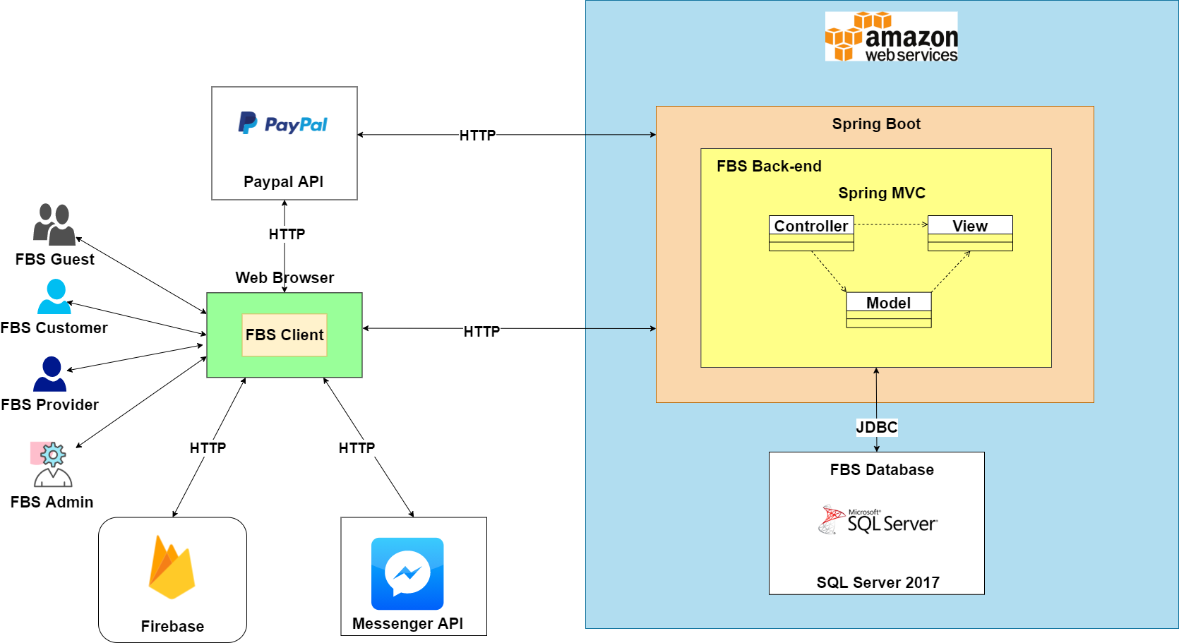

**Figure 2-1**: System Architectural Overview

As described in figure 2-1, the system will have the following components

* **FBS Back-end**: this is developing software that will be built on the Spring MVC framework and deployed on the AWS server.
* **FBS Front-end**: this is developing software that will be built on the ReactJS framework and deployed on the AWS server.
* **Web browser**: this contains FBS client that run in the browser
* **Messenger API**: user use to chat with FBS admin
* **Paypal API**: this is a payment API (Application Programming Interfaces) designed for managing payments
* **Firebase**: this is an application development platform that provides developers with a variety of tools and services to help us build, improve and grow our website. We use it to build a real-time chat and notification application for our website.
* **Amazon Web Service**: this is the world's most comprehensive and broadly adopted cloud platform, offering a lot of featured services from data centers globally.
* **Spring Boot:** this is an open source Java-based framework used to provide a good platform for Java developers to develop a stand-alone and production-grade spring application that you can just run. We use it to develop our services in the FBS back-end system.
* **SQL Server 2017**: this is a powerful and reliable free data management system that delivers a rich and reliable data store for lightweight Web Sites and desktop applications.

### 

### 2.2 Assumptions

This system is designed basing on these following assumptions:

* Spring Boot 2.4.5
* ReactJS 17.0.2
* Google chrome, Internet Explorer, Microsoft Edge, Cốc Cốc, ...
* Firebase 8.6.2
* Paypal API v2
* Messenger API 0.8.0
* AWS(Amazon Web Service)
* SQL server 2017

### 2.3 Design Constraints

This system should be compiled with the following items below:

* End-user environment: Any web browser that users have been installed on their personal computer like Google Chrome, Edge.
* Operating System that is used for running judge host daemon has at least 4GB RAM.
* Every process in this system must be less than 3s, and not exceed 1 second with the best condition of the Internet.
* ReactJS, Spring boot framework

Design requirements:

* FBS Server-side: MVC architecture
* FBS Client: Component based architecture

## 3 Architecture Design

### 3.1 Software Architecture

#### 3.1.1 Process View

##### 3.1.1.1 View Restaurant Process

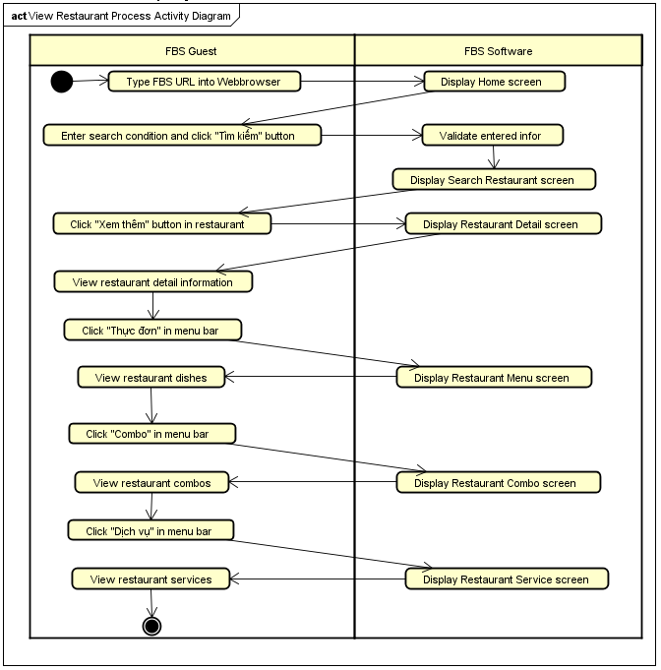

**Figure 3-1**: View restaurant process

As described in Figure 3-1, the view restaurant process will have the following steps:

**Step 1**: FBS guest starts this process when he/she types the URL of the FBS website into the location field of the Web browser.

**Step 2**: FBS software displays the Home screen

**Step 3:** FBS guest enters search conditions: selects province/ city, selects city/ district, or selects the type of feast, or enters keywords name of the restaurant and clicks “Tìm kiếm” button

**Step 4:** FBS software validates entered information and displays the Search Restaurant screen

**Step 5:** FBS guestclicks “Xem thêm” button at the restaurant that wants to view

**Step 6:** FBS software displays the Restaurant Detail screen

**Step 7:** FBS guest view detailed information about restaurant, include name, province, images, description, rate of restaurant and feedbacks from customer of the restaurant

**Step 8:** FBS guest clicks “Thực đơn”/ “Combo”/ “Dịch vụ” hyperlink in menubar

**Step 9:** FBS software displays the Restaurant Menu/ Restaurant Combo/ Restaurant Service screen

**Step 10:** At last, FBS guest views restaurant dishes, combos, services

##### 3.1.1.2 Registration Process

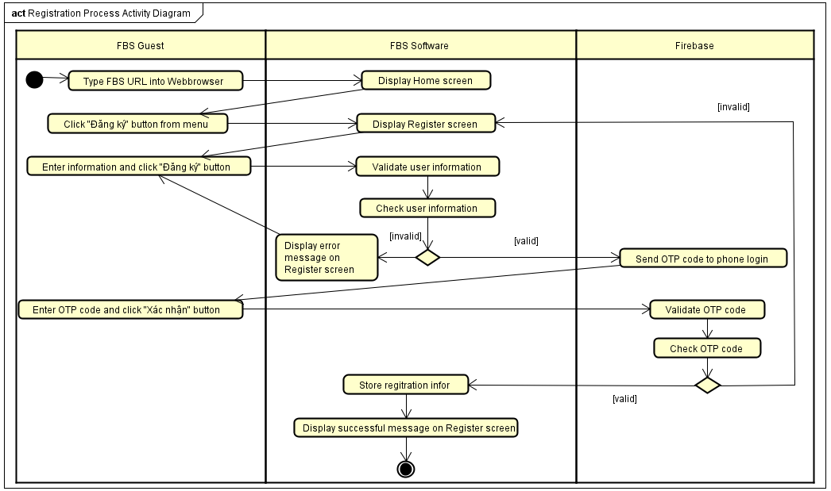

**Figure 3-2**: Registration process

As describe in Figure 3-2, the registration process will have the following steps:

**Step 1**: FBS guest starts this process when he/she types the URL of FBS website into the location field of the Web browser.

**Step 2**: FBS software displays the Home screen

**Step 3:** FBS guest click “Đăng ký” button from header

**Step 4:** FBS software displays Register screen to require the user to enter account information

**Step 5:** FBS guest enters information: username, phone login, password, and re-password and clicks “Đăng ký” button

**Step 6:** After validating user information**,** FBS software checks this data.

**Step 7:** If information is invalid, FBS software will display error messages on the Register screen and information must be re-entered. Otherwise, if the information is valid, Firebase will send an OTP code to phone login

**Step 8:** FBS guest enters OTP code and clicks “Xác nhận” button

**Step 9:** Firebase validate and check OTP code

**Step 10:** If the OTP code entered is not correct, FBS software will display the Register screen again. If the OTP code entered is correct, FBS software will store registration information and display a successful message on the Register screen

##### 3.1.1.3 Login Process

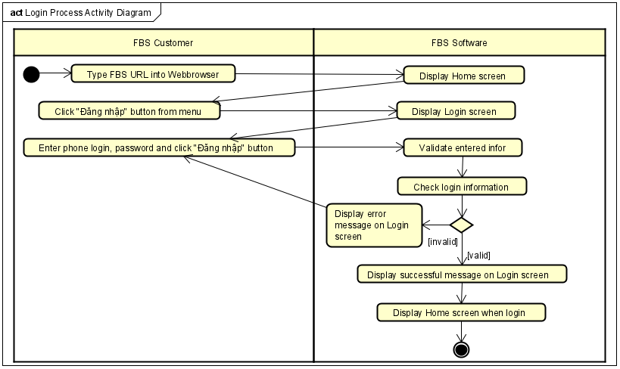

**Figure 3-3**: Login process

As described in Figure 3-3, the login process will have the following steps:

**Step 1**: FBS customer starts this process when he/she types the URL of FBS website into the location field of the Web browser.

**Step 2**: FBS software displays the Home screen

**Step 3:** FBS customer click “Đăng nhập” button from header

**Step 4:** FBS software displays the Login screen to require the user to enter account information

**Step 5:** FBS customer enters information: phone login, password and clicks “Đăng nhập” button

**Step 6:** After validating entered information, FBS software checks this data

**Step 7:** If information is invalid, FBS software will display error messages on the Login screen and information must be re-entered. Otherwise, if the information is valid, FBS software will display a successful message on the Login screen and redirect to the Home screen in logged in state

##### 3.1.1.4 Create Feast Order Process

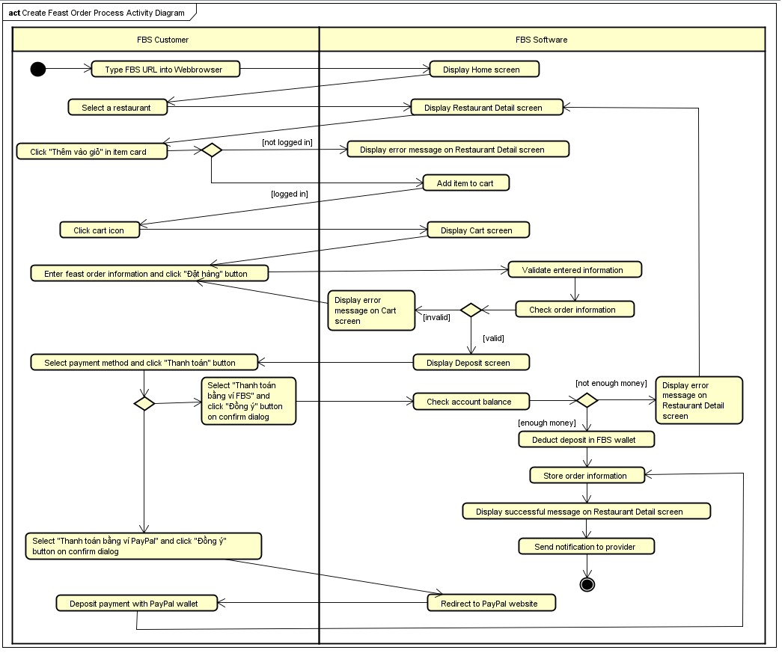

**Figure 3-4**: Create feast order process

As described in Figure 3-4, the create feast order process will have the following steps:

**Step 1**: FBS customer starts this process when he/she types the URL of FBS website into the location field of the Web browser.

**Step 2**: FBS software displays the Home screen

**Step 3:** FBS customer selects a restaurant

**Step 4:** FBS software displays the Restaurant Detail screen

**Step 5:** FBS customer view items in the restaurant and clicks “Thêm vào giỏ” button in item card

**Step 6:** If FBS customer is not logged in, FBS software will display an error message on the Restaurant Detail screen. If FBS customer is logged in, the item will be added to the cart.

**Step 7:** After selecting done, FBS customer clicks cart icon

**Step 8:** FBS software displays the Cart screen

**Step 9:** FBS customer enters feast order information: table type, organize session, number of guests, organize date, note, quantity of item and feast type. If the party is held at home, FBS customers must provide more information about the place where the party will be held. Then, he/she clicks “Đặt hàng” button

**Step 10:** FBS software validate and check entered order information

**Step 11:** If information is invalid, FBS software will display error messages on the Cart screen and information must be re-entered. Otherwise, if the information is valid, FBS software will display the Deposit screen

**Step 12:** FBS customer selects payment method and clicks “Thanh toán” button

**Step 12.1:** If FBS customer selects “Thanh toán bằng ví FBS” and clicks “Đồng ý” button on confirm dialog

**Step 12.1.1:** FBS software checks balance in customer’s FBS wallet

**Step 12.1.2:** If not enough money, FBS software will display an error message on the Restaurant Detail screen. If enough money, FBS software will deduct deposit of order in FBS wallet

**Step 12.2:** If FBS customer selects “Thanh toán bằng ví PayPal” and clicks “Đồng ý” button on confirm dialog

**Step 12.2.1:** FBS software redirect to PayPal website

**Step 12.1.2:** FBS customer deposit payment with PayPal wallet

**Step 13:** FBS software stores order with status is pending, displays successful message on Restaurant Detail screen and sends notification to FBS provider

##### 3.1.1.5 Cancel Feast Order Process

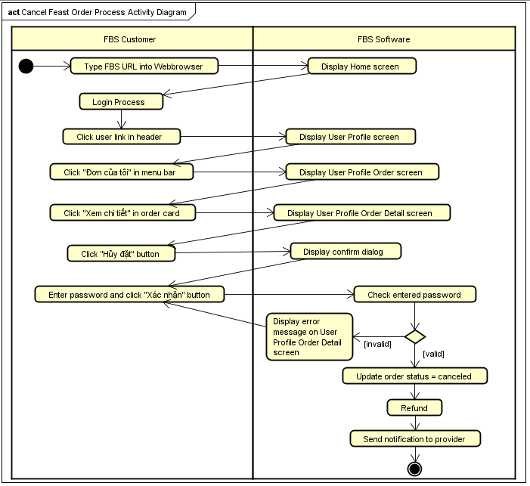

**Figure 3-5**: Cancel feast order process

As describe in Figure 3-5, the cancel feast order process will have the following steps:

**Step 1**: FBS customer starts this process when he/she types the URL of FBS website into the location field of the Web browser.

**Step 2**: FBS software displays the Home screen in logged in state

**Step 3**: FBS customer performs the Login process and then clicks user link in the header

**Step 4:** FBS software displays the User Profile screen

**Step 5:** FBS customer clicks “Đơn của tôi” in menu bar

**Step 6:** FBS software displays the User Profile Order screen

**Step 7:** FBS customer clicks “Xem chi tiết” hyperlink in the order that wants to cancel

**Step 8:** FBS software displays the User Profile Order Detail screen

**Step 9:** In the User Profile Order Detail screen, FBS customer clicks “Hủy đặt” button

**Step 10:** FBS software displays the confirm dialog to require the user to enter password

**Step 11:** FBS customer enters password and then clicks “Xác nhận” button

**Step 12:** FBS software check entered password

**Step 13:** If password is invalid, FBS software will display an error message on User Profile Order Detail screen and password must be re-entered. Otherwise, if password is valid, FBS software will update the order status to canceled

**Step 14:** When the order is canceled, FBS customer and FBS provider will be refunded according to the system's regulations

**Step 15:** FBS software sends a notification about canceling the order to FBS provider

##### 3.1.1.6 Accept Order Process

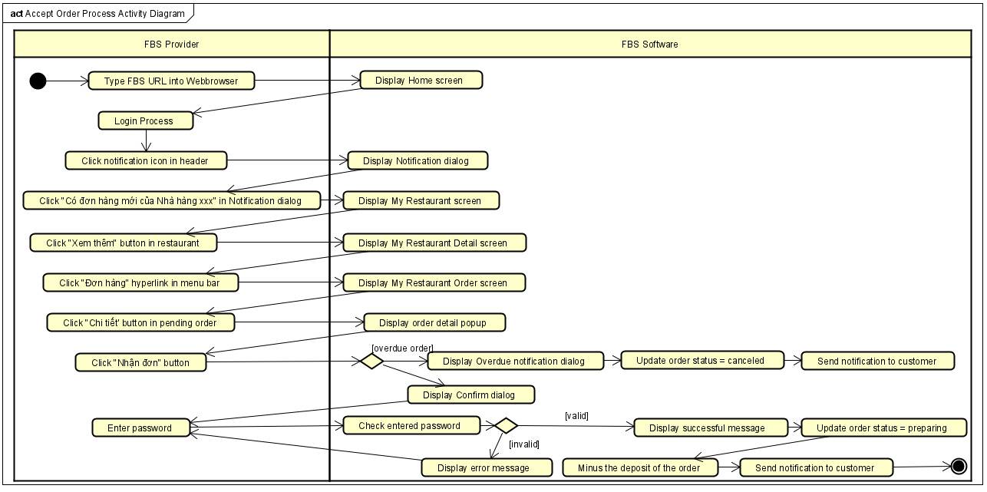

**Figure 3-6**: Accept order process

As describe in Figure 3-6, the accept order process will have the following steps:

**Step 1**: FBS provider starts this process when he/she types the URL of FBS website into the location field of the Web browser.

**Step 2**: FBS software displays the Home screen

**Step 3**: FBS provider performs the Login processand then clicks the Notification icon in the header

**Step 4:** FBS software displays the Notification dialog

**Step 5:** FBS provider clicks “Có đơn hàng mới của Nhà hàng xxx” in Notification dialog

**Step 6:** FBS software displays the My Restaurant screen

**Step 7:** FBS provider clicks “Xem thêm” button in the restaurant has new order

**Step 8:** FBS software displays the My Restaurant Detail screen

**Step 9:** FBS provider clicks “Đơn hàng” hyperlink in menu bar

**Step 10:** FBS software displays the My Restaurant Order screen

**Step 11:** In the My Restaurant Order screen, FBS provider clicks “Chi tiết” button in pending order

**Step 12:** FBS software displays the Order Detail popup

**Step 13:** In the the Order Detail popup, FBS provider clicks “Nhận đơn” button

**Step 14:** If the order is overdue, FBS software will display Overdue notification dialog and the order status is updated to canceled. Then FBS software sends notification to FBScustomer about canceling the order**.** If the order is valid, FBS software displays the confirm dialog to require the user to enter password

**Step 15:** FBS provider enters password and then clicks “Đồng ý” button

**Step 13:** FBS software check entered password

**Step 14:** If password is invalid, FBS software will display an error message on Order Detail popup and password must be re-entered. Otherwise, if password is valid, FBS software will display a successful message on Order Detail popup and the order status is updated to preparing.

**Step 15:** FBS software deducts the deposit of the order exactly equal to the deposit stated in the order

**Step 16:** FBS software sends a notification about accepting the order to FBS customer

##### 3.1.1.7 Cancel Order Process

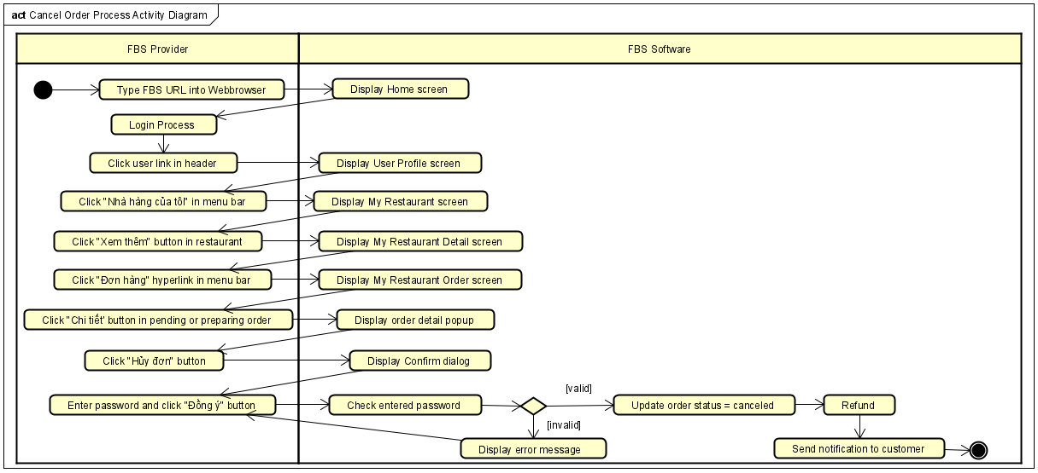

**Figure 3-7**: Cancel order process

As describe in Figure 3-7, the cancel order process will have the following steps:

**Step 1**: FBS provider starts this process when he/she types the URL of FBS website into the location field of the Web browser.

**Step 2**: FBS software displays the Home screen

**Step 3**: FBS provider performs the Login processand then clicks the user link in the header

**Step 4:** FBS software displays the User Profile screen

**Step 5:** FBS provider clicks “Nhà hàng của tôi” hyperlink in menu bar

**Step 6:** FBS software displays the My Restaurant screen

**Step 7:** FBS provider clicks “Xem thêm” button in the restaurant

**Step 8:** FBS software displays the My Restaurant Detail screen

**Step 9:** FBS provider clicks “Đơn hàng” hyperlink in menu bar

**Step 10:** FBS software displays the My Restaurant Order screen

**Step 11:** In the My Restaurant Order screen, FBS provider clicks “Chi tiết” button in pending or preparing order

**Step 12:** FBS software displays the Order Detail popup

**Step 13:** In the the Order Detail popup, FBS provider clicks “Hủy đơn” button

**Step 14:** FBS software displays the confirm dialog to require the user to enter password

**Step 15:** FBS provider enters password and then clicks “Đồng ý” button

**Step 13:** FBS software check entered password

**Step 14:** If password is invalid, FBS software will display an error message on Order Detail popup and password must be re-entered. Otherwise, if password is valid, FBS software will update order status to canceled.

**Step 15:** When the order is canceled, FBS customer and FBS provider will be refunded according to the system's regulations

**Step 16:** FBS software sends a notification about canceling the order to FBS customer

##### 3.1.1.8 Complete Order Process

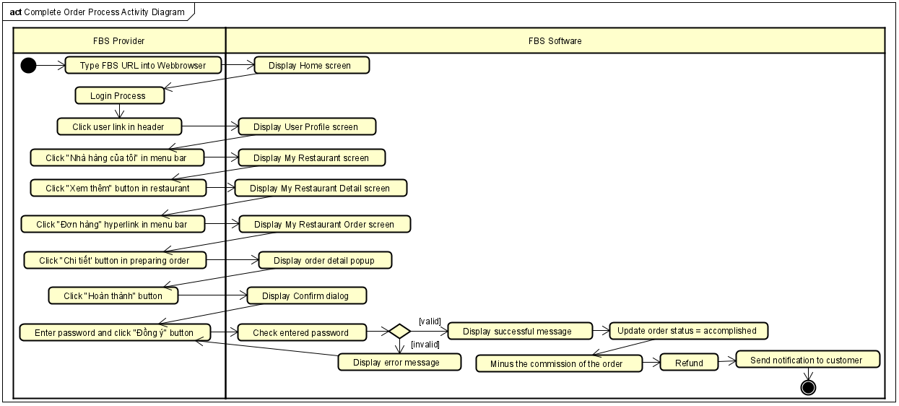

**Figure 3-8**: Complete order process

As describe in Figure 3-8, the complete order process will have the following steps:

**Step 1**: FBS provider starts this process when order is completed and FBS customer has paid for the order in full for FBS provider. He/she types the URL of FBS website into the location field of the Web browser.

**Step 2**: FBS software displays the Home screen

**Step 3**: FBS provider performs the Login processand then clicks the user link in the header

**Step 4:** FBS software displays the User Profile screen

**Step 5:** FBS provider clicks “Nhà hàng của tôi” hyperlink in menu bar

**Step 6:** FBS software displays the My Restaurant screen

**Step 7:** FBS provider clicks “Xem thêm” button in the restaurant

**Step 8:** FBS software displays the My Restaurant Detail screen

**Step 9:** FBS provider clicks “Đơn hàng” hyperlink in menu bar

**Step 10:** FBS software displays the My Restaurant Order screen

**Step 11:** In the My Restaurant Order screen, FBS provider clicks “Chi tiết” button in pending or preparing order

**Step 12:** FBS software displays the Order Detail popup

**Step 13:** In the the Order Detail popup, FBS provider clicks “Hoàn thành” button

**Step 14:** FBS software displays the confirm dialog to require the user to enter password

**Step 15:** FBS provider enters password and then clicks “Đồng ý” button

**Step 13:** FBS software check entered password

**Step 14:** If password is invalid, FBS software will display an error message on Order Detail popup and password must be re-entered. Otherwise, if password is valid, FBS software will display a successful message on Order Detail popup and update order status to accomplished.

**Step 15:** When the order is completed, FBS software minus the commission of the order and FBS

provider will be refunded according to the system's regulations

**Step 16:** FBS software sends a notification about completing the order to FBS customer

##### 3.1.1.9 Add Restaurant Process

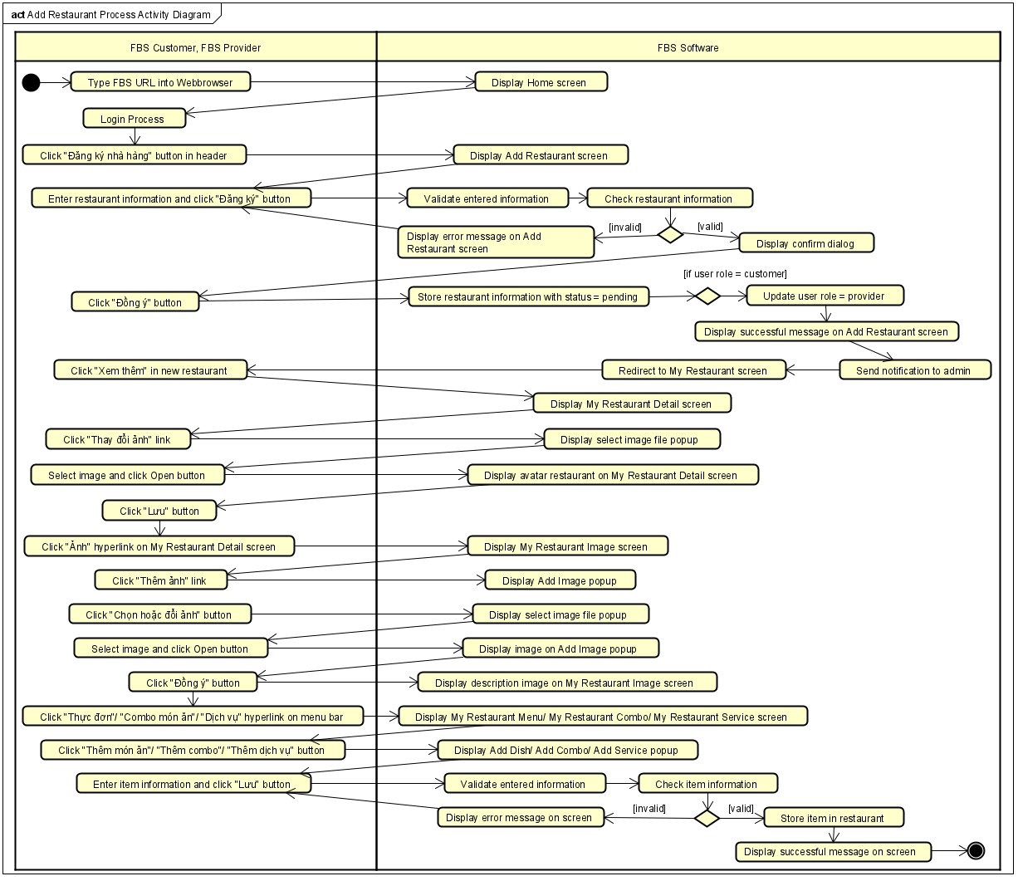

**Figure 3-9:** Add restaurant process

As describe in Figure 3-9, the add restaurant process will have the following steps:

**Step 1:** FBS customer/FBS provider starts this process when he/she types the URL of FBS website into the location field of the Web browser.

**Step 2:** FBS software displays the Home screen

**Step 3**: FBS customer/ FBS provider performs the Login processand then clicks “Đăng ký nhà hàng” hyperlink in the header

**Step 4:** FBS software displays the Add Restaurant screen

**Step 5:** FBS customer/ FBS provider enter restaurant information and clicks “Đăng ký” button

**Step 6:** After validating entered information**,** FBS software checks restaurant information

**Step 7:** If information is invalid, FBS software will display error messages on the Add Restaurant screen and information must be re-entered. Otherwise, if the information is valid, FBS software will display Confirm dialog

**Step 8:** FBS customer/ FBS provider clicks “Đồng ý” button in the dialog

**Step 9:** FBS software stores a new restaurant with status pending. After that, if the user has the role of customer, it will be updated to provider. Then, FBS software display a successful message on Add Restaurant screen, sends a notification to FBS admin about the new restaurant, and redirects to the My Restaurant screen

**Step 10:** FBS provider clicks “Xem thêm” in the new restaurant and performs adding avatars, descriptions image of the restaurant and add some items for menu, combo, and service

##### 3.1.1.10 Restaurant Review Process

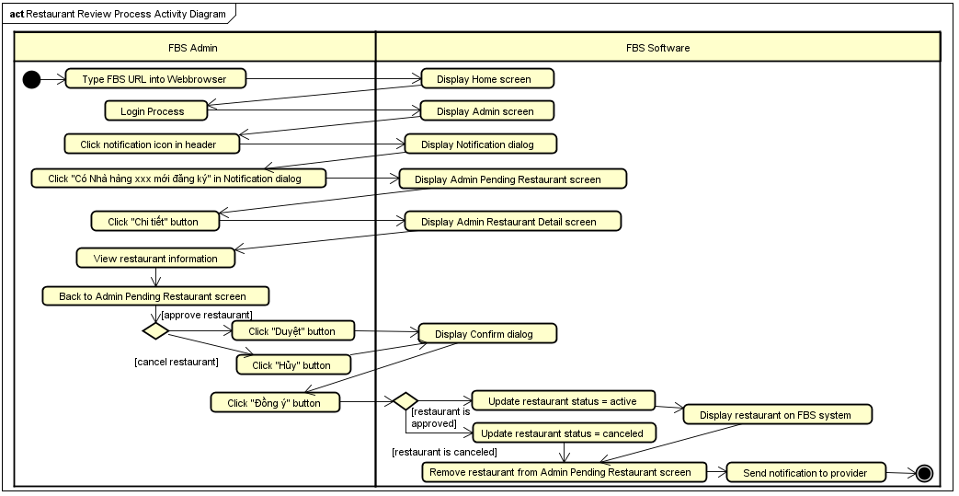

**Figure 3-10**: Restaurant review process

As described in Figure 3-10, the restaurant review process will have the following steps:

**Step 1**: FBS admin starts this process when he/she types the URL of FBS website into the location field of the Web browser.

**Step 2**: FBS software displays the Home screen

**Step 3**: FBS admin performs the Login process

**Step 4:** FBS software displays the Admin screen

**Step 5:** FBS admin clicks notification icon in header

**Step 6:** FBS software displays Notification dialog

**Step 7:** FBS admin clicks “Có nhà hàng xxx mới đăng ký” hyperlink in Notification dialog

**Step 8:** FBS software displays Admin Pending Restaurant screen

**Step 9:** FBS admin clicks “Chi tiết” button on the restaurant that wants to review

**Step 10:** FBS software displays Admin Restaurant Detail screen

**Step 11:** FBS admin views restaurant information and checks if the restaurant's information is valid and following the system's standards. Then he/she backs to Admin Pending Restaurant screen

**Step 12:** If the restaurant is invalid, FBS admin clicks “Hủy” button. If the restaurant is valid, FBS admin clicks “Duyệt” button

**Step 13:** FBS software displays confirm dialog

**Step 14:** FBS admin clicks “Đồng ý” button on dialog

**Step 15:** If the restaurant is approved, FBS software will update the status of the restaurant to active, displaying the restaurant on the FBS system. Otherwise, if the restaurant is canceled, FBS software will update the status of the restaurant to canceled. After that, the restaurant is removed from the Admin Pending Restaurant screen and FBS software will send a message to FBS provider about whether the restaurant was approved or canceled

#### 3.1.2 Logical View

##### 3.1.2.1 FBS Back-End

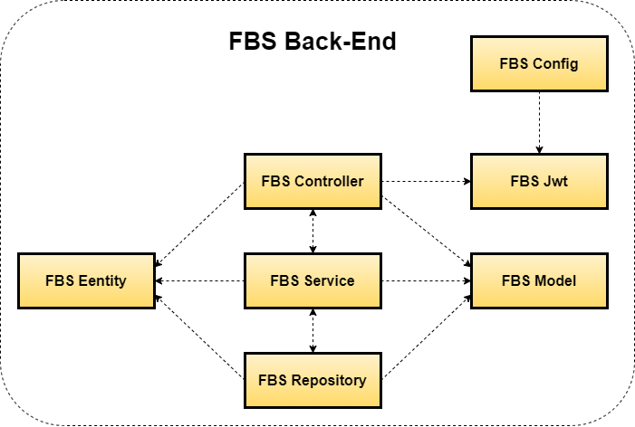

**Figure 3-11**: FBS Back-end Logical View

|  |  |  |
| --- | --- | --- |
| **No** | **Component name** | **Description** |
| 01 | FBS Controller | Acts as a go-between for the service layer and the FBS Front-end, passing on different input requests to the service |
| 02 | FBS Service | This component acts as a logic layer that receives passing on input requests from controller to the repository |
| 03 | FBS Repository | This component is used to connect and get data directly from the database, put into the respective entities and response to the service. |
| 04 | FBS Config | This component helps define configuration for Spring Security. |
| 05 | FBS Model | This component includes interfaces used to receive data retrieved from the database and classes used to receive data received from the client. |
| 06 | FBS Entity | This component constraint objects that help Spring boot manipulates the database |
| 07 | FBS Jwt | This component constraint jwt class that create token that help represent the transfer requests between the two sides FBS Client and FBS Server |

**Table 3-1**: FBS Back-End description

##### 3.1.2.2 FBS Front-End

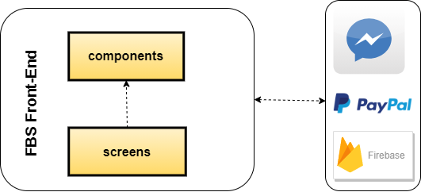

**Figure 3-12:** FBS Front-End

|  |  |  |
| --- | --- | --- |
| **No** | **Component name** | **Description** |
| 01 | components | Contains front-end classes for each child component present in the system |
| 02 | screens | Contains front-end classes for each base component present in the system |

**Table 3-2**: FBS Front-End description

#### 3.1.3 Development View

##### 3.1.3.1 Back-end Package Diagram

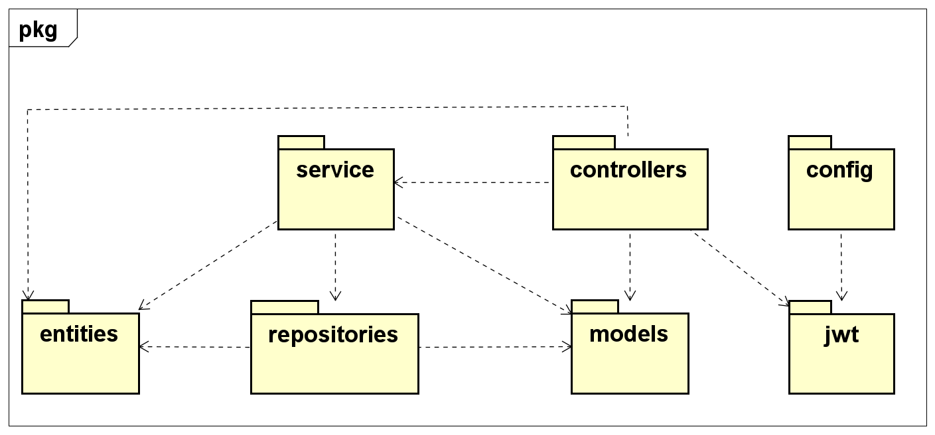

**Figure 3-13:** FBS Package Diagram

**Packages Description**

|  |  |  |
| --- | --- | --- |
| **No** | **Package** | **Description** |
| 01 | controller | Contain classes that are defined as controllers, the main function is connected between client and server through API endpoints. |
| 02 | service | Contain classes that are defined as service, handle processing business logic and work as a bridge between controller and repository. |
| 03 | repository | Contain classes that are defined as repositories, handle getting data from the database. |
| 04 | entity | Contain classes to keep data received from the database. |
| 05 | models | Containing classes and interfaces used as data transfer between layers |
| 06 | config | Containing class helping define configuration for Spring Security |
| 07 | jwt | The front-end contains ReactJs code, communicates with the back-end API via HTTP requests using JWT to retrieve data and perform operations. |

**Table 3-3**: Packages Description

##### 3.1.3.1 Front-end Package Diagram

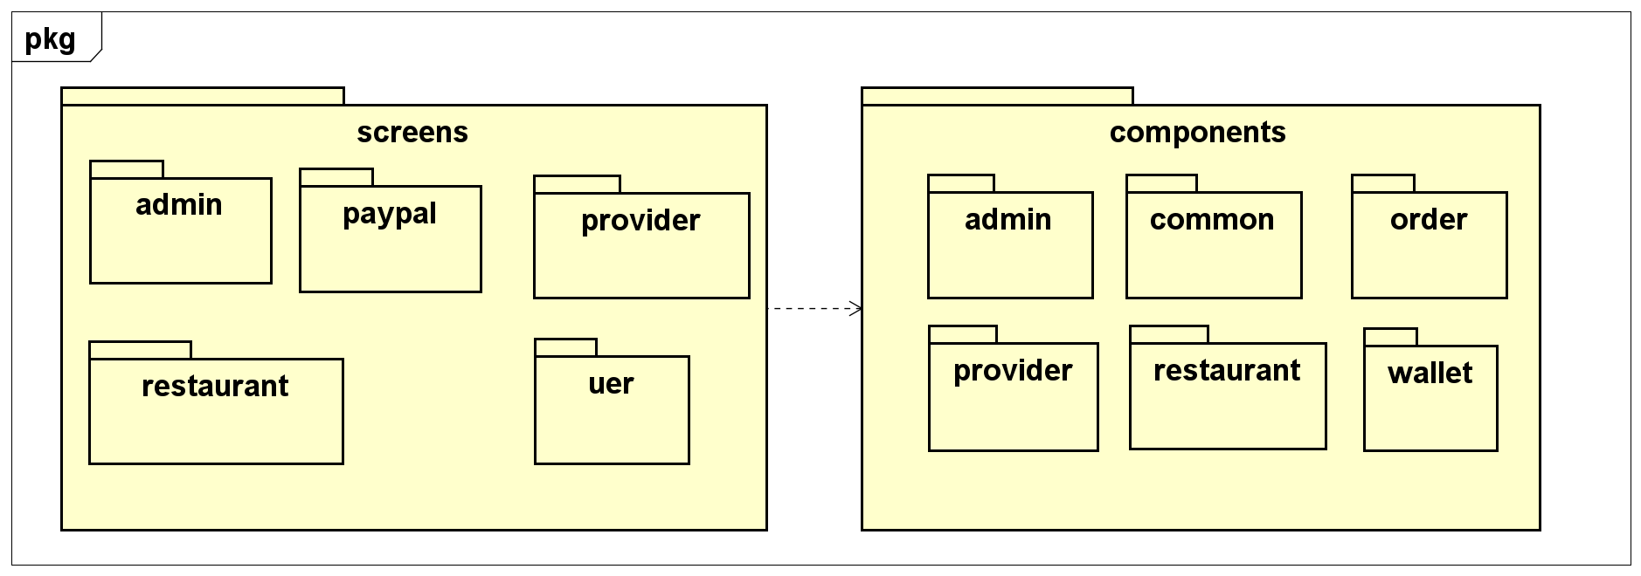

**Figure 3-14:** FBS Package Diagram

**Packages Description**

|  |  |  |
| --- | --- | --- |
| **No** | **Package** | **Description** |
| 01 | screens | Contains the classes used to render interfaces for the pages in the project. |
| 02 | components | All the components of the projects that are the children of main views |

**Table 3-4**: Packages Description

##### 3.1.3.2 Component Diagram [optional]

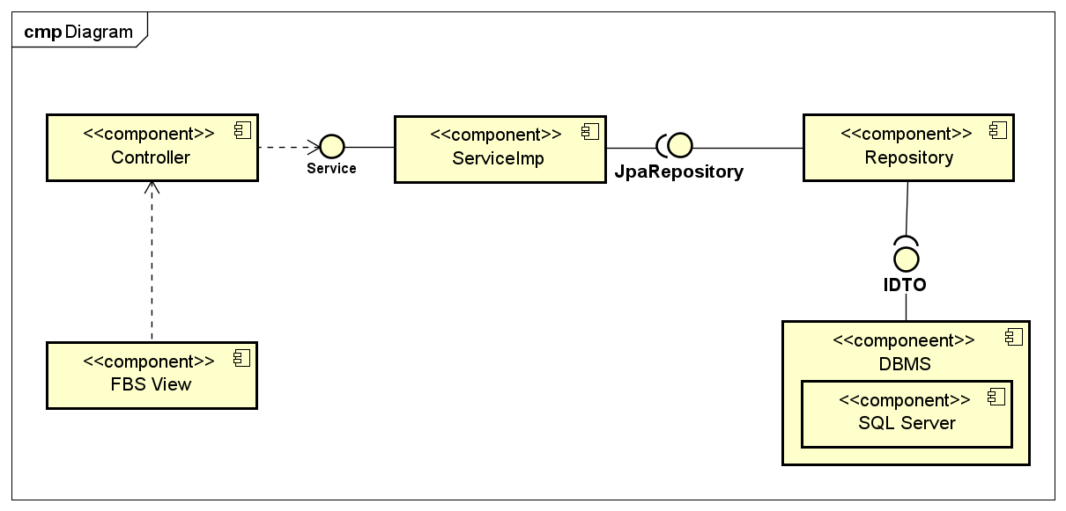

**Figure 3-15:** FBS Component Diagram

**Components Description**

|  |  |  |
| --- | --- | --- |
| **No** | **Component** | **Description** |
| 01 | FBS View | Contains the system's front-end classes |
| 02 | Controller | Acts as a go-between for the service layer and the FBS View, passing on different input requests to the Service |
| 03 | Service | This is interface that receive requests from controller and declare handler functions |
| 04 | ServiceImp | Used to implement the functions declared in Service |
| 05 | JpaRepository | JPA specific extension of Repository. It contains the full API of CrudRepository. So it contains APIs for basic CRUD operations. |
| 06 | Repository | Interfaces extended by JpaRepository are used to retrieve data from the database using query statements |
| 07 | Database | Database storage component |

**Table 3-5**: Components Description

#### 3.1.4 Deployment View

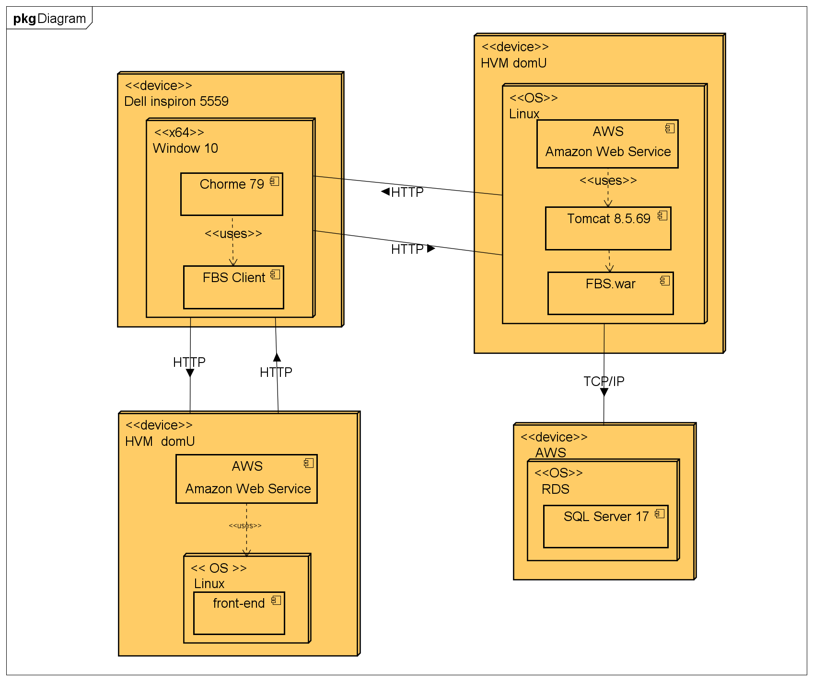

**Figure 3-16:** FBS Deployment structure

**Configuration Description**

|  |  |  |
| --- | --- | --- |
| **No** | **Component/Node** | **Description** |
| 01 | dell inspiron 5559 | Dell Inspiron 5559 is a Ubuntu laptop with a 15.60-inch display that has a resolution of 1920x1080 pixels. It is powered by a Core i7 processor and it comes with 16GB of RAM. The Dell Inspiron 5559 packs 2TB of HDD storage. |
| 02 | Windows 10 | Windows 10 is a major release of the Windows NT operating system developed by Microsoft. It is the successor to Windows 8.1, which was released nearly two years earlier, and itself was released to manufacturing on July 15, 2015, and broadly released for the general public on July 29, 2015 |
| 03 | Chrome 79 | Google Chrome is a cross-platform web browser developed by Google. It was first released in 2008 for Microsoft Windows built with free software components from Apple WebKit and Mozilla Firefox. It was later ported to Linux, macOS, iOS, and Android where it is the default browser built into the OS. |
| 04 | FBS client | Client of FBS system |
| 05 | HVM domU | HVM (Hardware Virtual Machine) is one of the two modes that XEN can virtualize machines in. In this mode it makes use of Hardware virtualization technology like VT-X and emulation of hardware devices to virtualize non paravirtualized guests such as Windows. |
| 06 | Linux | Linux is a family of open-source Unix-like operating systems based on the Linux kernel, an operating system kernel first released on September 17, 1991, by Linus Torvalds. Linux is typically packaged in a Linux distribution. |
| 07 | AWS | Amazon Web Services is a subsidiary of Amazon providing on-demand cloud computing platforms and APIs to individuals, companies, and governments, on a metered pay-as-you-go basis. |
| 08 | Tomcat 8.5.69 | This is the top-level entry point of the documentation bundle for the Apache Tomcat Servlet/JSP container. Apache Tomcat version 8.5 implements the Servlet 3.1 and JavaServer Pages 2.3 specifications from the Java Community Process, and includes many additional features that make it a useful platform for developing and deploying web applications and web services. |
| 09 | FBS.war | The file is deployed |
| 10 | SQL Server 17 | As a database server version 17, it is a software product with the primary function of storing and retrieving data as requested by software application |

**Table 3-6**: Configuration Description

## 4 Detailed Component Design

### 4.1 Guest

#### 4.1.1 UC-01 Search Restaurants

##### 4.1.1.1 Screen design

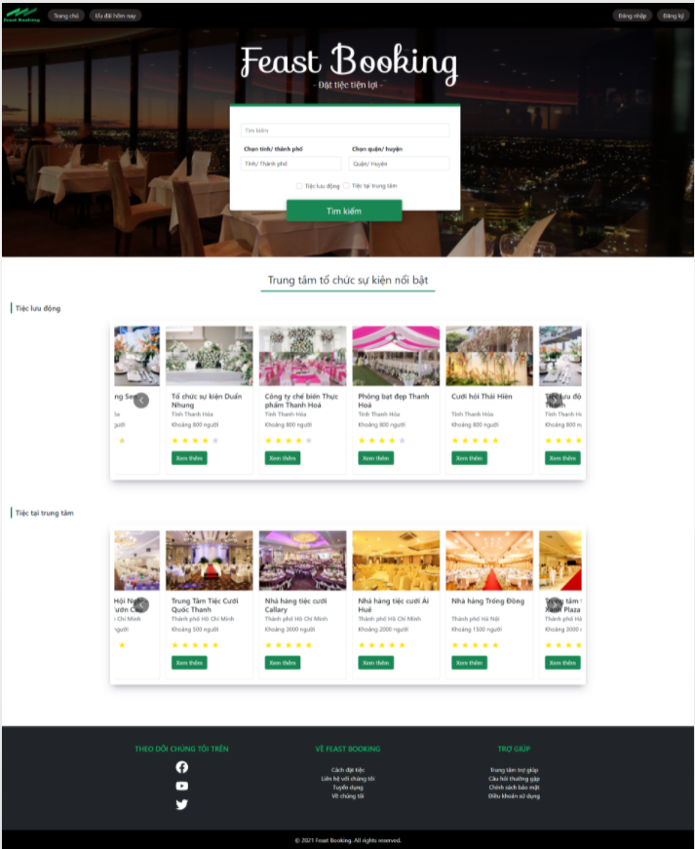

**Figure 4-1:** Search Restaurant

|  |  |  |  |  |  |
| --- | --- | --- | --- | --- | --- |
| **#** | **Object/Control Name** | **Type** | **Require** | **Length** | **Description** |
| **Header** | | | | | |
| 1 | Logo Image | <Link></Link> |  |  | Link to Home screen |
| 2 | Trang chủ | <Link>Trang chủ</Link> |  |  | Link to Home screen |
| 3 | Ưu đãi hôm nay | <Link>Ưu đãi hôm nay</Link> |  |  | Link to View All Promotion screen |
| 4 | Đăng ký nhà hàng | <Link>Đăng ký nhà hàng</Link> |  |  | Link to Add Restaurant screen |
| 5 | Đăng nhập | <Link>Đăng nhập</Link> |  |  | Button to sign in |
| 6 | Đăng ký | <Link>Đăng ký</Link> |  |  | Button to sign up |
| **Main** | | | | | |
| 1 | Tìm Kiếm | <Input type="submit" value="Tìm kiếm" /> | No |  | The textbox to enter search keywords or restaurant’s name |
| 2 | Tỉnh/ Thành phố | <option>Tỉnh/ Thành phố</option> | No |  | List of province |
| 3 | Quận/ Huyện | <option>Quận/ Huyện</option> | No |  | List districts of selected province |
| 4 | Tiệc lưu động | <Input type="checkbox" /> Tiệc lưu động | No |  | Choose the type of feast |
| 5 | Tiệc tại trung tâm | <Label check> <Input type="checkbox" /> Tiệc tại trung tâm </Label> | No |  | Choose the type of feast |
| 6 | Tìm kiếm | <Input type="submit" value="Tìm kiếm" /> |  |  | The button to trigger Search function |
| 7 | Restaurant Card | <Container /> |  |  | The card display restaurant information that matches the search terms |
| 8 | Restaurant Photo | <CardImg /> |  |  | Avatar of the restaurant |
| 10 | Xem thêm | <Button>Xem thêm</Button> |  |  | This button links to Restaurant Detail screen |
| **Footer** | | | | | |
| 1 | Theo dõi chúng tôi trên | <h5>Theo dõi chúng tôi trên</h5> |  |  |  |
| 2 | Twitter Logo | <a href="#!" ><FaTwitter /></a> |  |  | Link to FBS’s Twitter account |
| 3 | Facebook Logo | <a href="#!" ><Facebook /></a> |  |  | Link to FBS’s Facebook account |
| 4 | Youtube Logo | <a href="#!"><FaYoutube /></a> |  |  | Link to FBS’s Youtube channel |
| 5 | Về Feast Booking | <h5 >Về Feast Booking</h5> |  |  |  |
| 6 | Cách đặt tiệc | <a href="#!" >Cách đặt tiệc</a> |  |  | Guide on how to book a feast at the FBS system |
| 7 | Liên hệ với chúng tôi | <a href="#!" >Liên hệ với chúng tôi</a> |  |  | How to contact the system |
| 8 | Tuyển dụng | <a href="#!" >Tuyển dụng</a> |  |  | Recruitment news of FBS |
| 9 | Về chúng tôi | <a href="#!" >Về chúng tôi</a> |  |  | Introduce to FBS system |
| 10 | Trợ giúp | <h5>Trợ giúp</h5> |  |  |  |
| 11 | Trung tâm trợ giúp | <a href="#!">Trung tâm trợ giúp</a> |  |  | User support |
| 12 | Câu hỏi thường gặp | <a href="#!">Câu hỏi thường gặp</a> |  |  | Frequently asked questions by users |
| 13 | Chính sách bảo mật | <a href="#!">Chính sách bảo mật</a> |  |  | Privacy policy |
| 14 | Điều khoản sử dụng | <a href="#!">Điều khoản sử dụng</a> |  |  | Terms of use |

**Table 4-1:** Search Restaurant Screen Definition

##### 4.1.1.2 Class diagram

###### **4.1.1.2.1 Back end**

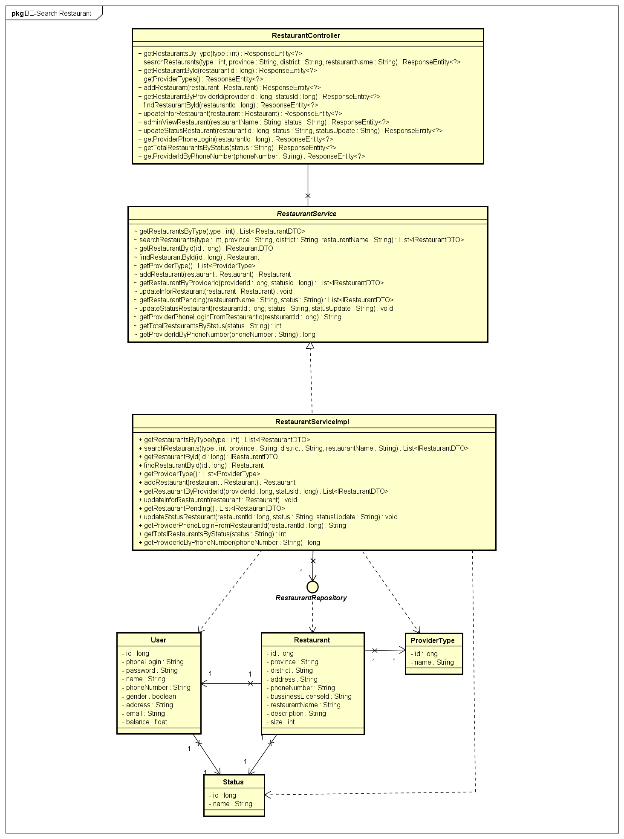

**Figure 4-2:** Search Restaurants - Back-end Class Diagram

###### **4.1.1.2.2 Front end**

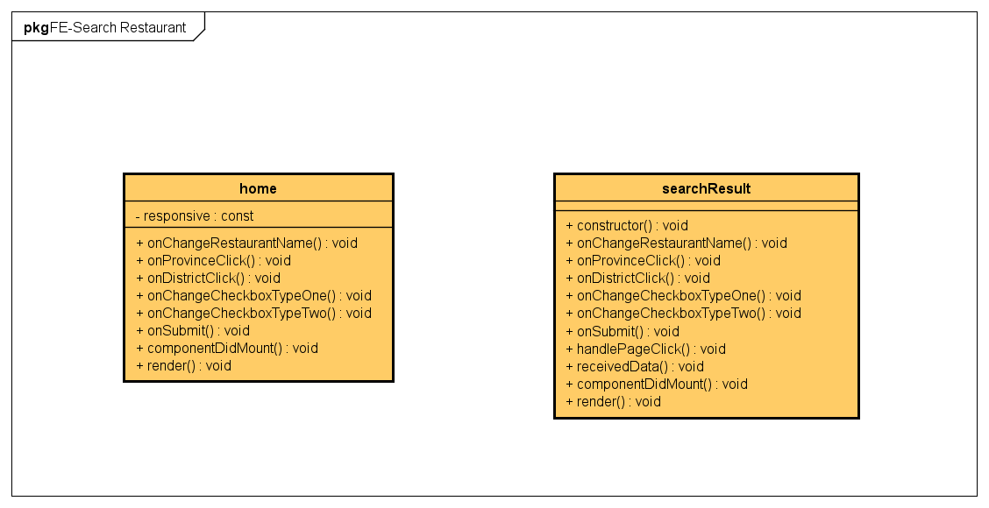

**Figure 4-3:** Search Restaurants - Front-end Class Diagram

##### 4.1.1.3 Class Description

###### **4.1.1.3.1 home**

|  |  |  |  |  |
| --- | --- | --- | --- | --- |
| **Class** | **home** | | | |
| **Description** | Define attributes and methods for these attributes in home front-end class | | | |
| **Base Class** | Component | | | |
| **Constructor** | - state  - onProvinceClick  - onChangeRestaurantName  - onDistrictClick  - onChangeCheckboxTypeOne  - onChangeCheckboxTypeTwo  - onSubmit | | | |
| **Prototype** |  | | | |
| **Source File** | ofbs-master\front-end\src\screens\home.js | | | |
| **Namespace** |  | | | |
| **Attributes** | **Name** | **Type** | **Description** | |
| responsive | const | component detailed declaration for each device | |
| **Methods** | **Name** | **Input** | **Output** | **Description** |
| onChangeRestaurantName | event |  | store temp value of restaurant name |
| onProvinceClick | event |  | get districts by province code |
| onDistrictClick | event |  | set district Name |
| onChangeCheckboxTypeOne | event |  | store temp value of type and set type |
| onChangeCheckboxTypeTwo | event |  | store temp value of type and set type |
| onSubmit | e |  | set status submit is true |
| componentDidMount |  |  | call API to get restaurant type and loading status |
| render |  |  | send data to HTML |

**Table 4-2:** home class description

###### **4.1.1.3.2 searchResult**

|  |  |  |  |  |
| --- | --- | --- | --- | --- |
| **Class** | **searchResult** | | | |
| **Description** | Define attributes and methods for these attributes in searchResult front-end class | | | |
| **Base Class** | Component | | | |
| **Constructor** | - state  - onProvinceClick  - onChangeRestaurantName  - onDistrictClick  - onChangeCheckboxTypeOne  - onChangeCheckboxTypeTwo  - onSubmit | | | |
| **Prototype** |  | | | |
| **Source File** | ofbs-master\front-end\src\screens\searchResult.js | | | |
| **Namespace** |  | | | |
| **Attributes** | **Name** | **Type** | **Description** | |
|  |  |  | |
| **Methods** | **Name** | **Input** | **Output** | **Description** |
| onChangeRestaurantName | event |  | store temp value of restaurant name |
| onProvinceClick | event |  | get districts by province code |
| onDistrictClick | event |  | set district Name |
| onChangeCheckboxTypeOne | event |  | store temp value of type and set type |
| onChangeCheckboxTypeTwo | event |  | store temp value of type and set type |
| onSubmit | e |  | set status submit is true |
| componentDidMount |  |  | call API to get restaurant type and loading status |
| render |  |  | send data to HTML |
| handlePageClick |  |  | handle Page |
| receivedData |  |  | store restaurant temp data received |

**Table 4-3**: searchResult class description

###### **4.1.1.3.3 RestaurantController**

|  |  |  |  |  |
| --- | --- | --- | --- | --- |
| **Class** | **RestaurantController** | | | |
| **Description** | Responsible for controlling the way that a user interacts with a restaurant | | | |
| **Base Class** | N/A | | | |
| **Constructor** | N/A | | | |
| **Prototype** | N/A | | | |
| **Source File** | ofbs-master\back-end\src\main\java\edu\fpt\ofbs\controllers\RestaurantController.java | | | |
| **Namespace** | N/A | | | |
| **Attributes** | **Name** | **Type** | **Description** | |
|  |  |  | |
| **Methods** | **Name** | **Input** | **Output** | **Description** |
| getRestaurantsByType | type | ResponseEntity | Using to receive and return restaurants by type of them |
| searchRestaurants | type  province  district  restaurantName | ResponseEntity | Using to receive and return search restaurants by type, province, district and restaurantName |
| getRestaurantById | restaurantId | ResponseEntity | using to receive and return a restaurant by id |
| getProviderTypes | N/A | ResponseEntity | Using to receive and return providers by them type |
| addRestaurant | restaurant | ResponseEntity | Using to receive and return add a new restaurant |
| getRestaurantByProviderId | providerId  statusId | ResponseEntity | Using to receive and return restaurant by provider id |
| findRestaurantById | restaurantId | ResponseEntity | Using to receive and return find restaurant by id |
| updateInforRestaurant | restaurant | ResponseEntity | Using to receive and return update information of restaurant |
| adminViewRestaurant | restaurantName  status | ResponseEntity | Using to receive and return view restaurant by admin |
| updateStatusRestaurant | restaurantId  status  statusUpdate | ResponseEntity | Using to receive and return update status of restaurant |
| getProviderPhoneLogin | restaurantId | ResponseEntity | Using to receive and return phone login of provider |
| getTotalRestaurantsByStatus | status | ResponseEntity | Using to receive and return total restaurant by status |
| getProviderIdByPhoneNumber | phoneNumber | ResponseEntity | Using to receive and return provider by phone number |

**Table 4-4**: RestaurantControllerclass description

###### **4.1.1.3.4 RestaurantServiceImpl**

|  |  |  |  |  |
| --- | --- | --- | --- | --- |
| **Class** | **RestaurantServiceImpl** | | | |
| **Description** | provide functionality to handle user requests with restaurants | | | |
| **Base Class** | RestaurantService | | | |
| **Constructor** | N/A | | | |
| **Prototype** |  | | | |
| **Source File** | ofbs-master\back-end\src\main\java\edu\fpt\ofbs\service\impl\RestaurantServiceImpl.java | | | |
| **Namespace** |  | | | |
| **Attributes** | **Name** | **Type** | **Description** | |
|  |  |  | |
| **Methods** | **Name** | **Input** | **Output** | **Description** |
| getRestaurantsByType | type | List<IRestaurantDTO> | Using to get restaurants by type of them |
| searchRestaurants | type  province  district  restaurantName | List<IRestaurantDTO> | Using to search restaurants by type, province, district and restaurantName |
|  | getRestaurantById | restaurantId | IRestaurantDTO | using to get a restaurant by id |
|  | getProviderTypes |  | List<ProviderType> | Using to get providers by them type |
|  | addRestaurant | restaurant | Restaurant | Using to add a new restaurant |
|  | getRestaurantByProviderId | providerId  statusId | List<IRestaurantDTO> | Using to get restaurant by provider id |
|  | findRestaurantById | restaurantId | Restaurant | Using to find restaurant by id |
|  | updateInforRestaurant | restaurant |  | Using to update information of restaurant |
|  | updateStatusRestaurant | restaurantId  status  statusUpdate |  | Using to update status of restaurant |
|  | getProviderPhoneLogin | restaurantId | String | Using to get phone login of provider |
|  | getTotalRestaurantsByStatus | status | int | Using to get total restaurant by status |
|  | getProviderIdByPhoneNumber | phoneNumber | long | Using to get provider by phone number |

**Table 4-5**: RestaurantServiceImpl class description

###### **4.1.1.3.5 RestaurantRepository**

|  |  |  |  |  |
| --- | --- | --- | --- | --- |
| **Class** | **RestaurantRepository** | | | |
| **Description** | manipulate the restaurant table in the database. | | | |
| **Base Class** |  | | | |
| **Constructor** |  | | | |
| **Prototype** |  | | | |
| **Source File** | ofbs-master\back-end\src\main\java\edu\fpt\ofbs\repositories\RestaurantRepository.java | | | |
| **Namespace** |  | | | |
| **Attributes** | **Name** | **Type** | **Description** | |
|  |  |  | |
| **Methods** | **Name** | **Input** | **Output** | **Description** |
| getRestaurantsByType | type | List<IRestaurantDTO> | Using to get restaurants by type of them |
| searchRestaurants | type  province  district  restaurantName | List<IRestaurantDTO> | Using to search restaurants by type, province, district and restaurantName |
|  | getRestaurantById | id | IRestaurantDTO | using to get a restaurant by id |
|  | adminViewRestaurant | restaurantName  status | List<IRestaurantDTO> | Using to get restaurant for admin can view |
|  | getRestaurantByProviderId | providerId  statusId | List<IRestaurantDTO> | Using to get Restaurant By Provider Id |
|  | getRestaurantByProviderId | providerId  statusId | List<IRestaurantDTO> | Using to get restaurant by provider id |
|  | findRestaurantById | restaurantId | Restaurant | Using to find restaurant by id |
|  | updateInforRestaurant | restaurant |  | Using to update information of restaurant |
|  | updateStatusRestaurant | restaurantId  status  statusUpdate |  | Using to update status of restaurant |
|  | getProviderPhoneLoginFromRestaurantId | restaurantId | String | Using to get phone login of provider |
|  | getTotalRestaurantsByStatus | status | int | Using to get total restaurant by status |
|  | getProviderIdByPhoneNumber | phoneNumber | long | Using to get provider by phone number |

**Table 4-6**: RestaurantRepository class description

###### **4.1.1.3.6 User**

|  |  |  |  |  |
| --- | --- | --- | --- | --- |
| **Class** | **User** | | | |
| **Description** | Define attributes for User entity and set/get method for these attributes | | | |
| **Base Class** |  | | | |
| **Constructor** |  | | | |
| **Prototype** |  | | | |
| **Source File** | ofbs-master\back-end\src\main\java\edu\fpt\ofbs\entities\User.java | | | |
| **Namespace** |  | | | |
| **Attributes** | **Name** | **Type** | **Description** | |
| id | long | id of user | |
| phoneLogin | String | phone login of user | |
| password | String | password | |
| name | String | user name | |
|  | phoneNumber | String | user phone number | |
|  | gender | boolean | user gender | |
|  | address | String | user address | |
|  | email | String | user email | |
|  | balance | float | user balance | |
| **Methods** | **Name** | **Input** | **Output** | **Description** |
|  |  |  |  |

**Table 4-7**: User class description

###### **4.1.1.3.7 Restaurant**

|  |  |  |  |  |
| --- | --- | --- | --- | --- |
| **Class** | **Restaurant** | | | |
| **Description** | Define attributes for Restaurant entity and set/get method for these attributes | | | |
| **Base Class** |  | | | |
| **Constructor** |  | | | |
| **Prototype** |  | | | |
| **Source File** | ofbs-master\back-end\src\main\java\edu\fpt\ofbs\entities\Restaurant.java | | | |
| **Namespace** |  | | | |
| **Attributes** | **Name** | **Type** | **Description** | |
| id | long | id of restaurant | |
| province | String | province of restaurant | |
| district | String | restaurant district | |
| address | String | restaurant address | |
|  | phoneNumber | String | restaurant phone number | |
|  | bussinessLicenseId | boolean | restaurant bussinessLicenseId | |
|  | restaurantName | String | restaurant name | |
|  | description | String | restaurant description | |
|  | size | float | restaurant size | |
| **Methods** | **Name** | **Input** | **Output** | **Description** |
|  |  |  |  |

**Table 4-8**: Restaurant class description

###### **4.1.1.3.8 ProviderType**

|  |  |  |  |  |
| --- | --- | --- | --- | --- |
| **Class** | **ProviderType** | | | |
| **Description** | Define attributes for ProviderType entity and set/get method for these attributes | | | |
| **Base Class** |  | | | |
| **Constructor** |  | | | |
| **Prototype** |  | | | |
| **Source File** | ofbs-master\back-end\src\main\java\edu\fpt\ofbs\entities\ProviderType.java | | | |
| **Namespace** |  | | | |
| **Attributes** | **Name** | **Type** | **Description** | |
| id | long | provider type id | |
| name | String | type name of provider | |
| **Methods** | **Name** | **Input** | **Output** | **Description** |
|  |  |  |  |

**Table 4-9**: ProviderType class description

###### **4.1.1.3.9 Status**

|  |  |  |  |  |
| --- | --- | --- | --- | --- |
| **Class** | **Status** | | | |
| **Description** | Define attributes for Status entity and set/get method for these attributes | | | |
| **Base Class** |  | | | |
| **Constructor** |  | | | |
| **Prototype** |  | | | |
| **Source File** | ofbs-master\back-end\src\main\java\edu\fpt\ofbs\entities\Status.java | | | |
| **Namespace** |  | | | |
| **Attributes** | **Name** | **Type** | **Description** | |
| id | long | Status id | |
| name | String | Status name | |
| **Methods** | **Name** | **Input** | **Output** | **Description** |
|  |  |  |  |

**Table 4-10**: Status class description

##### 4.1.1.4 Sequence Diagram

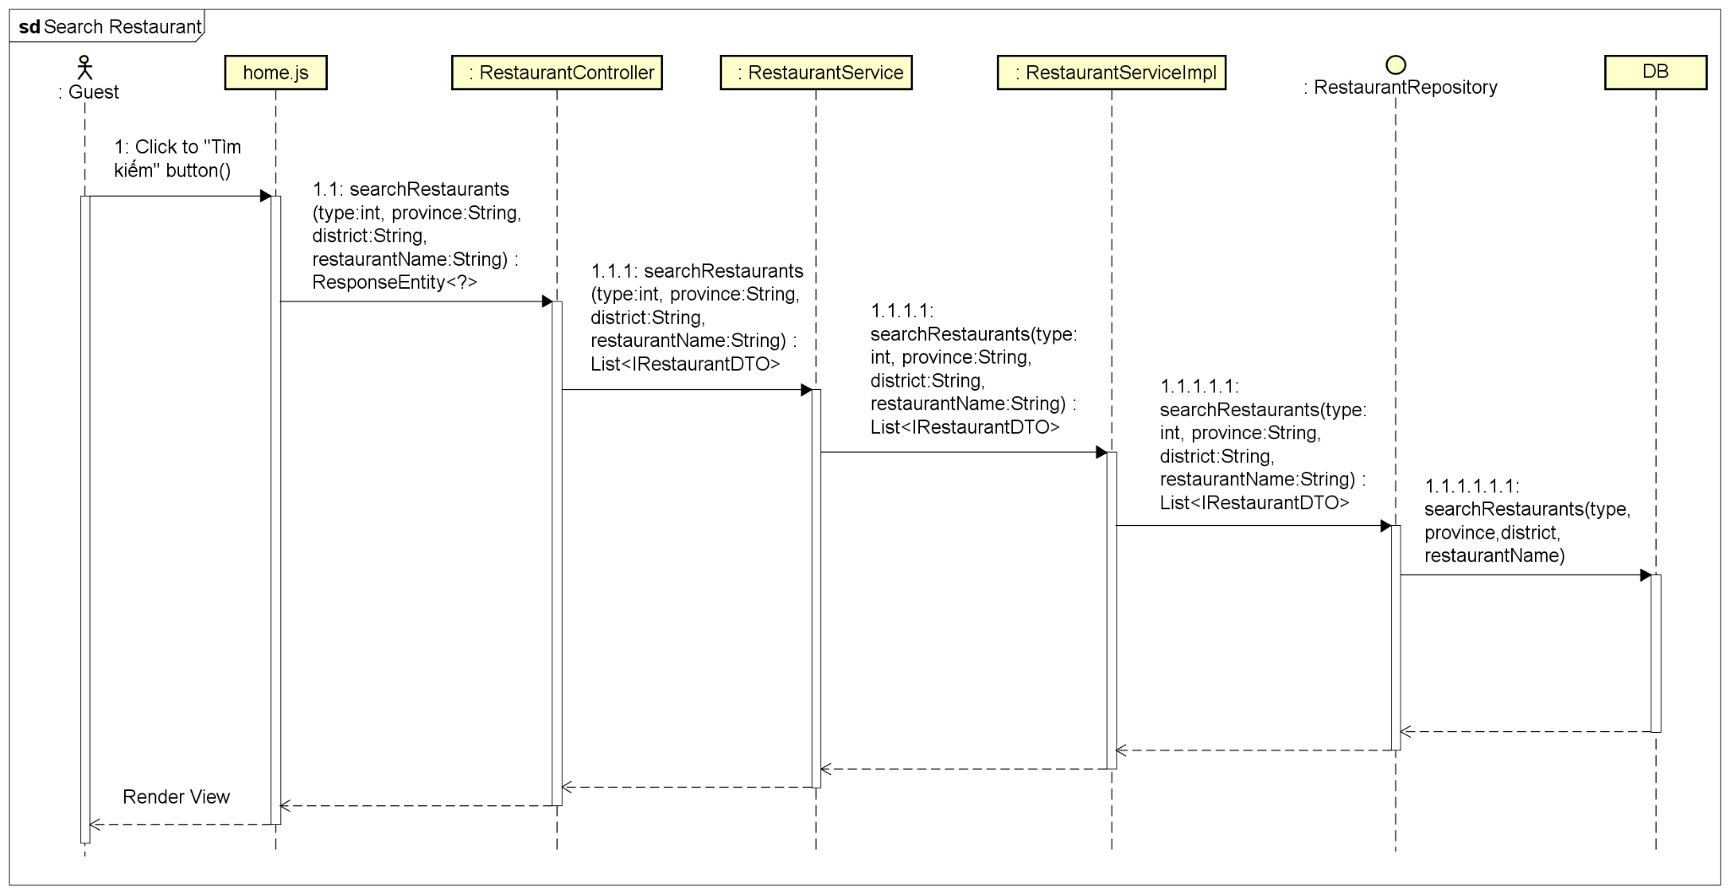

**Figure 4-4:** Search Restaurants -Sequence Diagram

#### 4.1.2 UC-02 View Restaurant Services

##### 4.1.2.1 Screen design

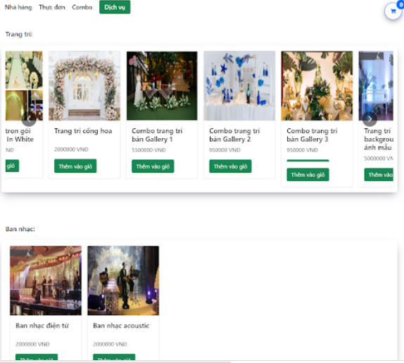

**Figure 4-5** View Restaurant Services

|  |  |  |  |  |  |
| --- | --- | --- | --- | --- | --- |
| **#** | **Object/Control Name** | **Type** | **Required** | **Length** | **Description** |
| **Header** (same as header of Search Restaurant screen) | | | | | |
| **Main** | | | | | |
| 1 | Nhà hàng | <a href="/restaurant-detail">Nhà hàng</a> |  |  | This hyperlink links to Restaurant Detail screen |
| 2 | Thực đơn | <a href="/restaurant-detail/menu">Thực đơn</a> |  |  | This hyperlink links to View Dish screen |
| 3 | Combo | <a href="/restaurant-detail/combo">Combo</a> |  |  | This hyperlink links to View Combo screen |
| 4 | Dịch vụ | <a href="/restaurant-detail/service">Dịch vụ</a> |  |  | This hyperlink links to View Service screen |
| 5 | Cart Icon | <div></div> |  |  | This button links to View Cart screen |
| 6 | Category Title | <Container> </Container> |  |  | Title of Service category  Value: Trang trí, Ban nhạc, Vũ đoàn, Ca sĩ, MC (Dẫn chương trình), Quay phim - Chụp ảnh |
| 7 | Services Slideshow |  |  |  | Slideshow of services |
| 8 | Service Card | <div></div> |  |  | Card display information of service |
| 9 | Service Image | <img /> |  |  | Avatar of service |
| 10 | Service Name | <h5></h5> |  |  | Name of service |
| 11 | Service Price | <p></p> |  |  | Sale price of service |
| 12 | Thêm vào giỏ hàng | <button type="button">Thêm vào giỏ</button> |  |  | The button to add service to the cart |
| 13 | Information Icon | <FaInfoCircle /> |  |  | The button to view detailed information of service |
| **Footer** (same as footer of Search Restaurant screen) | | | | | |

**Table 4-11:** View Restaurant Services screen description

##### 4.1.2.2 Class diagram

###### **4.1.2.2.1 Back end**

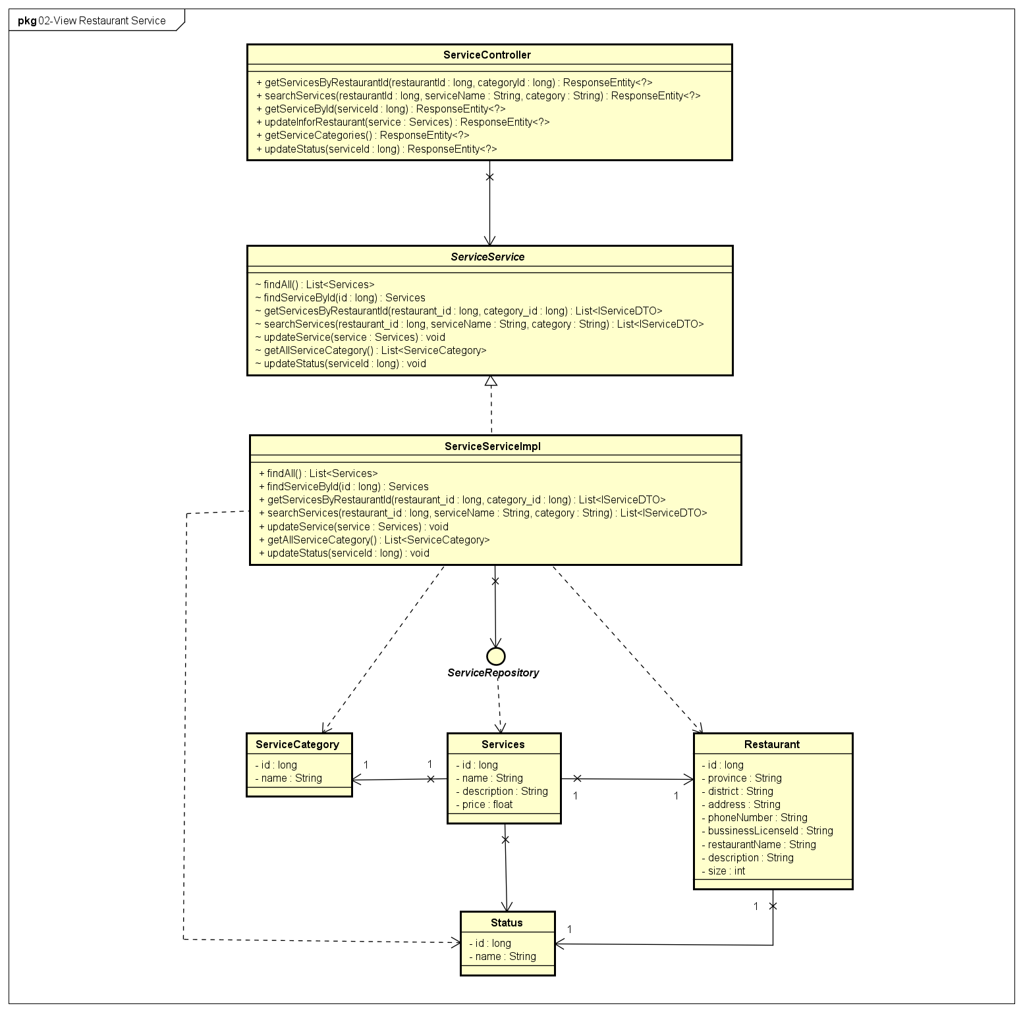

**Figure 4-6** View Restaurant Services - Backend Class Diagram

###### **4.1.2.2.2 Front end**

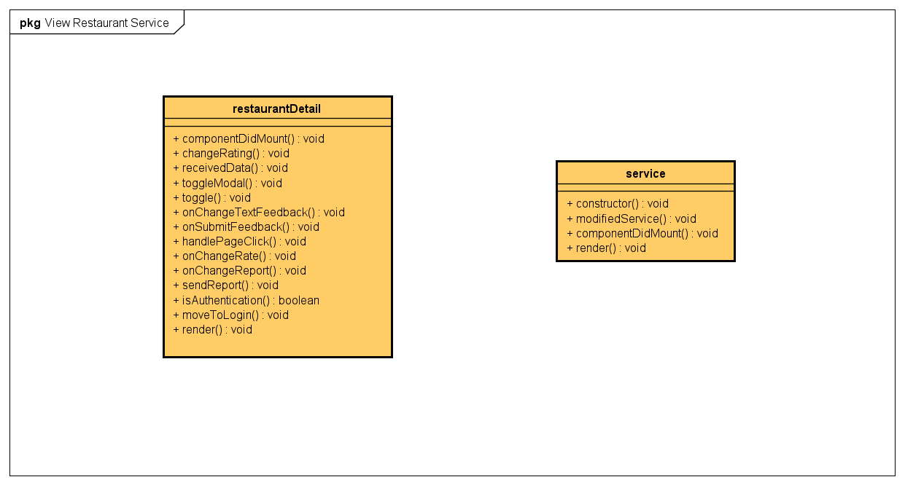

**Figure 4-7** View Restaurant Services - Front-end Class Diagram

##### 4.1.2.3 Class Description

###### **4.1.2.3.1 restaurantDetail**

|  |  |  |  |  |
| --- | --- | --- | --- | --- |
| **Class** | **restaurantDetail** | | | |
| **Description** | Define attributes and methods for these attributes in restaurantDetail front-end class | | | |
| **Base Class** |  | | | |
| **Constructor** | state  changeRating  handlePageClick  onChangeTextFeedback  onSubmitFeedback  toggleModal  toggle  onChangeReport  sendReport | | | |
| **Prototype** |  | | | |
| **Source File** | ofbs-master\front-end\src\screens\restaurant\restaurantDetail.js | | | |
| **Namespace** |  | | | |
| **Attributes** | **Name** | **Type** | **Description** | |
|  |  |  | |
| **Methods** | **Name** | **Input** | **Output** | **Description** |
| componentDidMount |  |  | use API to get restaurant data from back end |
| changeRating |  |  | change rate of restaurant |
| receivedData |  |  | store received data |
| toggleModal |  |  | check display modal status |
| toggle |  |  | check modal status |
| onChangeTextFeedback | e |  | set new feedback value |
| onSubmitFeedback | e |  | submit new feedback |
| handlePageClick | e |  | handle when a page is clicked |
| onChangeRate | rate |  | set new rate value |
| onChangeReport |  |  | set new report value |
| sendReport |  |  | submit new report |
| isAuthentication |  |  | check authentication status |
| moveToLogin | e |  | move to login screen |
| render |  |  | send data to HTML |

**Table 4-12:** restaurantDetail class description

###### **4.1.2.3.2 service**

|  |  |  |  |  |
| --- | --- | --- | --- | --- |
| **Class** | **service** | | | |
| **Description** | Define attributes and methods for these attributes in service front-end class | | | |
| **Base Class** |  | | | |
| **Constructor** | state | | | |
| **Prototype** |  | | | |
| **Source File** | ofbs-master\front-end\src\screens\restaurant\service.js | | | |
| **Namespace** |  | | | |
| **Attributes** | **Name** | **Type** | **Description** | |
|  |  |  | |
| **Methods** | **Name** | **Input** | **Output** | **Description** |
| modifiedService | services |  | modified service data |
| componentDidMount |  |  | use API to get restaurant data from back end |
| render |  |  | send data to HTML |

**Table 4-13:** service class description

###### **4.1.2.3.3 ServiceController**

|  |  |  |  |  |
| --- | --- | --- | --- | --- |
| **Class** | **ServiceController** | | | |
| **Description** | Responsible for controlling the way that a user interacts with service | | | |
| **Base Class** |  | | | |
| **Constructor** |  | | | |
| **Prototype** |  | | | |
| **Source File** | ofbs-master\back-end\src\main\java\edu\fpt\ofbs\controllers\ServiceController.java | | | |
| **Namespace** |  | | | |
| **Attributes** | **Name** | **Type** | **Description** | |
|  |  |  | |
| **Methods** | **Name** | **Input** | **Output** | **Description** |
| getServicesByRestaurantId | restaurantId  categoryId | ResponseEntity | get list service by restaurant id |
| searchServices | restaurantId  serviceName  category | ResponseEntity | search service by some data |
| getServiceById | serviceId | ResponseEntity | get a service by id |
| updateInforRestaurant | service | ResponseEntity | update service data |
| getServiceCategories |  | ResponseEntity | get categories of service |
| updateStatus | serviceId | ResponseEntity | update status of service |

**Table 4-14**: ServiceController class description

###### **4.1.2.3.4 ServiceServiceImpl**

|  |  |  |  |  |
| --- | --- | --- | --- | --- |
| **Class** | **ServiceServiceImpl** | | | |
| **Description** | provide functionality to handle user requests with service | | | |
| **Base Class** |  | | | |
| **Constructor** |  | | | |
| **Prototype** |  | | | |
| **Source File** | ofbs-master\back-end\src\main\java\edu\fpt\ofbs\service\impl\ServiceServiceImpl.java | | | |
| **Namespace** |  | | | |
| **Attributes** | **Name** | **Type** | **Description** | |
|  |  |  | |
| **Methods** | **Name** | **Input** | **Output** | **Description** |
| findAll |  | List<Services> | get list service |
| findServiceById | id | Services | get service by id |
| getServicesByRestaurantId | restaurant_id  category_id | List<IServiceDTO> | get list service of a restaurant |
| searchServices | restaurant_id  serviceName  category | List<IServiceDTO> | get list service by search value |
| updateService | service |  | update service information |
| getAllServiceCategory |  | List<ServiceCategory> | get a list of all services by category |
| updateStatus | serviceId |  | update service status |

**Table 4-15**: ServiceServiceImpl class description

###### **4.1.2.3.5 ServiceRepository**

|  |  |  |  |  |
| --- | --- | --- | --- | --- |
| **Class** | **ServiceRepository** | | | |
| **Description** | manipulate the service table in the database. | | | |
| **Base Class** | JpaRepository<Services, Long> | | | |
| **Constructor** |  | | | |
| **Prototype** |  | | | |
| **Source File** | ofbs-master\back-end\src\main\java\edu\fpt\ofbs\repositories\ServiceRepository.java | | | |
| **Namespace** |  | | | |
| **Attributes** | **Name** | **Type** | **Description** | |
|  |  |  | |
| **Methods** | **Name** | **Input** | **Output** | **Description** |
| getServicesByRestaurantId | restaurant_id  category_id | List<IServiceDTO> | get list service of a restaurant |
| searchServices | restaurant_id  serviceName  category | List<IServiceDTO> | get list service |
| updateStatus | statusId  serviceId |  | update service status |

**Table 4-16**: ServiceRepository class description

###### **4.1.2.3.6 ServiceCategory**

|  |  |  |  |  |
| --- | --- | --- | --- | --- |
| **Class** | **ServiceCategory** | | | |
| **Description** | Define attributes for ServicerCategory entity and set/get method for these attributes | | | |
| **Base Class** |  | | | |
| **Constructor** |  | | | |
| **Prototype** |  | | | |
| **Source File** | ofbs-master\back-end\src\main\java\edu\fpt\ofbs\entities\ServiceCategory.java | | | |
| **Namespace** |  | | | |
| **Attributes** | **Name** | **Type** | **Description** | |
| id | long | category id of a service | |
| name | String | category name of a service | |
| **Methods** | **Name** | **Input** | **Output** | **Description** |
|  |  |  |  |

**Table 4-17**: ServiceCategory class description

###### **4.1.2.3.7 Services**

|  |  |  |  |  |
| --- | --- | --- | --- | --- |
| **Class** | **Services** | | | |
| **Description** | Define attributes for Service entity and set/get method for these attributes | | | |
| **Base Class** |  | | | |
| **Constructor** |  | | | |
| **Prototype** |  | | | |
| **Source File** | ofbs-master\back-end\src\main\java\edu\fpt\ofbs\entities\Services.java | | | |
| **Namespace** |  | | | |
| **Attributes** | **Name** | **Type** | **Description** | |
| id | long | category id of a service | |
| name | String | category name of a service | |
| description | String | description of a service | |
| price | float | price of a service | |
| **Methods** | **Name** | **Input** | **Output** | **Description** |
|  |  |  |  |

**Table 4-18**: Services class description

##### 4.1.2.4 Sequence Diagram

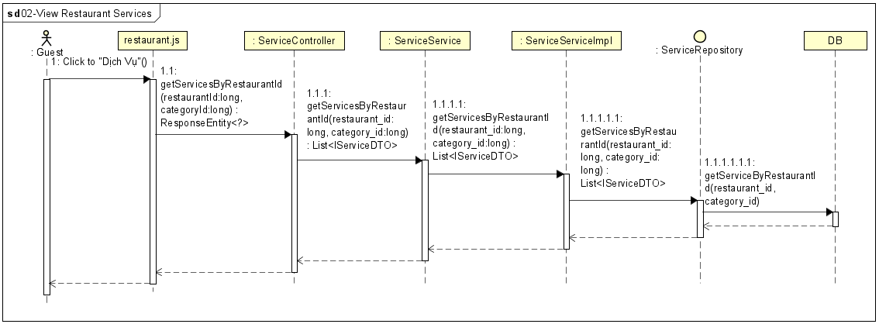

**Figure 4-7** View Restaurant Services - Front-end Class Diagram

#### 4.1.3 UC-03 View Restaurant Infor

##### 4.1.3.1 Screen design

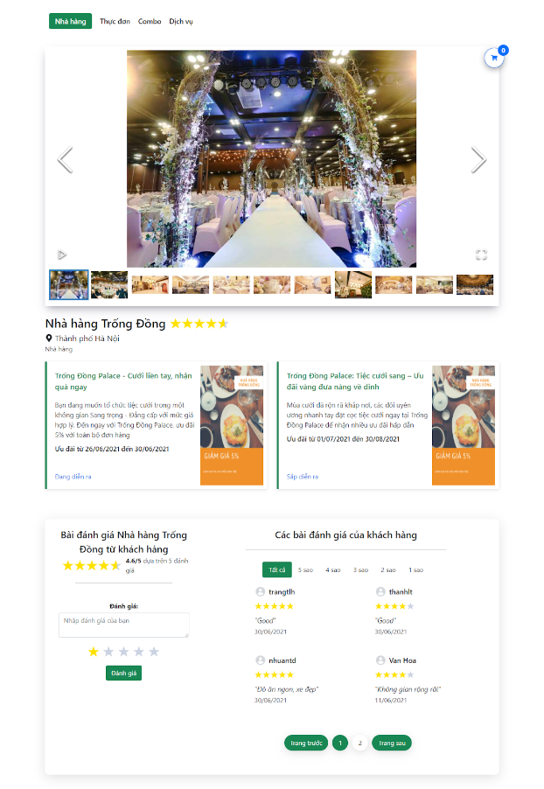

**Figure 4-8:** View Restaurant Information

|  |  |  |  |  |  |
| --- | --- | --- | --- | --- | --- |
| **#** | **Object/Control Name** | **Type** | **Required** | **Length** | **Description** |
| **Header** (same as header of Search Restaurant screen) | | | | | |
| **Main** | | | | | |
| 1 | Nhà hàng | <a href="/restaurant-detail">Nhà hàng</a> |  |  | This hyperlink links to Restaurant Detail screen |
| 2 | Thực đơn | <a href="/restaurant-detail/menu">Thực đơn</a> |  |  | This hyperlink links to View Dish screen |
| 3 | Combo | <a href="/restaurant-detail/combo">Combo</a> |  |  | This hyperlink links to View Combo screen |
| 4 | Dịch vụ | <a href="/restaurant-detail/service">Dịch vụ</a> |  |  | This hyperlink links to View Service screen |
| 5 | Cart Icon | <div></div> |  |  | This button links to View Cart screen |
| 6 | Restaurant Image Slideshow | <Container > <ImageGallery/> </Container> |  |  | Slideshow of restaurant’s description image |
| 7 | Report Flag | <div><Flag /> Báo cáo</div> |  |  | This hyperlink links to the report form |
| 8 | Restaurant Name | <div></div> |  |  | Name of restaurant |
| 9 | Restaurant Province | <div> <FaMapMarkerAlt /> </div> |  |  | Province of restaurant |
| 10 | Restaurant Description | <div></div> |  |  | Detail description of the restaurant |
| 11 | Promotion Card | <Row > </Row> |  |  | Card of restaurant’s promotion  Value: Promotion name, Promotion image, Promotion description, Promotion start, and end date, Promotion status |
| 12 | Enter Feedback Text | <Input type="textarea" value={textFeedback} /> | Yes | 250 | Textarea to enter feedback/report |
| 13 | Star Rate | <StarRating /> | Yes |  | This rating to user insert rate, if it is report, rate is 0 |
| 14 | Đánh giá | <Button >Đánh giá</Button> |  |  | Add feedback or report |
| 15 | Rate Link | <div> <StarRatings /> </div> |  |  | Filter feedback by rate |
| 16 | Feedback Card | <Row> </Row> |  |  | Detailed information of each feedback  Value: User avatar, Username, star rate, Feedback content, Feedback date |
| **Footer** (same as footer of Search Restaurant screen) | | | | | |

**Table 4-19**:View Restaurant Infor screen Definition

##### 4.1.3.2 Class diagram

###### **4.1.3.2.1 Back end**

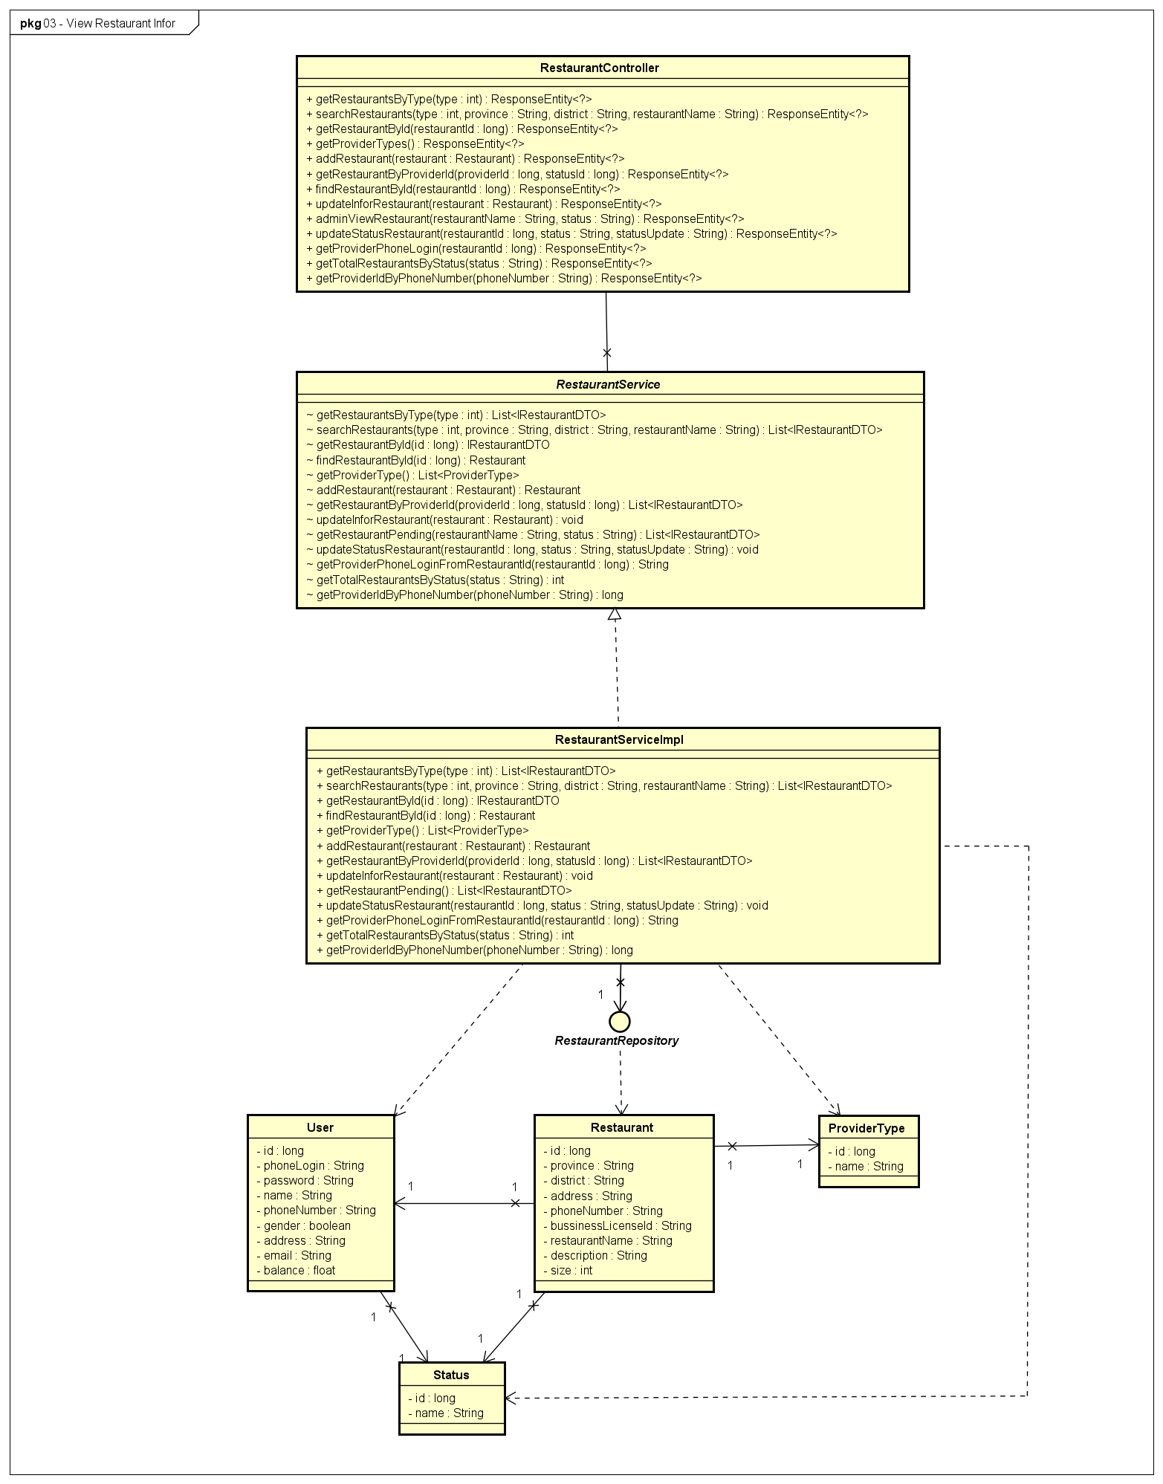

**Figure 4-9:** View Restaurant Information - Back-end Class Diagram

###### **4.1.3.2.2 Front end**

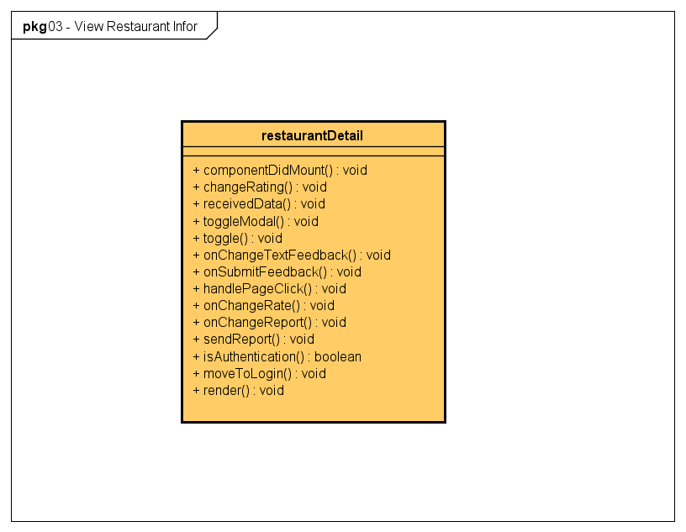

**Figure 4-10:** View Restaurant Information - Front-end Class Diagram

##### 4.1.3.3 Class Description

Reference to 4.1.1.3 & 4.4.6.3.2

##### 4.1.3.4 Sequence Diagram

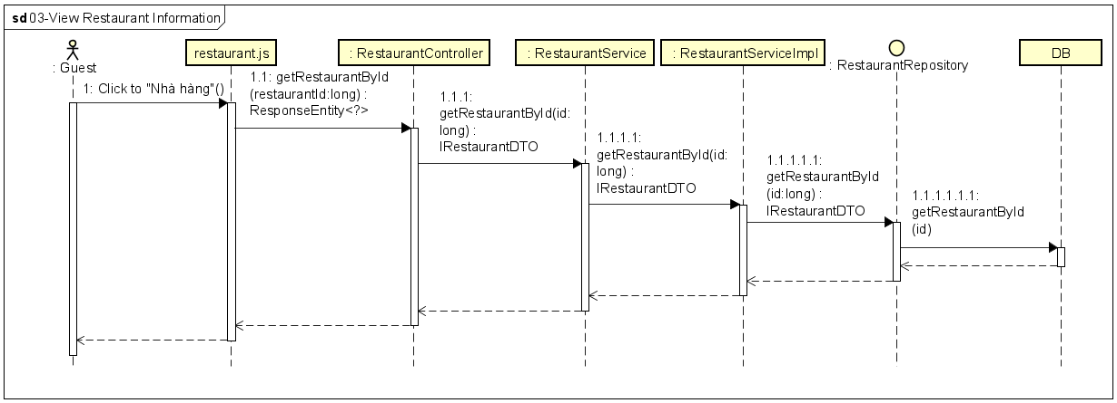

**Figure 4-11:** View Restaurant Information- Sequence Diagram

#### 4.1.4 UC-04 View Restaurant Combo

##### 4.1.4.1 Screen design

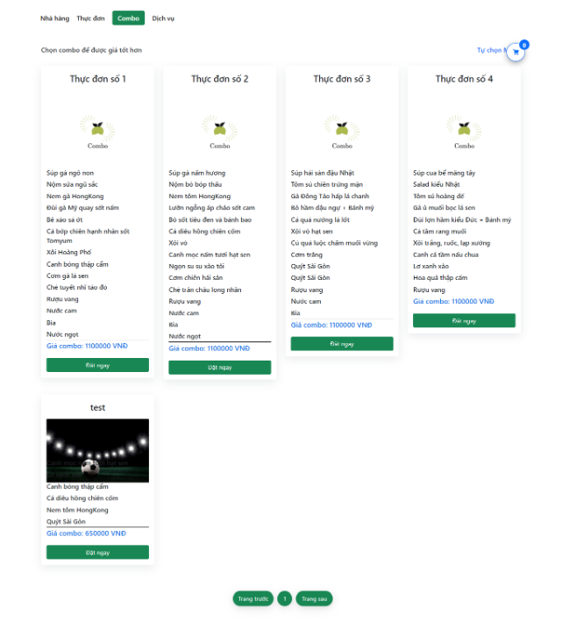

**Figure 4-12:** View Restaurant Combo

|  |  |  |  |  |  |
| --- | --- | --- | --- | --- | --- |
| **#** | **Object/ControlName** | **Type** | **Required** | **Length** | **Description** |
| **Header** (same as header of Search Restaurant screen) | | | | | |
| **Main** | | | | | |
| 1 | Cửa hàng | same ass View Restaurant Info screen |  |  | This hyperlink links to Restaurant Detail screen |
| 2 | Thực đơn | same ass View Restaurant Info screen |  |  | This hyperlink links to View Dish screen |
| 3 | Combo | same ass View Restaurant Info screen |  |  | This hyperlink links to View Combo screen |
| 4 | Dịch vụ | same ass View Restaurant Info screen |  |  | This hyperlink links to View Service screen |
| 5 | Cart Icon | same as View Restaurant Info screen |  |  | This button links to View Cart screen |
| 8 | Combo Card | <Container className="restaurant-detail-combo"> |  |  | Card display information of combo |
| 9 | Combo Name | <div></div> |  |  | Name of combo |
| 10 | Combo’s Dishes | <div></div> |  |  | List dishes of combo |
| 11 | Combo Price | <div >Giá combo:</div> |  |  | Sale price of the combo |
| 12 | Đặt ngay | <Button > Đặt ngay </Button> |  |  | The button to add the combo to the cart |
| 13 | Information Icon | Same ass View Restaurant Services screen |  |  | The button to view information of combo |
| **Footer** (same as footer of Search Restaurant screen) | | | | | |

**Table 4-20:** View Restaurant Combo screen Definition

##### 4.1.4.2 Class diagram

###### **4.1.4.2.1 Back end**

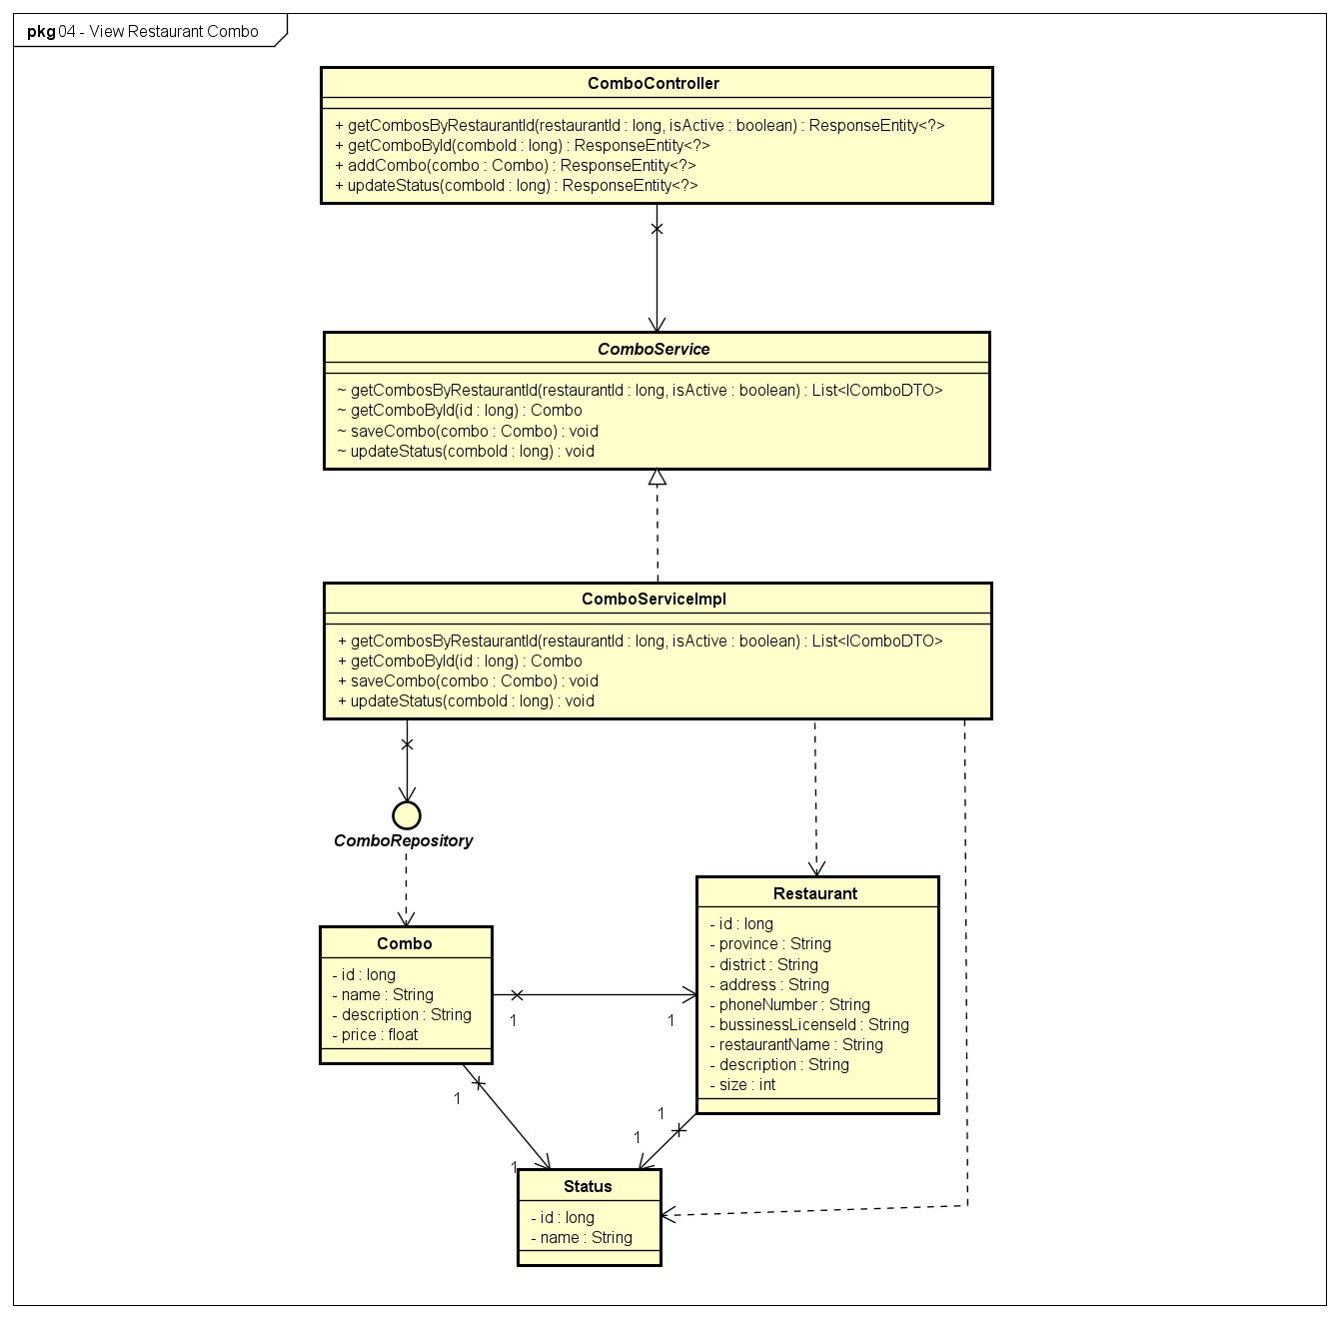

**Figure 4-12:** View Restaurant Combo - Back-end Class Diagram

###### **4.1.4.2.2 Front end**

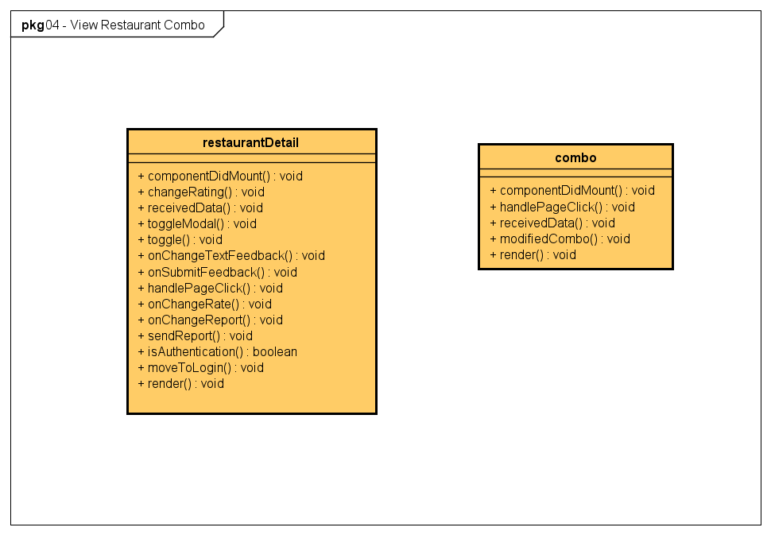

**Figure 4-13:** View Restaurant Combo - Front-end Class Diagram

##### 4.1.4.3 Class Description

###### **4.1.4.3.1 combo**

|  |  |  |  |  |
| --- | --- | --- | --- | --- |
| **Class** | **combo** | | | |
| **Description** | Define attributes and methods for these attributes in combo front-end class | | | |
| **Base Class** | Component | | | |
| **Constructor** | state | | | |
| **Prototype** |  | | | |
| **Source File** | ofbs-master\front-end\src\screens\restaurant\combo.js | | | |
| **Namespace** |  | | | |
| **Attributes** | **Name** | **Type** | **Description** | |
|  |  |  | |
| **Methods** | **Name** | **Input** | **Output** | **Description** |
| componentDidMount |  |  | use API to get combo data from back end |
| handlePageClick | e |  | handle Page |
| receivedData |  |  | store combo temp data received |
| modifiedCombo | combo |  | modified combo data |
| render |  |  | send data to HTML |

**Table 4-21**: combo class description

###### **4.1.4.3.2 ComboController**

|  |  |  |  |  |
| --- | --- | --- | --- | --- |
| **Class** | **ComboController** | | | |
| **Description** | Responsible for controlling the way that a user interacts with combo | | | |
| **Base Class** |  | | | |
| **Constructor** |  | | | |
| **Prototype** |  | | | |
| **Source File** | ofbs-master\back-end\src\main\java\edu\fpt\ofbs\controllers\ComboController.java | | | |
| **Namespace** |  | | | |
| **Attributes** | **Name** | **Type** | **Description** | |
|  |  |  | |
| **Methods** | **Name** | **Input** | **Output** | **Description** |
| getCombosByRestaurantId | restaurantId  isActive | ResponseEntity | get list combos of a restaurant |
| getComboById | comboId | ResponseEntity | get a combo by id |
| updateInforDish | combo | ResponseEntity | update data of a dish in a combo |
| updateStatus | comboId | ResponseEntity | update combo status |

**Table 4-22**: ComboController class description

###### **4.1.4.3.3 ComboServiceImpl**

|  |  |  |  |  |
| --- | --- | --- | --- | --- |
| **Class** | **ComboServiceImpl** | | | |
| **Description** | provide functionality to handle user requests with combo | | | |
| **Base Class** | ComboService | | | |
| **Constructor** |  | | | |
| **Prototype** |  | | | |
| **Source File** | ofbs-master\back-end\src\main\java\edu\fpt\ofbs\service\impl\ComboServiceImpl.java | | | |
| **Namespace** |  | | | |
| **Attributes** | **Name** | **Type** | **Description** | |
|  |  |  | |
| **Methods** | **Name** | **Input** | **Output** | **Description** |
| getCombosByRestaurantId | restaurantId  isActive | List<IComboDTO> | get list combo of a restaurant |
| getComboById | id | Combo | get a combo by id |
| saveCombo | combo |  | save a new combo |
| updateStatus | comboId |  | update combo status |

**Table 4-23**: ComboServiceImpl class description

###### **4.1.4.3.4 ComboRepository**

|  |  |  |  |  |
| --- | --- | --- | --- | --- |
| **Class** | **ComboRepository** | | | |
| **Description** | manipulate the combo table in the database. | | | |
| **Base Class** | JpaRepository<Combo, Long> | | | |
| **Constructor** |  | | | |
| **Prototype** |  | | | |
| **Source File** | ofbs-master\back-end\src\main\java\edu\fpt\ofbs\repositories\ComboRepository.java | | | |
| **Namespace** |  | | | |
| **Attributes** | **Name** | **Type** | **Description** | |
|  |  |  | |
| **Methods** | **Name** | **Input** | **Output** | **Description** |
| getCombosByRestaurantId | restaurantId  isActive | List<IComboDTO> | get list combo of a restaurant |
| updateStatus | statusId  comboId |  | update combo status |

**Table 4-24**: ComboRepository class description

###### **4.1.4.3.5 Combo**

|  |  |  |  |  |
| --- | --- | --- | --- | --- |
| **Class** | **Combo** | | | |
| **Description** | Define attributes for Combo entity and set/get method for these attributes | | | |
| **Base Class** |  | | | |
| **Constructor** |  | | | |
| **Prototype** |  | | | |
| **Source File** | ofbs-master\back-end\src\main\java\edu\fpt\ofbs\entities\Combo.java | | | |
| **Namespace** |  | | | |
| **Attributes** | **Name** | **Type** | **Description** | |
| id | long | id of a Combo | |
| name | String | name of a Combo | |
| description | String | description of a Combo | |
| price | float | price of a Combo | |
| **Methods** | **Name** | **Input** | **Output** | **Description** |
|  |  |  |  |

**Table 4-25**: Combo class description

##### 4.1.4.4 Sequence Diagram

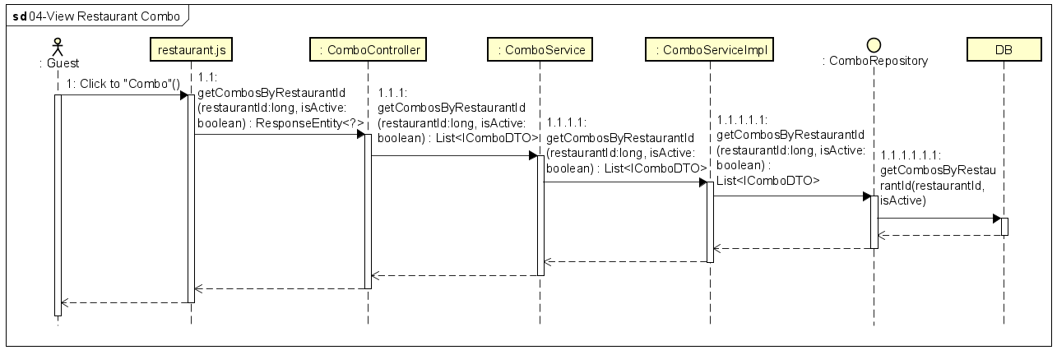

**Figure 4-14:** View Restaurant Combo - Sequence Diagram

#### 4.1.5 UC-05 Search Restaurant Dishes

##### 4.1.5.1 Screen design

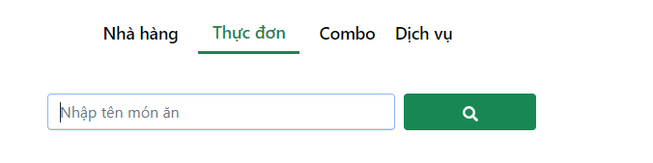

**Figure 4-15:** Search Restaurant Dishes

|  |  |  |  |  |  |
| --- | --- | --- | --- | --- | --- |
| **#** | **Object/Control Name** | **Type** | **Required** | **Length** | **Description** |
| **Main** | | | | | |
| 1 | Nhà hàng | Same as View Restaurant Services screen |  |  | This hyperlink links to Restaurant Detail screen |
| 2 | Thực đơn | Same as View Restaurant Services screen |  |  | This hyperlink links to View Dish screen |
| 3 | Combo | Same as View Restaurant Services screen |  |  | This hyperlink links to View Combo screen |
| 4 | Dịch vụ | Same as View Restaurant Services screen |  |  | This hyperlink links to View Service screen |
| 5 | Nhập tên món ăn | <Input type="text" value={nameSearch} /> | Yes |  | The textbox to enter search keywords |
| 6 | Search icon | <Button> <FaSearch /> </Button> |  |  | The button to trigger Search function |

**Table 4-26:** Search Restaurant Dishes screen Definition

##### 4.1.5.2 Class diagram

###### **4.1.5.2.1 Back end**

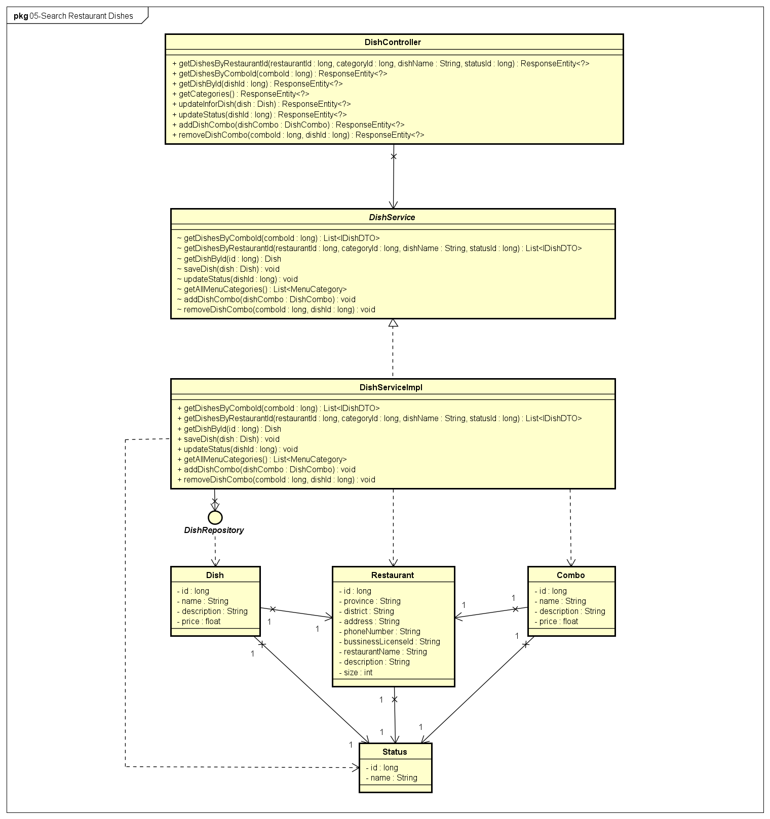

**Figure 4-16:** Search Restaurant Dishes- Back-end Class Diagram

###### **4.1.5.2.2 Front end**

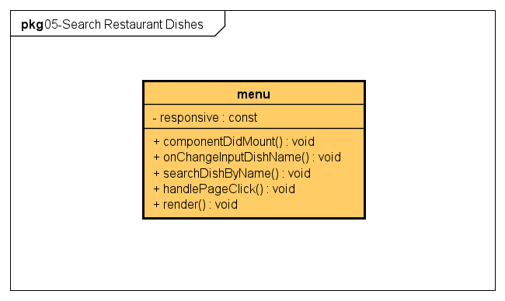

**Figure 4-17:** Search Restaurant Dishes - Front-end Class Diagram

##### 4.1.5.3 Class Description

###### **4.1.5.3.1 menu**

|  |  |  |  |  |
| --- | --- | --- | --- | --- |
| **Class** | **menu** | | | |
| **Description** | Define attributes and methods for these attributes in menu front-end class | | | |
| **Base Class** | menuComponent | | | |
| **Constructor** | state  onChangeInputDishName  searchDishByName  handlePageClick | | | |
| **Prototype** |  | | | |
| **Source File** | ofbs-master\front-end\src\screens\restaurant\menu.js | | | |
| **Namespace** |  | | | |
| **Attributes** | **Name** | **Type** | **Description** | |
| responsive | const | component detailed declaration for each device | |
| **Methods** | **Name** | **Input** | **Output** | **Description** |
| componentDidMount |  |  | call API to get restaurant type and loading status |
| onChangeInputDishName | e |  | store temp value of dish name |
| searchDishByName |  |  | get list Dish |
| handlePageClick |  |  | handle page is selected |
| render |  |  | send data to HTML |

**Table 4-27**: menu class description

###### **4.1.5.3.2 DishController**

|  |  |  |  |  |
| --- | --- | --- | --- | --- |
| **Class** | **DishController** | | | |
| **Description** | Responsible for controlling the way that a user interacts with dish | | | |
| **Base Class** |  | | | |
| **Constructor** |  | | | |
| **Prototype** |  | | | |
| **Source File** | ofbs-master\back-end\src\main\java\edu\fpt\ofbs\controllers\DishController.java | | | |
| **Namespace** |  | | | |
| **Attributes** | **Name** | **Type** | **Description** | |
|  |  |  | |
| **Methods** | **Name** | **Input** | **Output** | **Description** |
| getDishesByRestaurantId | restaurantId  categoryId  dishName  statusId | ResponseEntity | get list dish of a restaurant |
| getDishesByComboId | comboId | ResponseEntity | get list dish in a combo |
| getDishById | dishId | ResponseEntity | get a list by id |
| getCategories |  | ResponseEntity | get all menu categories |
| updateInforDish | dish | ResponseEntity | update information of a dish |
| updateStatus | dishId | ResponseEntity | update status of dish |
| addDishCombo | dishCombo | ResponseEntity | add a dish to a combo |
| removeDishCombo | comboId  dishId | ResponseEntity | remove a dish from a combo |

**Table 4-28**: DishController class description

###### **4.1.5.3.3 DishServiceImpl**

|  |  |  |  |  |
| --- | --- | --- | --- | --- |
| **Class** | **DishServiceImpl** | | | |
| **Description** | provide functionality to handle user requests with dish | | | |
| **Base Class** | DishService | | | |
| **Constructor** |  | | | |
| **Prototype** |  | | | |
| **Source File** | ofbs-master\back-end\src\main\java\edu\fpt\ofbs\service\impl\DishServiceImpl.java | | | |
| **Namespace** |  | | | |
| **Attributes** | **Name** | **Type** | **Description** | |
|  |  |  | |
| **Methods** | **Name** | **Input** | **Output** | **Description** |
| getDishesByComboId | comboId | List<IDishDTO> | get list dish of a combo |
| getDishesByRestaurantId | restaurantId  categoryId  dishName  statusId | List<IDishDTO> | get list dist of a resta |
| getDishById | id | Dish | get a dish by id |
| saveDish | dish |  | save a new Dish |
| updateStatus | dishId |  | update status of dish |
| getAllMenuCategories |  | List<MenuCategory> | get name of all menu categories |
| addDishCombo | dishCombo |  | add a dish to a combo |
| removeDishCombo | comboId |  | remove a dish from a combo |

**Table 4-29**: DishServiceImpl class description

###### **4.1.5.3.4 DishRepository**

|  |  |  |  |  |
| --- | --- | --- | --- | --- |
| **Class** | DishRepository | | | |
| **Description** | manipulate the dish table in the database. | | | |
| **Base Class** | JpaRepository<Dish, Long> | | | |
| **Constructor** |  | | | |
| **Prototype** |  | | | |
| **Source File** | ofbs-master\back-end\src\main\java\edu\fpt\ofbs\repositories\DishRepository.java | | | |
| **Namespace** |  | | | |
| **Attributes** | **Name** | **Type** | **Description** | |
|  |  |  | |
| **Methods** | **Name** | **Input** | **Output** | **Description** |
| getDishesByComboId | comboId | List<IDishDTO> | get list dish of a combo |
| getDishesByRestaurantId | restaurantId  categoryId  dishName  statusId | List<IDishDTO> | get lit dish of a restaurant |
| updateStatus | statusId  dishId |  | update status of a dish |

**Table 4-30**: DishRepository class description

##### 4.1.5.4 Sequence Diagram

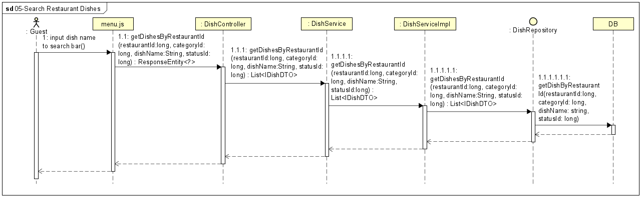

**Figure 4-18:** Search Restaurant Dishes - Sequence Diagram

#### 4.1.6 UC-06 View Restaurant Dishes

##### 4.1.6.1 Screen design

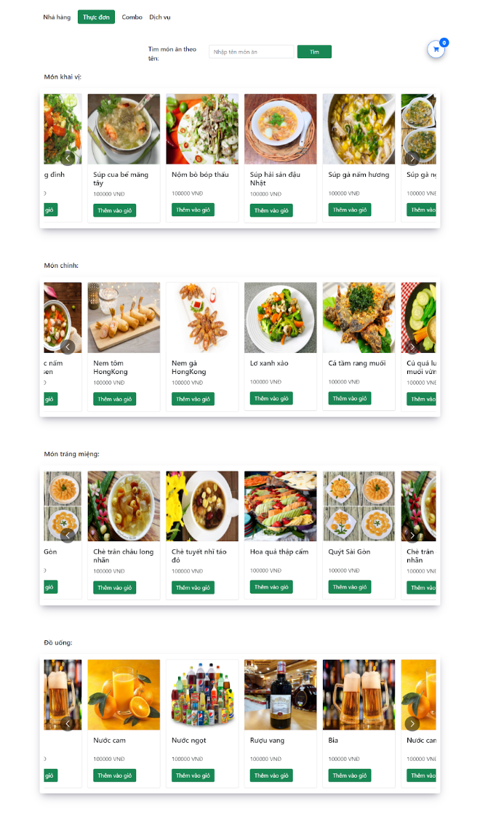

**Figure 4-19** View Restaurant Dishes

|  |  |  |  |  |  |
| --- | --- | --- | --- | --- | --- |
| **#** | **Object/Control Name** | **Type** | **Required** | **Length** | **Description** |
| **Header** (same as header of Search Restaurant screen) | | | | | |
| **Main** | | | | | |
| 1 | Nhà hàng | Same as View Restaurant Services screen |  |  | This hyperlink links to Restaurant Detail screen |
| 2 | Thực đơn | Same as View Restaurant Services screen |  |  | This hyperlink links to View Dish screen |
| 3 | Combo | Same as View Restaurant Services screen |  |  | This hyperlink links to View Combo screen |
| 4 | Dịch vụ | Same as View Restaurant Services screen |  |  | This hyperlink links to View Service screen |
| 5 | Cart Icon | same as View Restaurant Info screen |  |  | This button links to View Cart screen |
| 6 | Nhập tên món ăn | same as Search Restaurant Dish screen | No |  | The textbox to enter search keywords |
| 7 | Search icon | same as Search Restaurant Dish screen |  |  | The button to trigger Search function |
| 8 | Category Title | <Container></Container> |  |  | Title of Dish category  Value: Khai vị, Món chính, Tráng miệng, Đồ uống |
| 9 | Dishes Slideshow | <Container> |  |  | Slideshow of dishes |
| 10 | Dish Image | <CardImg /> |  |  | Image of dish |
| 11 | Dish Name | <div></div> |  |  | Name of dish |
| 12 | Dish Price | <div ></div> |  |  | Sale price of dish |
| 13 | Thêm vào giỏ | <Button > Thêm vào giỏ </Button> |  |  | The button to add the dish to the cart |
| 14 | Information Icon | Same as View Restaurant Services screen |  |  | The button to view detailed information of dish |
| **Footer** (same as footer of Search Restaurant screen) | | | | | |

**Table 4-31**: View Restaurant Dishes screen Definition

##### 4.1.6.2 Class diagram

###### **4.1.6.2.1 Back End**

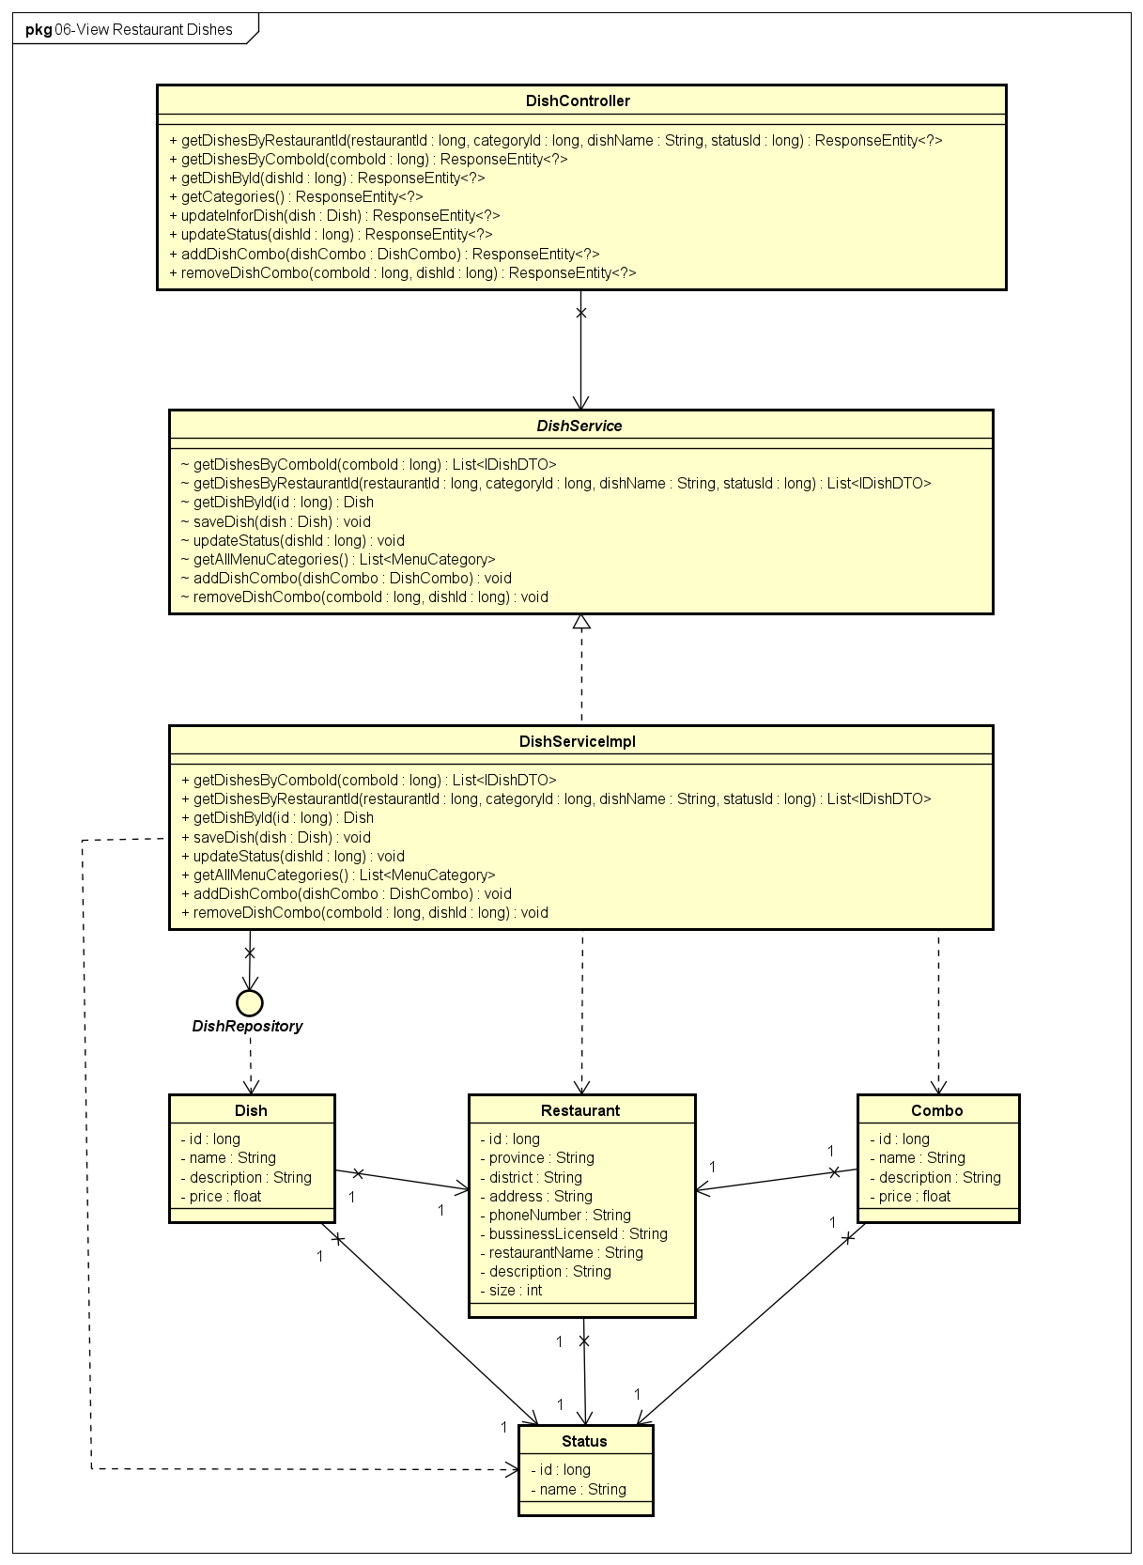

**Figure 4-20** View Restaurant Dishes - Back-end Class Diagram

###### **4.1.6.2.2 Front End**

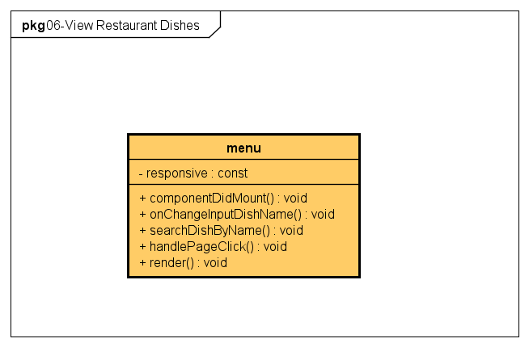

**Figure 4-21:** View Restaurant Dishes - Front-end Class Diagram

##### 4.1.6.3 Class Description

Reference to class description (4.1.5.3)

##### 4.1.6.4 Sequence Diagram

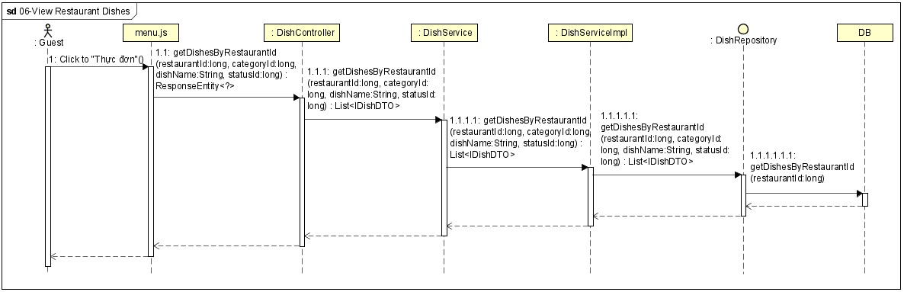

**Figure 4-21:** View Restaurant Dishes - Sequence Diagram

#### 4.1.7 UC-07 View Detail Item

##### 4.1.7.1 Screen design

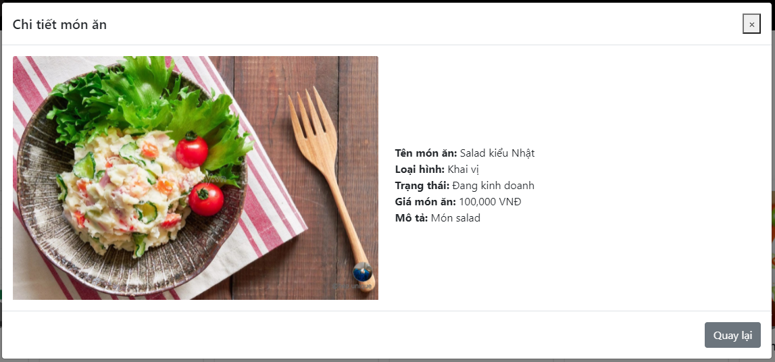

**Figure 4-22:** View Detail Item

|  |  |  |  |  |  |
| --- | --- | --- | --- | --- | --- |
| **#** | **Object/Control Name** | **Type** | **Required** | **Length** | **Description** |
| **Main** | | | | | |
| 1 | Title Chi tiết món ăn | <h5>Chi tiết món ăn</h5> |  |  |  |
| 2 | Item Image | <CardImg alt="món ăn" /> |  |  | Avatar of item |
| 3 | Tên món ăn | <b>Tên món ăn:</b> |  |  | Name of dish |
| 4 | Loại hình | <b>Loại hình:</b> |  |  | Category of dish |
| 5 | Trạng thái | <b>Trạng thái:</b> |  |  | Status of dish |
| 6 | Giá món ăn | <b>Giá món ăn:</b> |  |  | Sale price of dish |
| 7 | Mô tả | <b>Mô tả:</b> |  |  | Description of dish |
| 8 | Quay lại | <Button >Quay lại</Button> |  |  | Button to close Item Detail screen |

**Table 4-32**:View Detail Item Screen Definition

##### 4.1.7.2 Class diagram

###### **4.1.7.2.1 Back End**

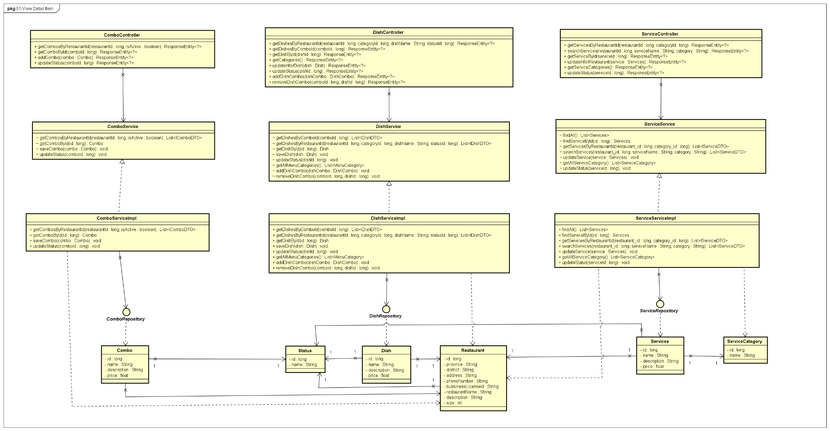

**Figure 4-22:** View Detail Item - Back-end Class Diagram

###### **4.1.7.2.2 Front End**

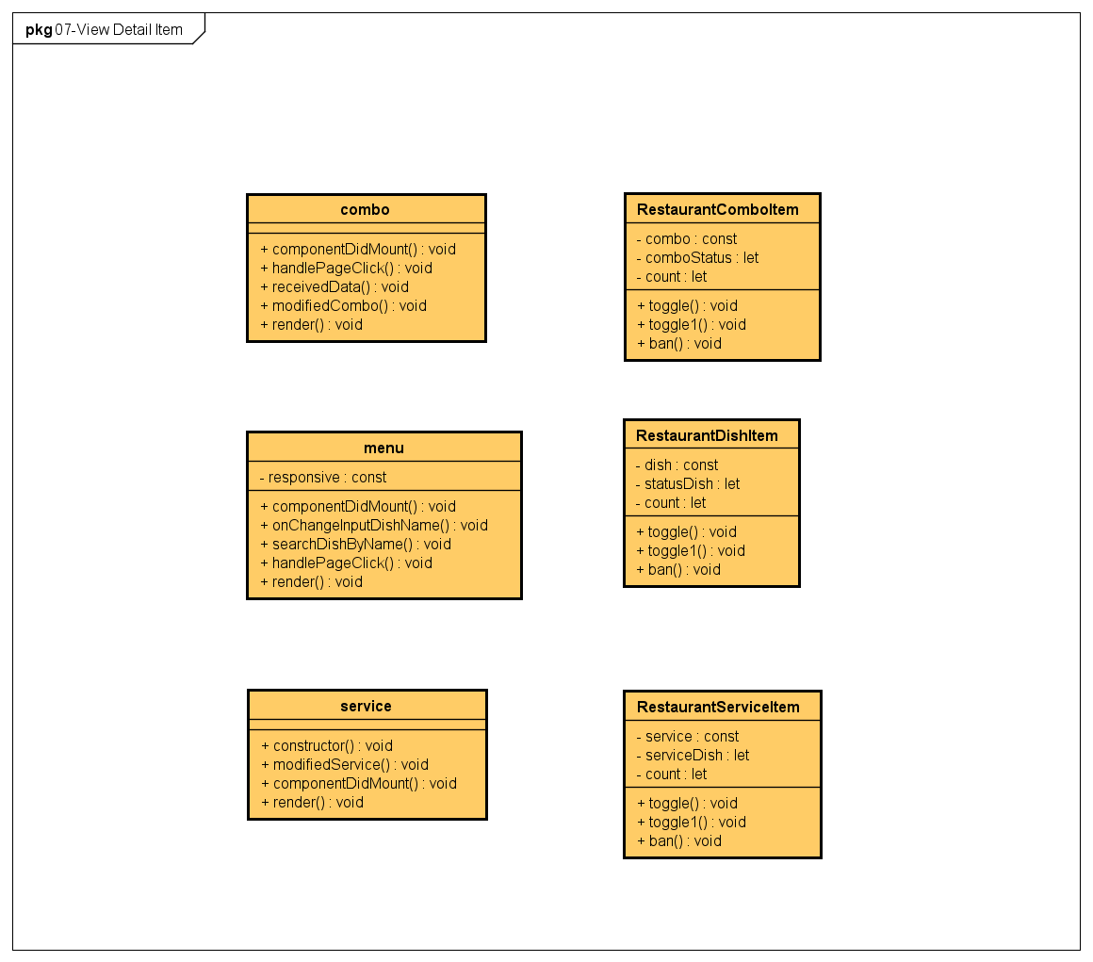

**Figure 4-22:** View Detail Item - Front-end Class Diagram

##### 4.1.7.3 Class Description

###### **4.1.7.3.1 RestaurantComboItem**

|  |  |  |  |  |
| --- | --- | --- | --- | --- |
| **Class** | **RestaurantComboItem** | | | |
| **Description** | Define attributes and methods for these attributes in RestaurantComboItem front-end class | | | |
| **Base Class** |  | | | |
| **Constructor** |  | | | |
| **Prototype** |  | | | |
| **Source File** | ofbs-master\front-end\src\components\admin\RestaurantComboItem.js | | | |
| **Namespace** |  | | | |
| **Attributes** | **Name** | **Type** | **Description** | |
| combo | const | combo | |
| comboStatus | let | status of combo | |
| count | let | count number of combos | |
| **Methods** | **Name** | **Input** | **Output** | **Description** |
| toggle |  |  | check modal status to set data of combo |
| toggle1 |  |  | set modal status |
| ban |  |  | ban combo of a restaurant |

**Table 4-33:** RestaurantComboItem class description

###### **4.1.7.3.2 RestaurantDishItem**

|  |  |  |  |  |
| --- | --- | --- | --- | --- |
| **Class** | **RestaurantDishItem** | | | |
| **Description** | Define attributes and methods for these attributes in RestaurantDishItem front-end class | | | |
| **Base Class** |  | | | |
| **Constructor** |  | | | |
| **Prototype** |  | | | |
| **Source File** | ofbs-master\front-end\src\components\admin\RestaurantDishItem.js | | | |
| **Namespace** |  | | | |
| **Attributes** | **Name** | **Type** | **Description** | |
| dish | const | dish | |
| statusDish | let | status of dish | |
| count | let | count number of dish | |
| **Methods** | **Name** | **Input** | **Output** | **Description** |
| toggle |  |  | check modal status to set data of dish |
| toggle1 |  |  | set modal status |
| ban |  |  | ban dish of a restaurant |

**Table 4-34:** RestaurantDishItem class description

###### **4.1.7.3.2 RestaurantServiceItem**

|  |  |  |  |  |
| --- | --- | --- | --- | --- |
| **Class** | **RestaurantServiceItem** | | | |
| **Description** | Define attributes and methods for these attributes in RestaurantServiceItem front-end class | | | |
| **Base Class** |  | | | |
| **Constructor** |  | | | |
| **Prototype** |  | | | |
| **Source File** | ofbs-master\front-end\src\components\admin\RestaurantDishItem.js | | | |
| **Namespace** |  | | | |
| **Attributes** | **Name** | **Type** | **Description** | |
| service | const | service | |
| serviceDish | let | status of service | |
| count | let | count number of service | |
| **Methods** | **Name** | **Input** | **Output** | **Description** |
| toggle |  |  | check modal status to set data of service |
| toggle1 |  |  | set modal status |
| ban |  |  | ban service of a restaurant |

**Table 4-35:** RestaurantServiceItem class description

##### 4.1.7.4 Sequence Diagram

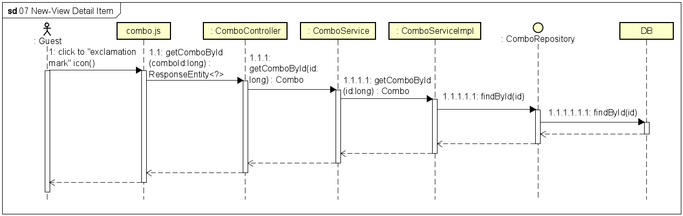

**Figure 4-23:** View Detail Item - Sequence Diagram

#### 4.1.8 UC-08 View All Promotions

##### 4.1.8.1 Screen design

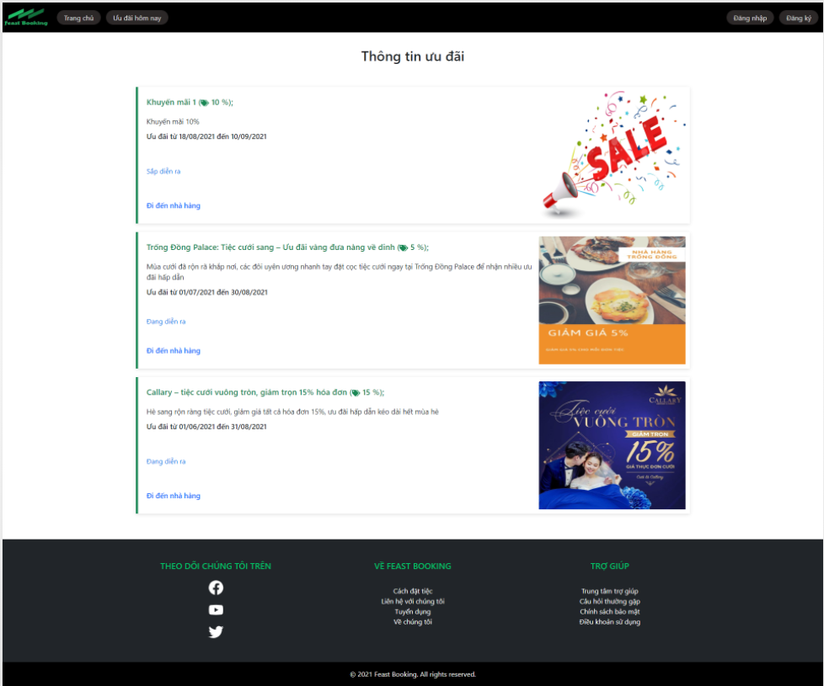

**Figure 4-24:** View All Promotions

|  |  |  |  |  |  |
| --- | --- | --- | --- | --- | --- |
| **#** | **Object/Control Name** | **Type** | **Require** | **Length** | **Description** |
| **Header** (same as header of Search Restaurant screen) | | | | | |
| **Main** | | | | | |
| 1 | Thông tin ưu đãi | <div >Thông tin ưu đãi</div> |  |  |  |
| 2 | Promotion Photo | <CardImg /> |  |  | Avatar of the promotion |
| 3 | Promotion Name | <div ><FaTags/> </div> |  |  | Name of promotion |
| 4 | Promotion Description | <div></div> |  |  | Short description of the promotion |
| 5 | Promotion Time | <div ></div> |  |  | Time of the promotion |
| 6 | Đi đến nhà hàng | <Link> Đi đến nhà hàng </Link> |  |  | This hyperlink links to Restaurant Detail page that has this promotion |
| **Footer** (same as footer of Search Restaurant screen) | | | | | |

**Table 4-36:** View All Promotions screen Definition

##### 4.1.8.2 Class diagram

###### **4.1.8.2.1 Back End**

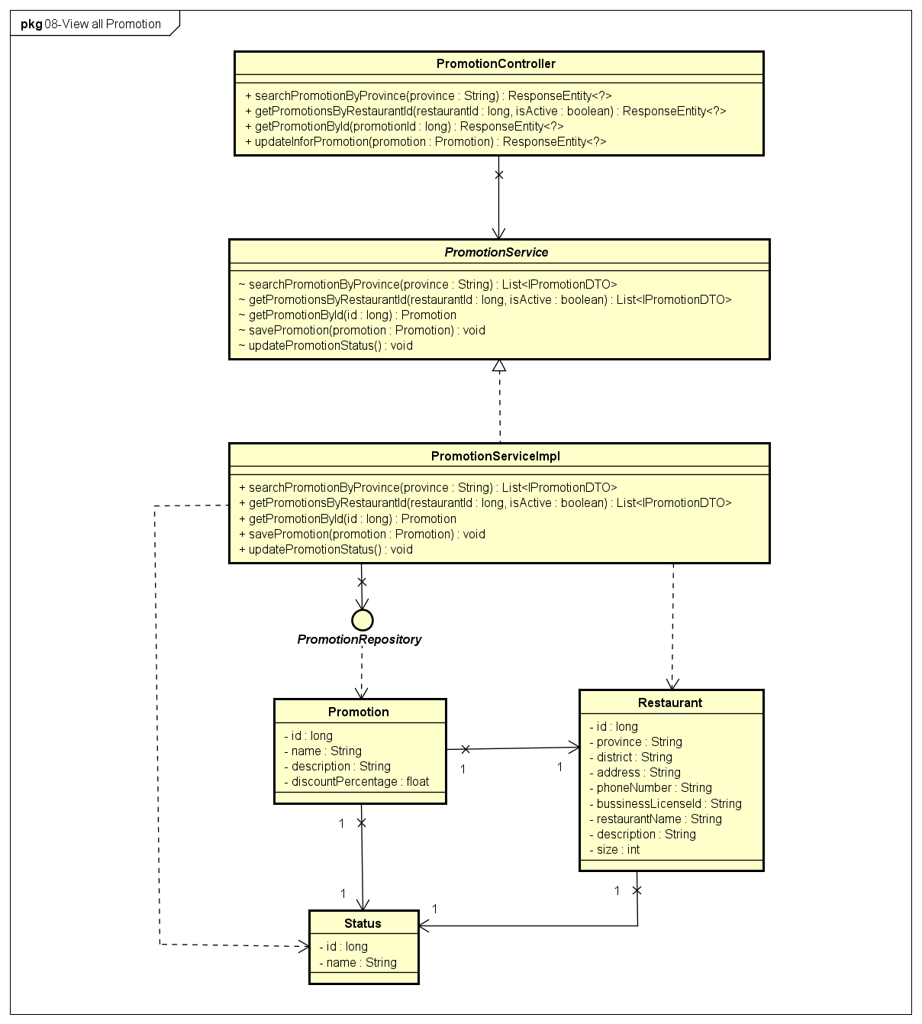

**Figure 4-25:** View All Promotions - Back-end Class Diagram

###### **4.1.8.2.2 Front End**

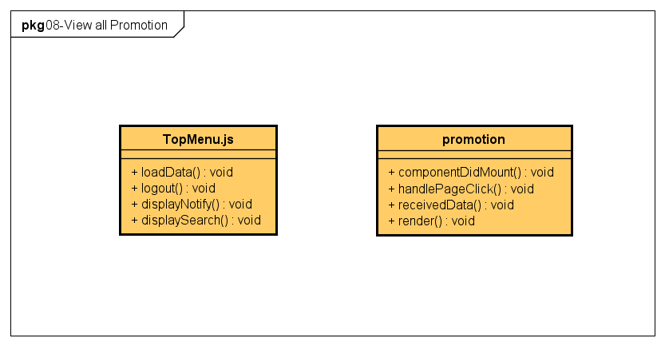

**Figure 4-26:** View All Promotions - Front-end Class Diagram

##### 4.1.8.3 Class Description

###### **4.1.8.3.1 TopMenu**

|  |  |  |  |  |
| --- | --- | --- | --- | --- |
| **Class** | **TopMenu** | | | |
| **Description** | Define attributes and methods for these attributes in TopMenu front-end class | | | |
| **Base Class** |  | | | |
| **Constructor** |  | | | |
| **Prototype** |  | | | |
| **Source File** | ofbs-master\front-end\src\components\common\topMenu.js | | | |
| **Namespace** |  | | | |
| **Attributes** | **Name** | **Type** | **Description** | |
|  |  |  | |
| **Methods** | **Name** | **Input** | **Output** | **Description** |
| loadData |  |  | load data from by API |
| logout | e |  | log out |
| displayNotify |  |  | display notify |
| displaySearch | type |  | display search |

**Table 4-37:** TopMenu class description

###### **4.1.8.3.2 promotion**

|  |  |  |  |  |
| --- | --- | --- | --- | --- |
| **Class** | **promotion** | | | |
| **Description** | Define attributes and methods for these attributes in promotion front-end class | | | |
| **Base Class** | Component | | | |
| **Constructor** | state | | | |
| **Prototype** |  | | | |
| **Source File** | ofbs-master\front-end\src\components\common\topMenu.js | | | |
| **Namespace** |  | | | |
| **Attributes** | **Name** | **Type** | **Description** | |
|  |  |  | |
| **Methods** | **Name** | **Input** | **Output** | **Description** |
| componentDidMount |  |  | use API to get promotion data from back end |
| handlePageClick |  |  | handle Page |
| receivedData |  |  | store promotion temp data received |
| render |  |  | send data to HTML |

**Table 4-38:** promotion class description

##### 4.1.8.4 Sequence Diagram

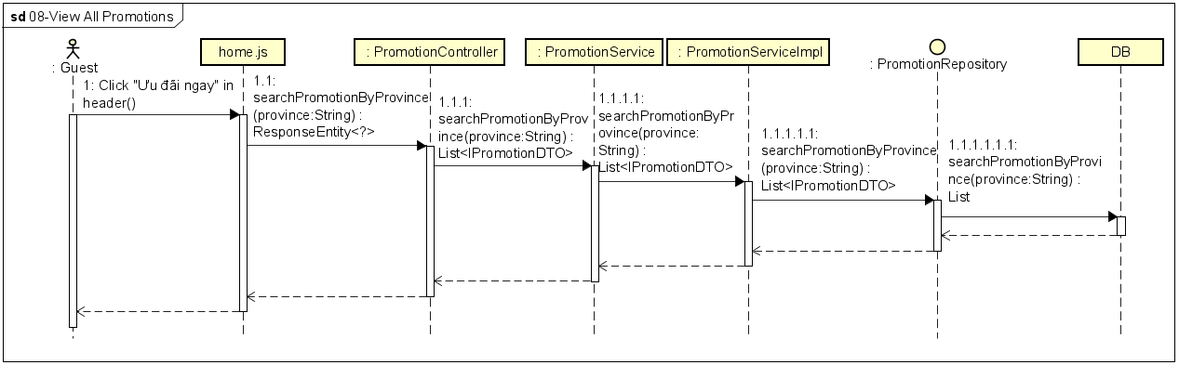

**Figure 4-27:** View All Promotions - Sequence Diagram

#### 4.1.9 UC-09 Register Account

##### 4.1.9.1 Screen design

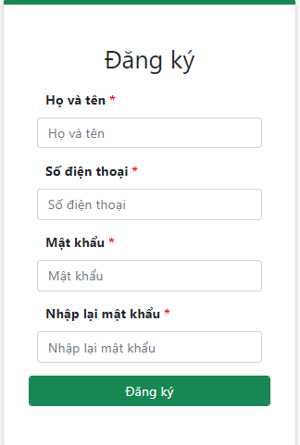

**Figure 4-28:** Register Account

|  |  |  |  |  |  |
| --- | --- | --- | --- | --- | --- |
| **#** | **Object/Control Name** | **Type** | **Required** | **Length** | **Description** |
| **Header** (same as header of Search Restaurant screen) | | | | | |
| **Main** | | | | | |
| 1 | Title Đăng ký | <div >Đăng ký</div> |  |  |  |
| 2 | Họ và tên | <Input type="text" placeholder="Họ và tên " /> | Yes | 100 | Enter username |
| 3 | Số điện thoại | <Input type="text" placeholder="Số điện thoại" required="required" /> | Yes | 10 | Enter phone to sign up |
| 4 | Mật khẩu | <Input type="password" required="required" /> | Yes | 32 | Enter a password, display "*" instead of a clear character |
| 5 | Nhập lại mật khẩu | <Input type="password" placeholder="Nhập lại mật khẩu" required="required" /> | Yes | 32 | Enter re-password, display "*" instead of a clear character |
| 6 | Đăng ký | <Input type="submit" value="Đăng ký" /> |  |  | The button to trigger Sign up function |

**Table 4-39:** Register Account screen Definition

##### 4.1.9.2 Class diagram

###### **4.1.9.2.1 Back End**

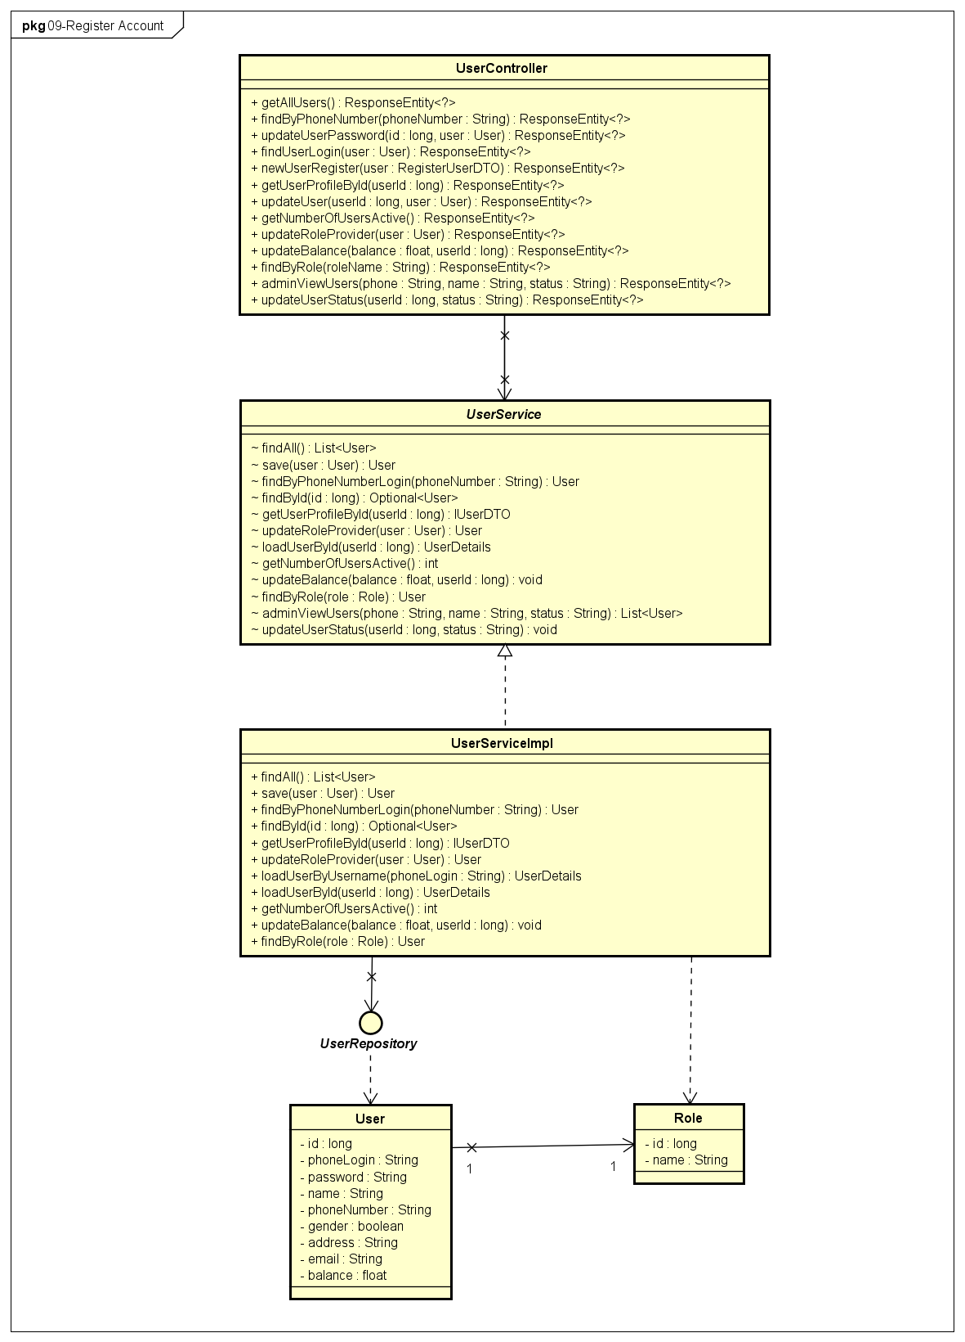

**Figure 4-29:** Register Account - Back-end Class Diagram

###### **4.1.9.2.2 Front End**

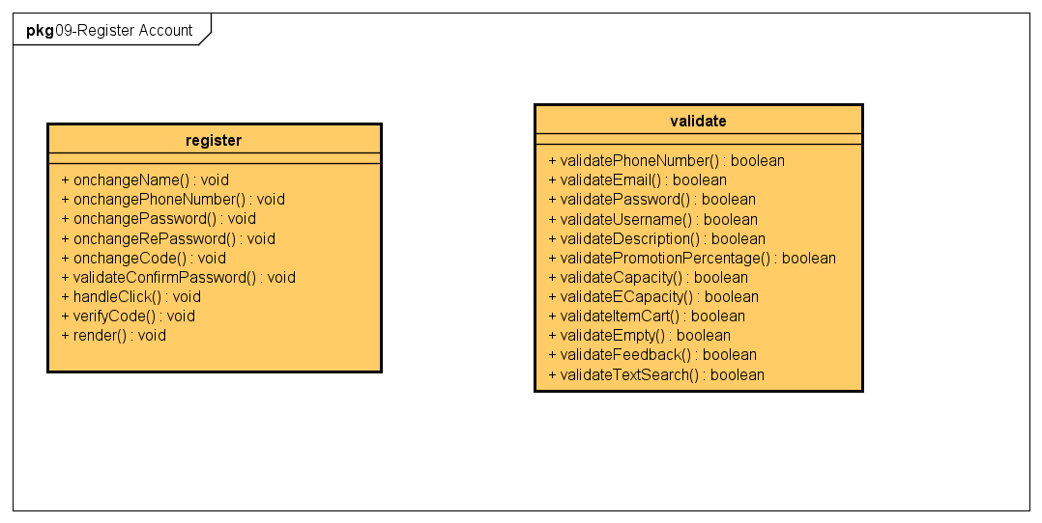

**Figure 4-30:** Register Account - Front-end Class Diagram

##### 4.1.9.3 Class Description

###### **4.1.9.3.1 register**

|  |  |  |  |  |
| --- | --- | --- | --- | --- |
| **Class** | **register** | | | |
| **Description** | Define attributes and methods for these attributes in register front-end class | | | |
| **Base Class** | Component | | | |
| **Constructor** | state  onchangeName  onchangePhoneNumber  onchangePassword  onchangeRePassword  handleClick  onchangeCode  validateConfirmPassword  verifyCode | | | |
| **Prototype** |  | | | |
| **Source File** |  | | | |
| **Namespace** |  | | | |
| **Attributes** | **Name** | **Type** | **Description** | |
|  |  |  | |
| **Methods** | **Name** | **Input** | **Output** | **Description** |
| onchangeName | e |  | set new name value |
| onchangePhoneNumber | e |  | set new phone number value |
| onchangePassword | e |  | set new password value |
| onchangeRePassword | e |  | set new re-password value |
| onchangeCode | e |  | set new code value |
| validateConfirmPassword |  |  | set new Confirm Password value |
| handleClick | e |  | handle captcha code and OTP code |
| verifyCode | phoneCaptcha  recaptcha  e |  | verify captcha code and OTP code |
| render |  |  | render register view |

**Table 4-40:** register class description

###### **4.1.9.3.2 validate**

|  |  |  |  |  |
| --- | --- | --- | --- | --- |
| **Class** | **validate** | | | |
| **Description** | Define attributes and methods for these attributes in validate front-end class | | | |
| **Base Class** |  | | | |
| **Constructor** |  | | | |
| **Prototype** |  | | | |
| **Source File** | ofbs-master\front-end\src\common\validate.js | | | |
| **Namespace** |  | | | |
| **Attributes** | **Name** | **Type** | **Description** | |
|  |  |  | |
| **Methods** | **Name** | **Input** | **Output** | **Description** |
| validatePhoneNumber | number | true/false | check validate phone number |
| validateEmail | email | true/false | check validate email |
| validatePassword | password | true/false | check validate password |
| validateUsername | username | true/false | check validate username |
| validateDescription | description | true/false | check validate description |
| validatePromotionPercentage | percentage | true/false | check validate percentage of promotion |
| validateCapacity | size | true/false | check validate capacity |
| validateECapacity | size | true/false | check validate ECapacity |
| validateItemCart | number | true/false | check validate cart item |
| validateEmpty | text | true/false | check validate empty value |
| validateFeedback | feedback | true/false | check validate feedback data |
| validateTextSearch | text | true/false | check validate text search |

**Table 4-41:** validate class description

###### **4.1.9.3.2 UserController**

|  |  |  |  |  |
| --- | --- | --- | --- | --- |
| **Class** | **UserController** | | | |
| **Description** | Responsible for controlling the way that a user interacts with user | | | |
| **Base Class** |  | | | |
| **Constructor** |  | | | |
| **Prototype** |  | | | |
| **Source File** | ofbs-master\back-end\src\main\java\edu\fpt\ofbs\controllers\UserController.java | | | |
| **Namespace** |  | | | |
| **Attributes** | **Name** | **Type** | **Description** | |
|  |  |  | |
| **Methods** | **Name** | **Input** | **Output** | **Description** |
| getAllUsers |  | ResponseEntity | use to get all users |
| findByPhoneNumber | phoneNumber | ResponseEntity | use to get user by phone number |
| updateUserPassword | id  user | ResponseEntity | use to update user password |
| findUserLogin | user | ResponseEntity | use to find user login |
| newUserRegister | user | ResponseEntity | use to save new user is registered |
| getUserProfileById | userId | ResponseEntity | use to get user profile by id |
| updateUser | userId  user | ResponseEntity | use to update user data |
| getNumberOfUsersActive |  | ResponseEntity | use to get number of users active |
| updateRoleProvider | user | ResponseEntity | use to update role of provider |
| updateBalance | balance  userId | ResponseEntity | use to update balance |
| findByRole | roleName | ResponseEntity | use to find user by role |
| adminViewUsers | phone  name  status | ResponseEntity | use to admin can view users |
| updateUserStatus | userId  status | ResponseEntity | use to change user status |

**Table 4-42:** UserController class description

###### **4.1.9.3.3 UserServiceImpl**

|  |  |  |  |  |
| --- | --- | --- | --- | --- |
| **Class** | **UserServiceImpl** | | | |
| **Description** | provide functionality to handle user requests with user functions | | | |
| **Base Class** | UserDetailsService  UserService | | | |
| **Constructor** |  | | | |
| **Prototype** |  | | | |
| **Source File** | ofbs-master\back-end\src\main\java\edu\fpt\ofbs\service\impl\UserServiceImpl.java | | | |
| **Namespace** |  | | | |
| **Attributes** | **Name** | **Type** | **Description** | |
|  |  |  | |
| **Methods** | **Name** | **Input** | **Output** | **Description** |
| findAll |  | List<User> | use to get all users |
| save | phoneNumber | User | use to save the new user data |
| findByPhoneNumberLogin | id  user | User | use to find user by phone number login |
| findById | user | Optional<User> | use to find a user by id |
| getUserProfileById | user | IUserDTO | use to get user profile by id |
| updateRoleProvider | userId | User | use to update role of provider |
| loadUserByUsername | userId  user | UserDetails | use to load a user by name |
| loadUserById |  | UserDetails | use to load a user by id |
| getNumberOfUsersActive | user | int | use to get number of users is active |
| updateBalance | balance  userId | ResponseEntity | use to update balance of user |
| findByRole | roleName |  | use to find user by role |
| updateUserStatus | userId  status | User | use to change user status |

**Table 4-43:** UserServiceImpl class description

###### **4.1.9.3.4 UserRepository**

|  |  |  |  |  |
| --- | --- | --- | --- | --- |
| **Class** | **UserRepository** | | | |
| **Description** | manipulate the user table in the database. | | | |
| **Base Class** | JpaRepository<User, Long> | | | |
| **Constructor** |  | | | |
| **Prototype** |  | | | |
| **Source File** | ofbs-master\back-end\src\main\java\edu\fpt\ofbs\repositories\UserRepository.java | | | |
| **Namespace** |  | | | |
| **Attributes** | **Name** | **Type** | **Description** | |
|  |  |  | |
| **Methods** | **Name** | **Input** | **Output** | **Description** |
| findByPhoneNumberLogin | phoneNumber | User | user to find user by phone number login |
| getUserProfileById | userId | IUserDTO | user to get a user profile by id |
| getNumberOfUsersActive |  | int | user to get number of users who is active |
| updateBalance | balance  userId |  | user to update balance of user |
| findByRole | role | User | user to find user by role |
| adminViewUsers | phone  name  status | List<User> | user to get user list for admin can view |
| updateUserStatus | userId  status |  | user to update user status |

**Table 4-44:** UserRepository class description

###### **4.1.9.3.5 Role**

|  |  |  |  |  |
| --- | --- | --- | --- | --- |
| **Class** | **Role** | | | |
| **Description** | Define attributes for Role entity and set/get method for these attributes | | | |
| **Base Class** |  | | | |
| **Constructor** |  | | | |
| **Prototype** |  | | | |
| **Source File** | ofbs-master\back-end\src\main\java\edu\fpt\ofbs\entities\Role.java | | | |
| **Namespace** |  | | | |
| **Attributes** | **Name** | **Type** | **Description** | |
| id | long | id of role | |
|  | name | String | name of role | |
| **Methods** | **Name** | **Input** | **Output** | **Description** |
|  |  |  |  |

**Table 4-45:** Role class description

##### 4.1.9.4 Sequence Diagram

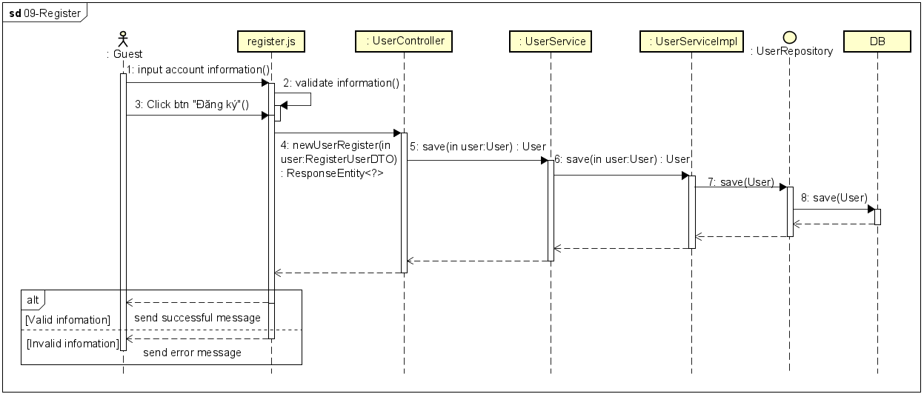

**Figure 4-31:** Register Account - Sequence Diagram

#### 4.1.10 UC-10 Chat With System

##### 4.1.10.1 Screen design

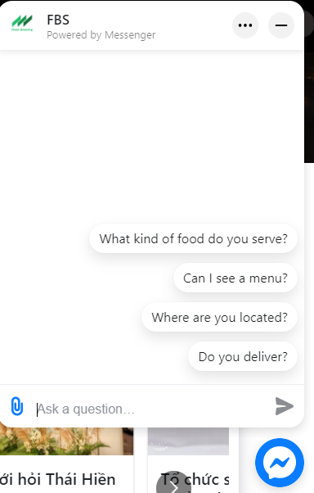

##### 

**Figure 4-32** Chat with system

### 4.2 Customer

#### 4.2.1 UC-11 Reset Password

##### 4.2.1.1 Screen design

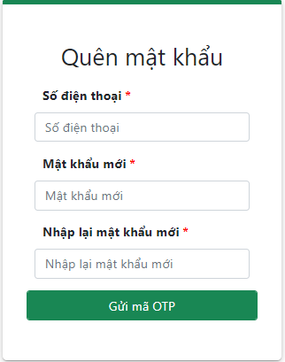

**Figure 4-32** Reset password

|  |  |  |  |  |  |
| --- | --- | --- | --- | --- | --- |
| **#** | **Object/Control Name** | **Type** | **Required** | **Length** | **Description** |
| **Header** (same as header of Search Restaurant screen) | | | | | |
| **Main** | | | | | |
| 1 | Title Quên mật khẩu | <div >Quên mật khẩu</div> |  |  |  |
| 2 | Số điện thoại | <Input type="text" placeholder="Số điện thoại" required="required" /> | Yes | 10 | Enter phone login |
| 3 | Mật khẩu mới | <Input type="password" placeholder="Mật khẩu mới" value={password} required="required" /> | Yes | 32 | Enter a new password, display "*" instead of a clear character |
| 4 | Nhập lại mật khẩu | <Input type="password" placeholder="Nhập lại mật khẩu mới" required="required" /> | Yes | 32 | Enter re-password, display "*" instead of clear character |
| 5 | Gửi mã OTP | <Input type="submit" value="Gửi mã OTP" /> |  |  | The button to send OTP |

**Table 4-46:** Reset Password screen Definition

##### 4.2.1.2 Class diagram

###### **4.2.1.2.1 Back End**

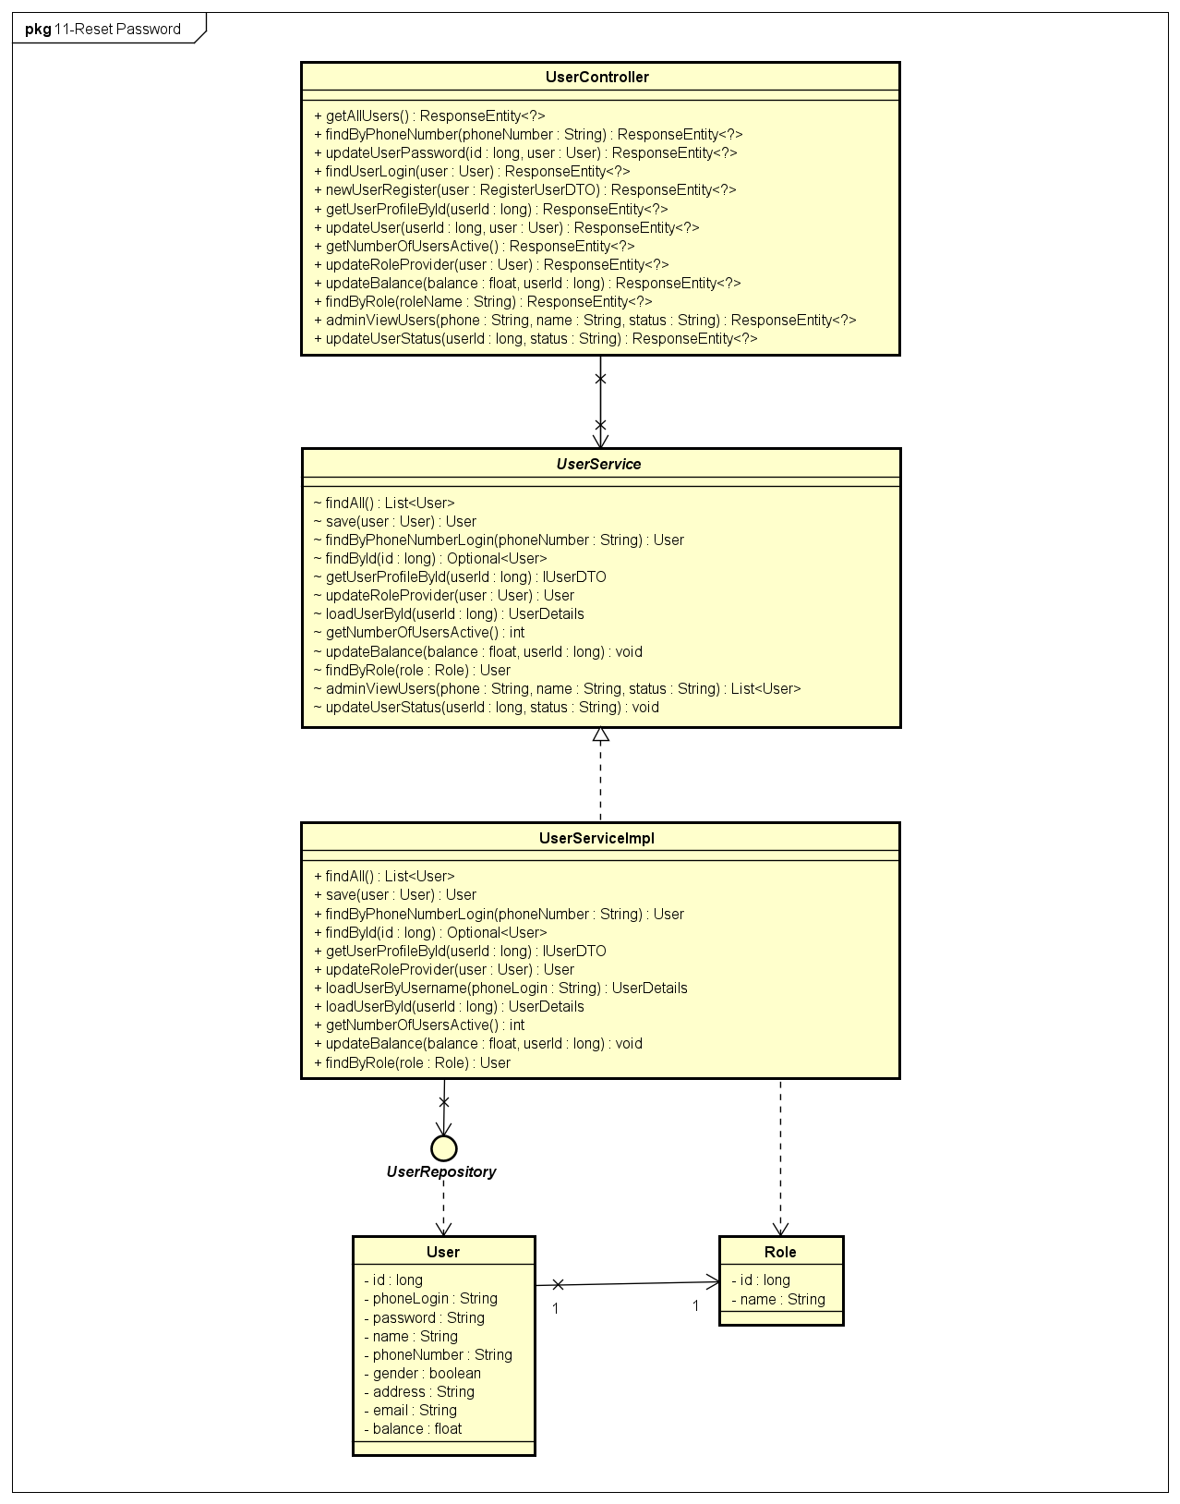

**Figure 4-33:** Reset password - Back-end Class Diagram

###### **4.2.1.2.2 Front End**

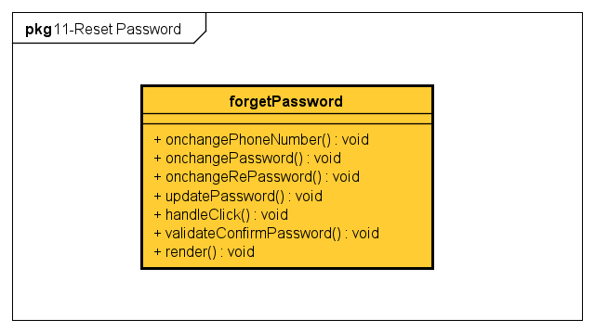

**Figure 4-34:** Reset password - Front-end Class Diagram

##### 4.2.1.3 Class Description

###### **4.2.1.3.1 forget-password**

|  |  |  |  |  |
| --- | --- | --- | --- | --- |
| **Class** | **forget-password** | | | |
| **Description** | Define attributes and methods for these attributes in forget-password front-end class | | | |
| **Base Class** | Component | | | |
| **Constructor** | state  onchangePhoneNumber  onchangePassword  onchangeRePassword  handleClick  updatePassword  validateConfirmPassword | | | |
| **Prototype** |  | | | |
| **Source File** | ofbs-master\bin\font-end\ofbs\src\screens\forget-password.js | | | |
| **Namespace** |  | | | |
| **Attributes** | **Name** | **Type** | **Description** | |
|  |  |  | |
| **Methods** | **Name** | **Input** | **Output** | **Description** |
| onchangePhoneNumber | e |  | set new phone number value |
| onchangePassword | e |  | set new password value |
| onchangeRePassword | e |  | set new re-password value |
| updatePassword |  |  | set new password value |
| handleClick | e |  | handle captcha code and OTP code |
| validateConfirmPassword |  | true/false | user to validate confirm password |
| render |  |  | render register view |

**Table 4-47:** forget-password class description

##### 4.2.1.4 Sequence Diagram

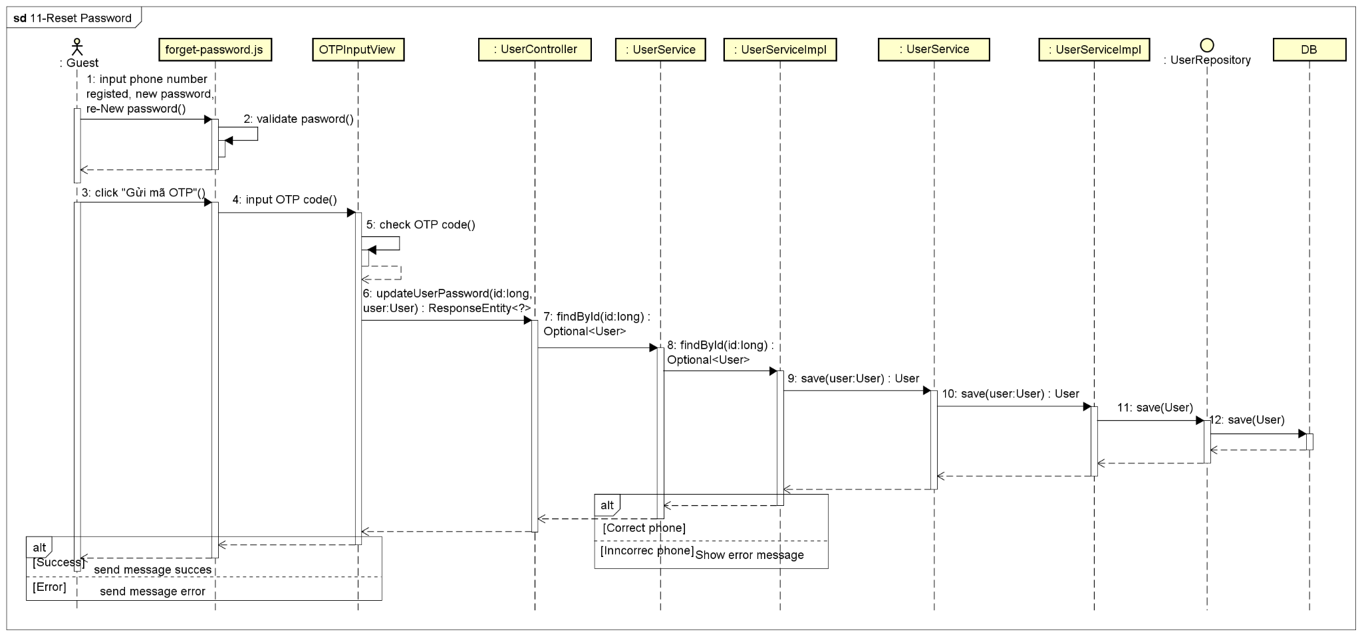

**Figure 4-35:** Reset password - Sequence Diagram

#### 4.2.2 UC-12 Sign In

##### 4.2.2.1 Screen design

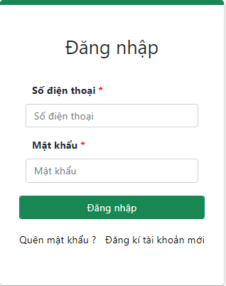

**Figure 4-36** Sign In

|  |  |  |  |  |  |
| --- | --- | --- | --- | --- | --- |
| **#** | **Object/Control Name** | **Type** | **Required** | **Length** | **Description** |
| **Header** (same as header of Search Restaurant screen) | | | | | |
| **Main** | | | | | |
| 1 | Title Đăng nhập | <div >Đăng nhập</div> |  |  |  |
| 2 | Số điện thoại | <Input type="text" placeholder="Số điện thoại" required="required" /> | Yes | 10 | Enter phone to login |
| 3 | Mật khẩu | <Input type="password" placeholder="Mật khẩu" required="required" /> | Yes | 32 | Enter a password, display "*" instead of a clear character |
| 4 | Đăng nhập | <Input type="submit" value="Đăng nhập" /> |  |  | The button to trigger Sign in function |
| 5 | Quên mật khẩu | <Link to="/forget-password" >Quên mật khẩu ?</Link> |  |  | Link to Forget Password screen |
| 6 | Đăng ký tài khoản mới | <Link to="/register" >Đăng kí tài khoản mới</Link> |  |  | Link to Register screen |

**Table 4-48:** Sign In screen Definition

##### 4.2.2.2 Class diagram

###### **4.2.2.2.1 Back End**

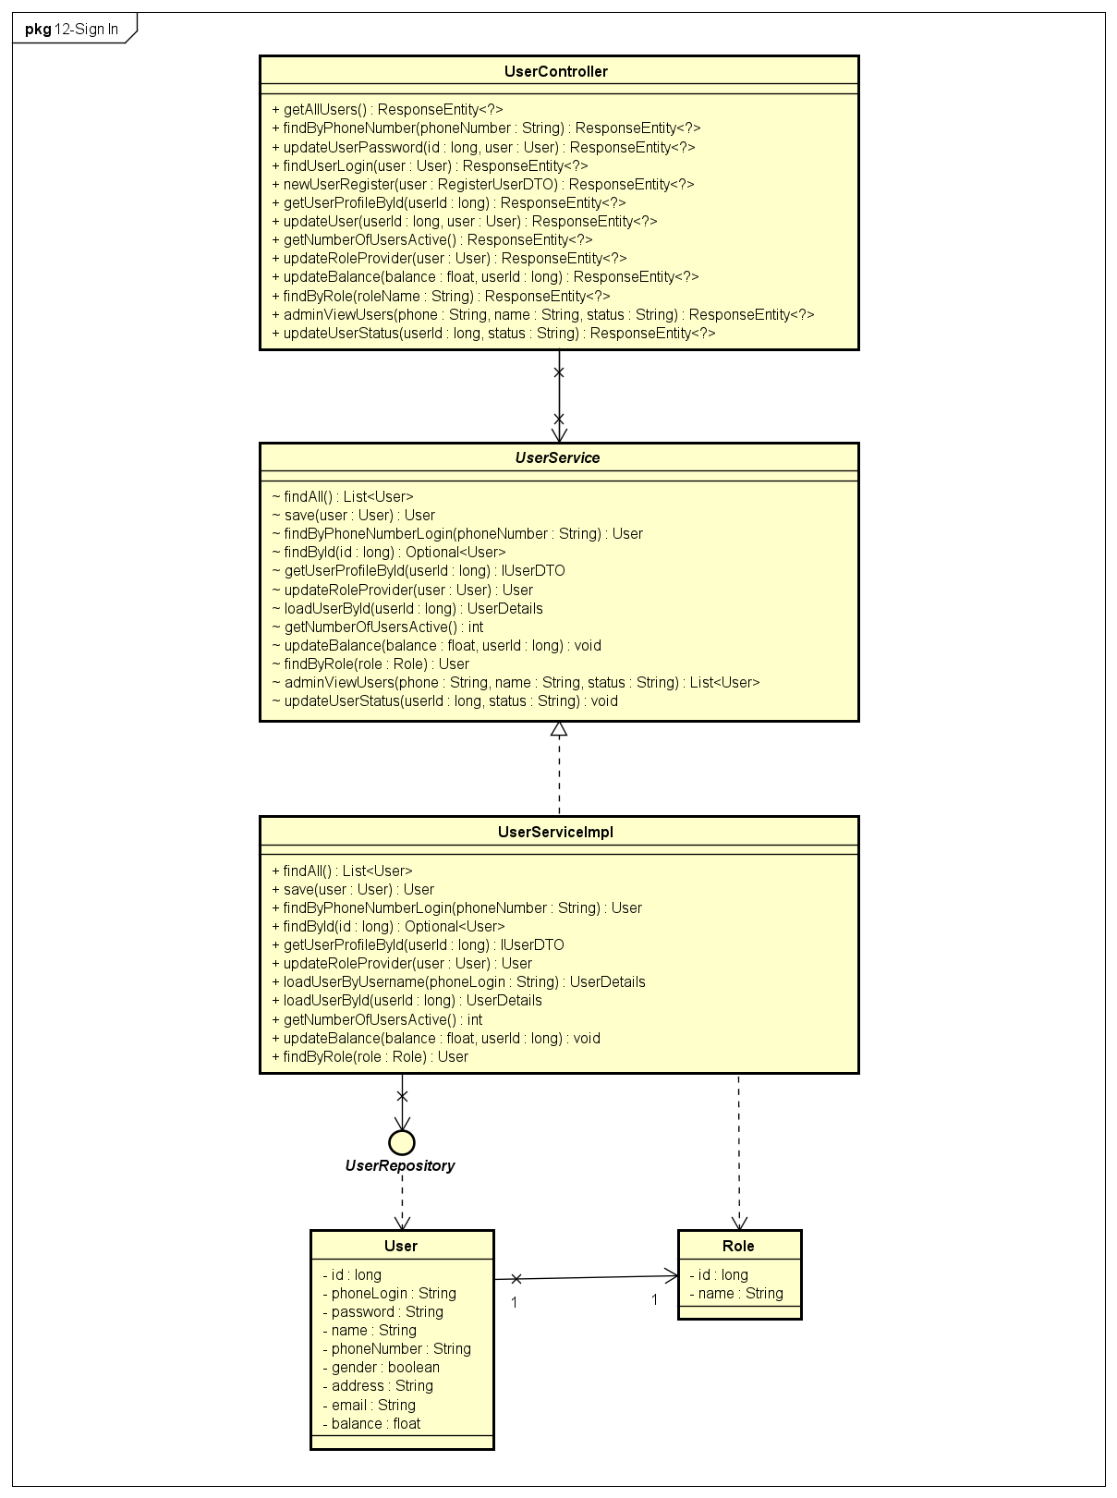

**Figure 4-37** Sign In - Back-end Class Diagram

###### **4.2.2.2.2 Front End**

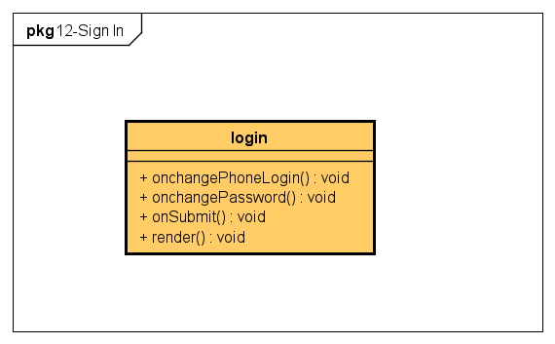

**Figure 4-38** Sign In - Front-end Class Diagram

##### 4.2.2.3 Class Description

###### **4.2.2.3 login**

|  |  |  |  |  |
| --- | --- | --- | --- | --- |
| **Class** | **login** | | | |
| **Description** | Define attributes and methods for these attributes in login front-end class | | | |
| **Base Class** | Component | | | |
| **Constructor** | state  onchangePhoneLogin  onchangePassword  onSubmit | | | |
| **Prototype** |  | | | |
| **Source File** | ofbs-master\bin\font-end\ofbs\src\screens\login.js | | | |
| **Namespace** |  | | | |
| **Attributes** | **Name** | **Type** | **Description** | |
|  |  |  | |
| **Methods** | **Name** | **Input** | **Output** | **Description** |
| onchangePhoneLogin | e |  | use to set phone number login value |
| onchangePassword | e |  | use to set password value |
| onSubmit | e |  | use to submit login |
| render |  |  | user to handle render view |

**Table 4-49:** login class description

##### 4.2.2.4 Sequence Diagram

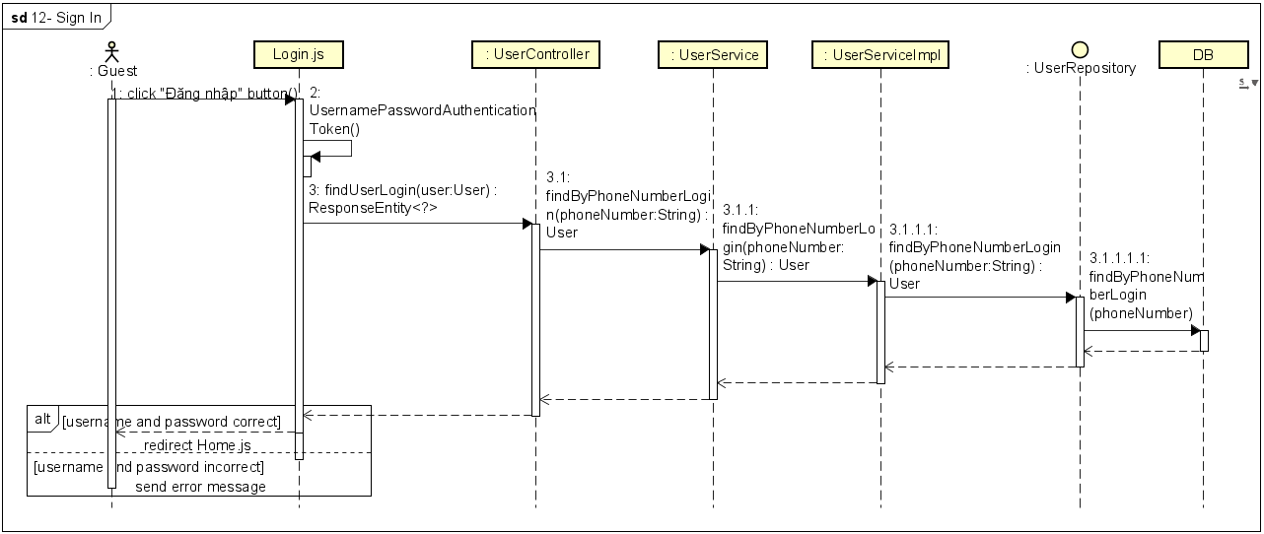

**Figure 4-39:** Sign In - Sequence Diagram

#### 4.2.3 UC-13 View Profile

##### 4.2.3.1 Screen design

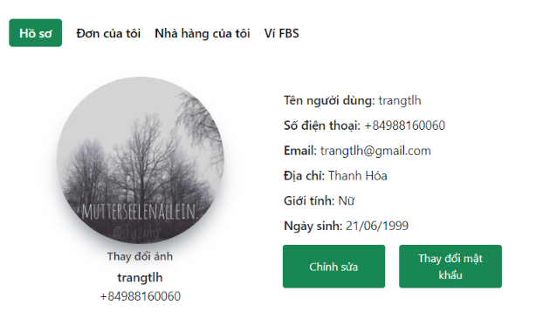

**Figure 4-40:** View Profile

|  |  |  |  |  |  |
| --- | --- | --- | --- | --- | --- |
| **#** | **Object/Control Name** | **Type** | **Required** | **Length** | **Description** |
| **Header(**same as header of Search Restaurant screen**)** | | | | | |
| **Main** | | | | | |
| 1 | Hồ sơ | <Link >Hồ sơ</Link> |  |  | Link to User Profile screen |
| 2 | Đơn của tôi | <Link >Đơn của tôi</Link> |  |  | Link to User Profile Order screen |
| 3 | Nhà hàng của tôi | <Link >Nhà hàng của tô</Link> |  |  | Link to My Restaurant screen |
| 4 | Ví FBS | <Link >Ví FBS</Link> |  |  | Link to Wallet Information screen |
| 5 | User Image | <CardImg /> |  |  | Avatar of user |
| 6 | Thay đổi ảnh | <div >Thay đổi ảnh</div> |  |  | Button to change avatar |
| 7 | Tên người dùng | <div>Tên người dùng:</div> |  |  | Username of user |
| 8 | Số điện thoại | <div>Số điện thoại:</div> |  |  | Phone number to contact of the user |
| 9 | Email | <div>Email:</div> |  |  | Email of user |
| 10 | Địa chỉ | <div>Địa chỉ:</div> |  |  | Address of user |
| 11 | Giới tính | <div>Giới tính:</div> |  |  | Gender of user |
| 12 | Ngày sinh | <div>Ngày sinh:</div> |  |  | Date of birth of user |
| 13 | Chỉnh sửa | <Button>Chỉnh sửa</Button> |  |  | Display Update Profile screen |
| 14 | Thay đổi mật khẩu | <ModalHeader >Thay đổi mật khẩu</ModalHeader> |  |  | Display Change Password screen |
| **Footer** (same as footer of Search Restaurant screen) | | | | | |

**Table 4-50:** View Profile screen Definition

##### 4.2.3.2 Class diagram

###### **4.2.3.2.1 Back End**

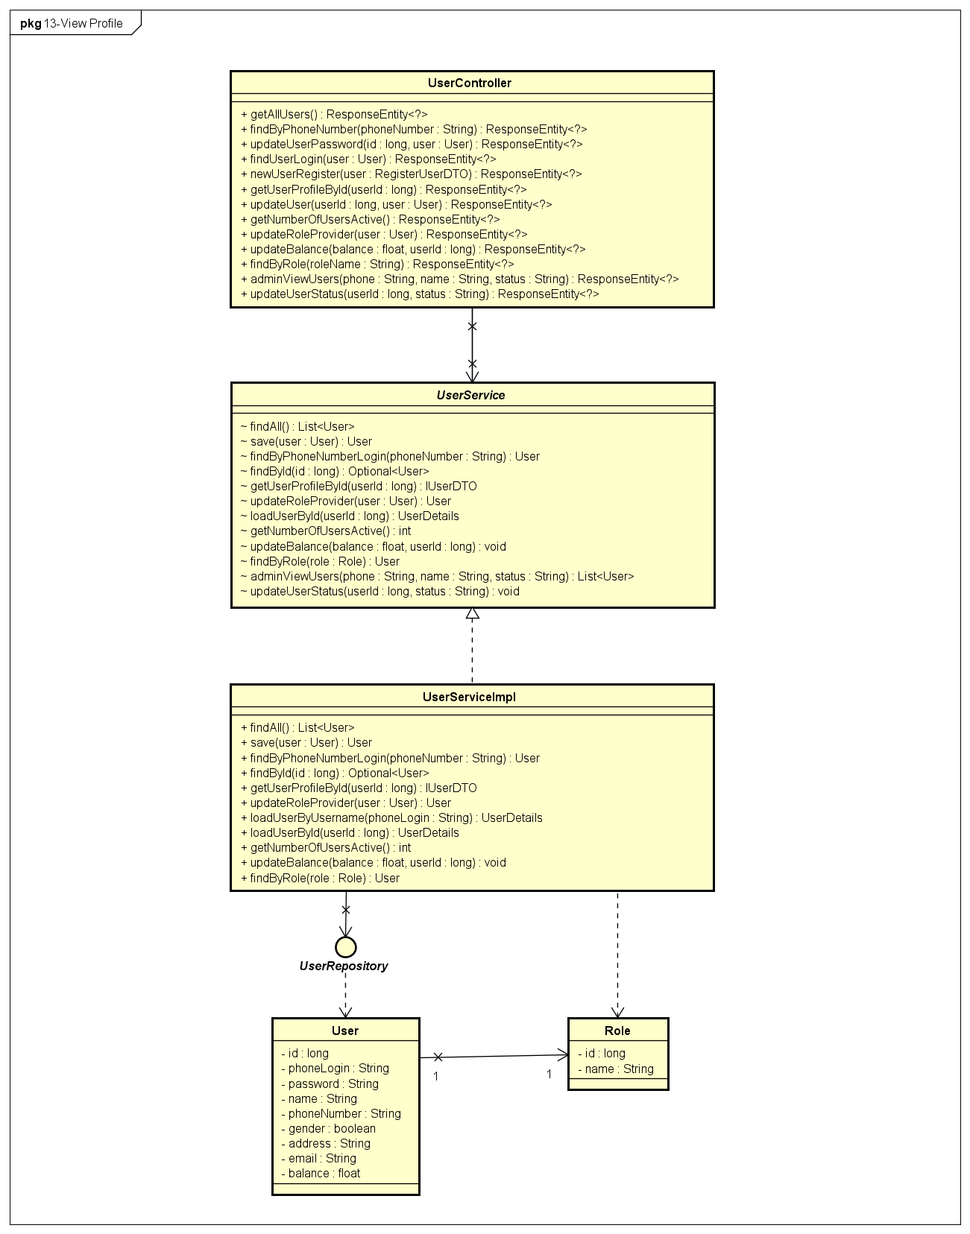

**Figure 4-41:** View Profile- Back-end Class Diagram

###### **4.2.3.2.2 Front End**

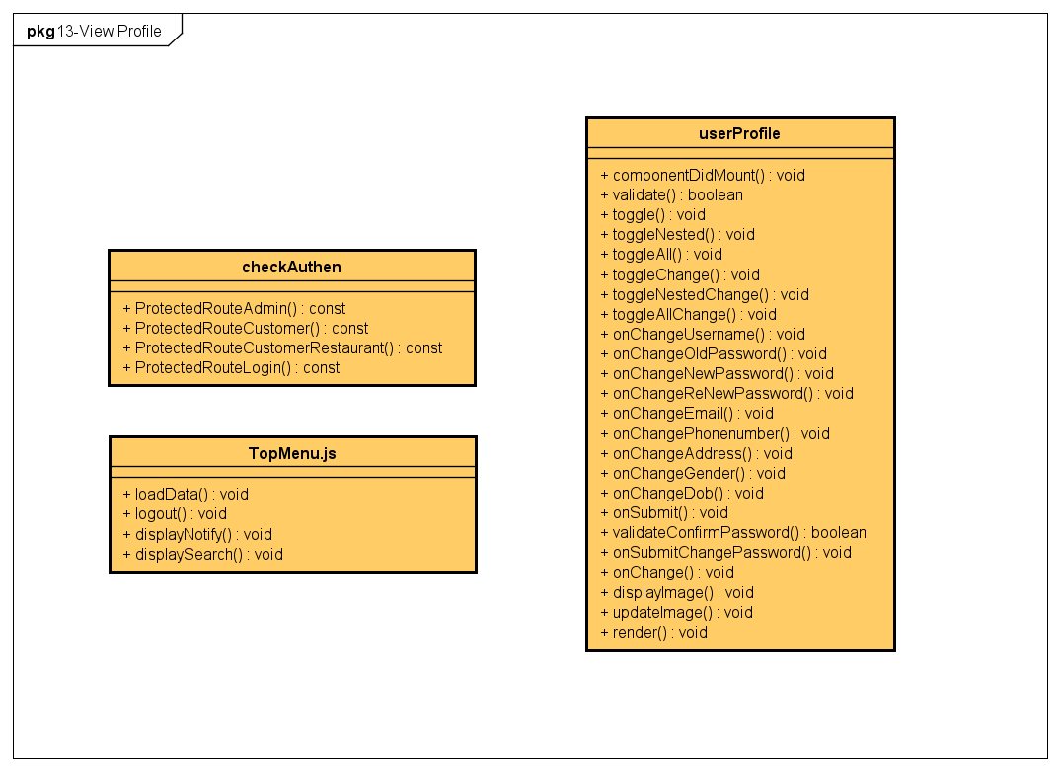

**Figure 4-42:** View Profile- Front-end Class Diagram

##### 4.2.3.3 Class Description

###### **4.2.3.3.1 checkAuthen**

|  |  |  |  |  |
| --- | --- | --- | --- | --- |
| **Class** | **checkAuthen** | | | |
| **Description** | Define attributes and methods for these attributes in checkAuthen front-end class | | | |
| **Base Class** |  | | | |
| **Constructor** |  | | | |
| **Prototype** |  | | | |
| **Source File** | ofbs-master\front-end\src\common\checkAuthen.js | | | |
| **Namespace** |  | | | |
| **Attributes** | **Name** | **Type** | **Description** | |
|  |  |  | |
| **Methods** | **Name** | **Input** | **Output** | **Description** |
| ProtectedRouteAdmin | component |  | Protected Route Admin |
| ProtectedRouteCustomer | component |  | Protected Route Customer |
| ProtectedRouteCustomerRestaurant | component |  | Protected Route Customer Restaurant |
| ProtectedRouteLogin | component |  | Protected Route Login |

**Table 4-51:** checkAuthen class description

###### **4.2.3.3.2 userProfile**

|  |  |  |  |  |
| --- | --- | --- | --- | --- |
| **Class** | **userProfile** | | | |
| **Description** | Define attributes and methods for these attributes in user profile front-end class | | | |
| **Base Class** | Component | | | |
| **Constructor** | state  toggle  toggleChange  toggleNested  toggleNestedChange  toggleAll  toggleAllChange  onChangeUsername  onChangeOldPassword  onChangeNewPassword  onChangeReNewPassword  onChangeAddress  onChangeEmail  onChangePhonenumber  onChangeGender  onChangeDob  onSubmit  onSubmitChangePassword  validateConfirmPassword  onChange  updateImage  validate | | | |
| **Prototype** |  | | | |
| **Source File** | ofbs-master\front-end\src\screens\user\userProfile.js | | | |
| **Namespace** |  | | | |
| **Attributes** | **Name** | **Type** | **Description** | |
|  |  |  | |
| **Methods** | **Name** | **Input** | **Output** | **Description** |
| componentDidMount |  |  | use API to get user data from back end |
| validate |  | true/false | use to validate user data |
| toggle |  |  | use to set state modal |
| toggleNested |  |  | use to set state nested modal |
| toggleAll |  |  | use to set state nested modal |
| toggleChange |  |  | use to set state modal change |
| toggleNestedChange |  |  | use to set state nested modal change is false |
| toggleAllChange |  |  | use to set close all change is true |
| onChangeUsername | e |  | use to set username value |
| onChangeOldPassword | e |  | use to set old password value |
| onChangeNewPassword | e |  | use to set new password value |
| onChangeReNewPassword | e |  | use to set re-new password value |
| onChangeEmail | e |  | use to set email value |
| onChangePhonenumber | e |  | use to set phone number value |
| onChangeAddress | e |  | use to set address value |
| onChangeGender | e |  | use to set gender value |
| onChangeDob | e |  | use to set dob value |
| onSubmit |  |  | use to submit data |
| validateConfirmPassword |  | true/false | use to validate confirm password |
| onSubmitChangePassword |  |  | use to submit password value |
| onChange |  |  | use to set state for image |
| displayImage |  |  | use to display image |
| updateImage |  |  | use to update image |
| render |  |  | use to view render |

**Table 4-52:** userProfile class description

##### 4.2.3.4 Sequence Diagram

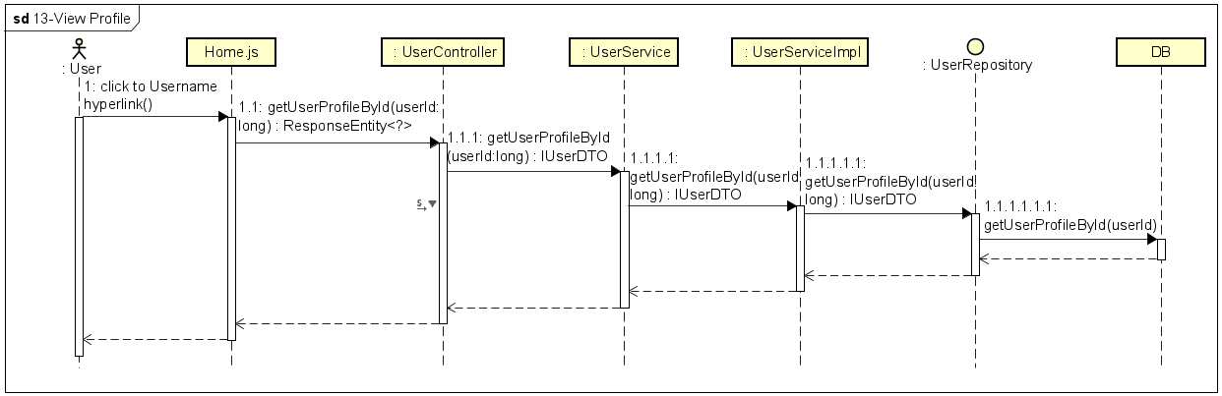

**Figure 4-43:** View Profile - Sequence Diagram

#### 4.2.4 UC-14 Update Profile

##### 4.2.4.1 Screen design

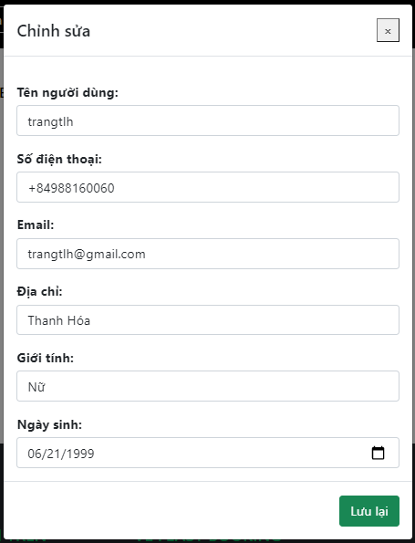

**Figure 4-44:** Update Profile

|  |  |  |  |  |  |
| --- | --- | --- | --- | --- | --- |
| **#** | **Object/Control Name** | **Type** | **Required** | **Length** | **Description** |
| **Main** | | | | | |
| 1 | Title Chỉnh sửa | <ModalHeader>Chỉnh sửa</ModalHeader> |  |  |  |
| 2 | Tên người dùng | <Label ><b>Tên người dùng </b></Label> | Yes | 100 | Username of user |
| 3 | Số điện thoại | <Label ><b>Số điện thoại </b></Label> | Yes | 10 | Phone number to contact of user |
| 4 | Email | <Label ><b>Email</b></Label> | No | 100 | Email of user |
| 5 | Địa chỉ | <Label><b>Địa chỉ</b></Label> | No | 100 | Address of user |
| 6 | Giới tính | <Label><b>Giới tính</b></Label> |  |  | Gender of user  Value: Name - Male, Nữ - Female, Khác - Other |
| 7 | Ngày sinh | <Label ><b>Ngày sinh </b></Label> |  |  | Date of birth of user |
| 8 | Lưu lại | <Input type="submit" value="Lưu lại" /> |  |  | Button to save change |
| 9 | Quay lại | <Button >Quay lại</Button> |  |  | Button to close User Profile Update form |

**Table 4-53:** Update Profile screen Definition

##### 4.2.4.2 Class diagram

###### **4.2.4.2.1 Back end**

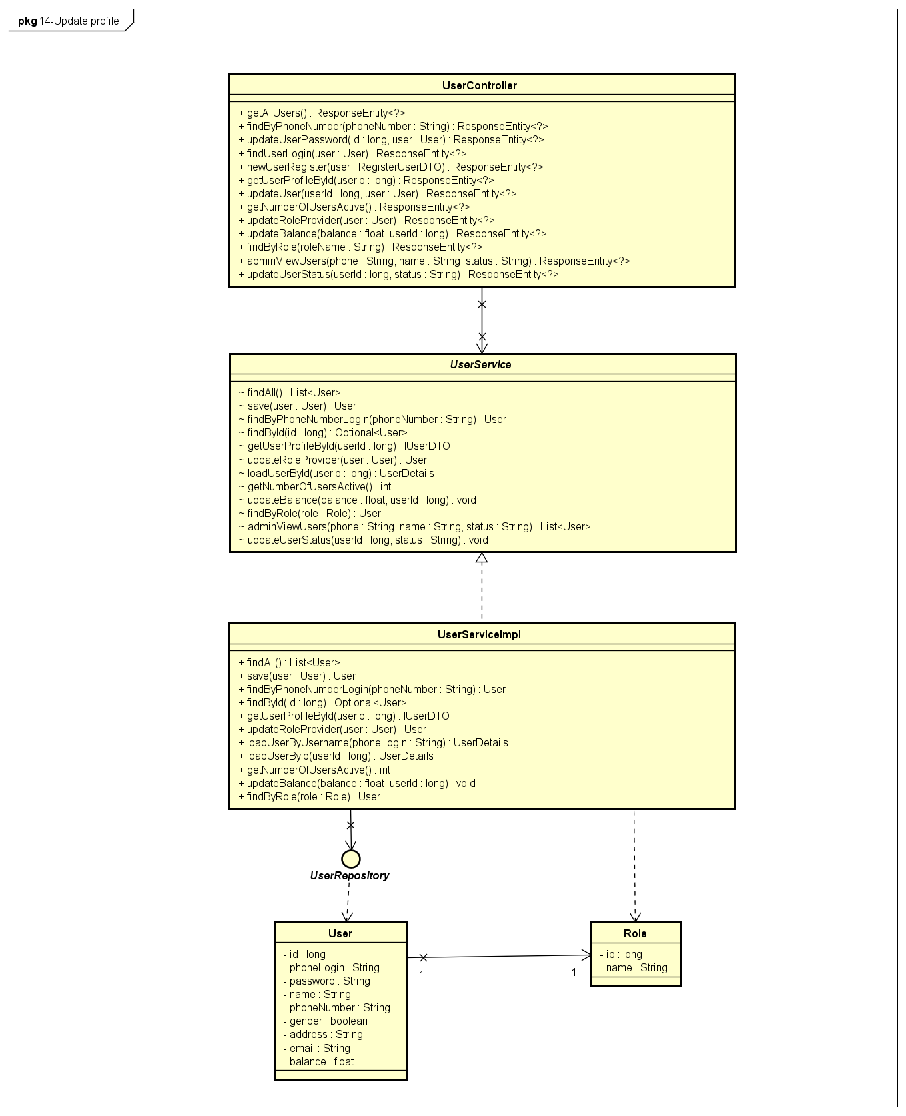

**Figure 4-45:** Update Profile - Back-end Class Diagram

###### **4.2.4.2.2 Front end**

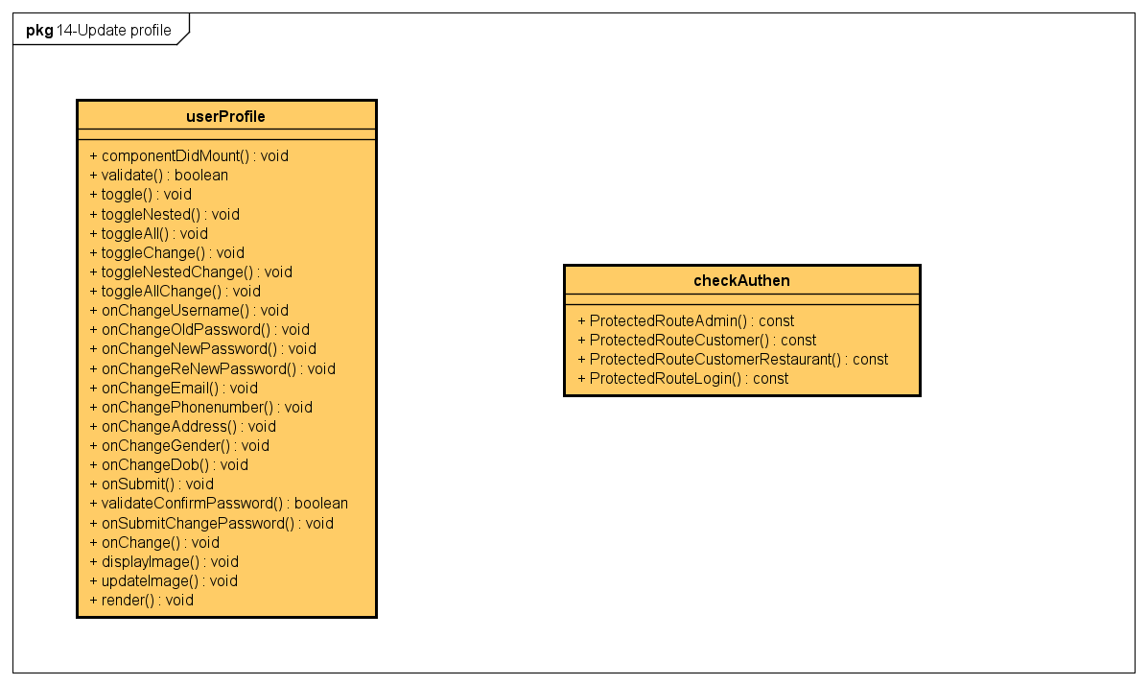

**Figure 4-46:** Update Profile - Front-end Class Diagram

##### 4.2.4.3 Class Description

Reference to 4.1.9.3

##### 4.2.4.4 Sequence Diagram

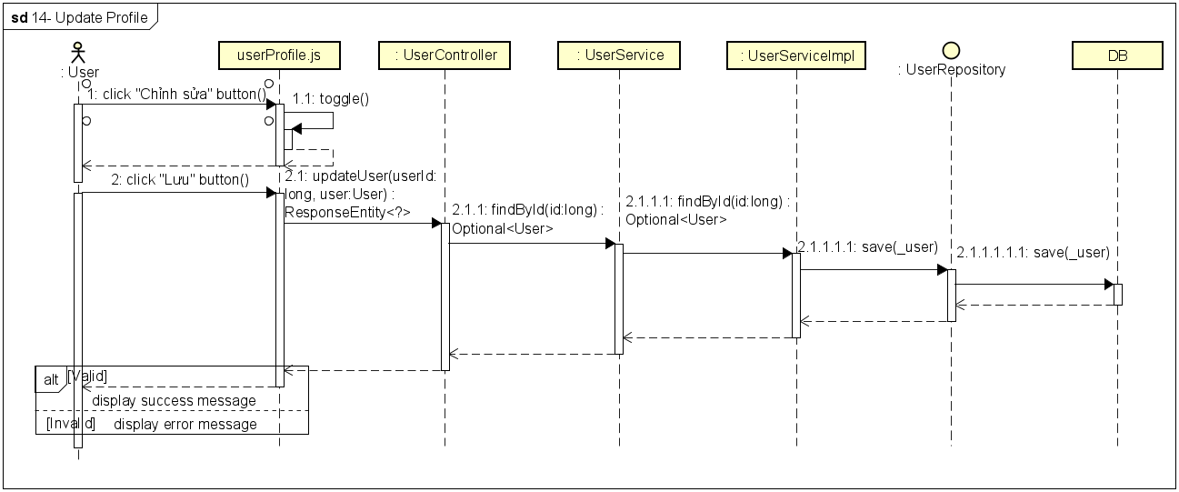

**Figure 4-47:** Update Profile - Sequence Diagram

#### 4.2.5 UC-15 Change Password

##### 4.2.5.1 Screen design

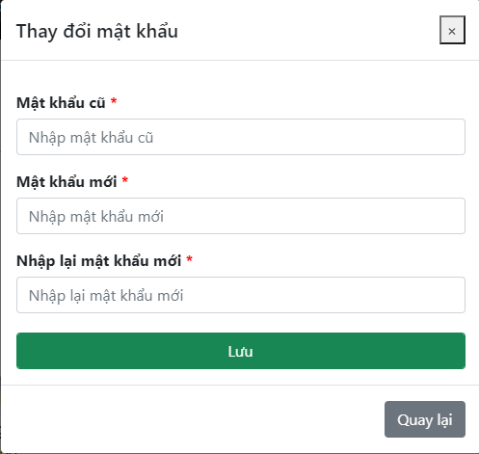

**Figure 4-48** Change Password

|  |  |  |  |  |  |
| --- | --- | --- | --- | --- | --- |
| **#** | **Object/Control Name** | **Type** | **Required** | **Length** | **Description** |
| **Main** | | | | | |
| 1 | Title Thay đổi mật khẩu | <ModalHeader >Thay đổi mật khẩu</ModalHeader> |  |  |  |
| 2 | Mật khẩu cũ | <Label ><b>Mật khẩu cũ </b></Label> | Yes | 32 | Enter an old password, display "*" instead of a clear character |
| 3 | Mật khẩu mới | <Label ><b>Mật khẩu mới </b></Label> | Yes | 32 | Enter a new password, display "*" instead of a clear character |
| 4 | Nhập lại mật khẩu mới | <Label ><b>Nhập lại mật khẩu mới </b></Label> | Yes | 32 | Enter re-password, display "*" instead of clear character |
| 5 | Lưu | <Input type="submit" value="Lưu" /> |  |  | The button to reset password |
| 6 | Quay lại | <Button >Quay lại</Button> |  |  | The button use to close change password form |

**Table 4-54:** Change Password screen definition

##### 4.2.5.2 Class diagram

###### **4.2.5.2.1 Back End**

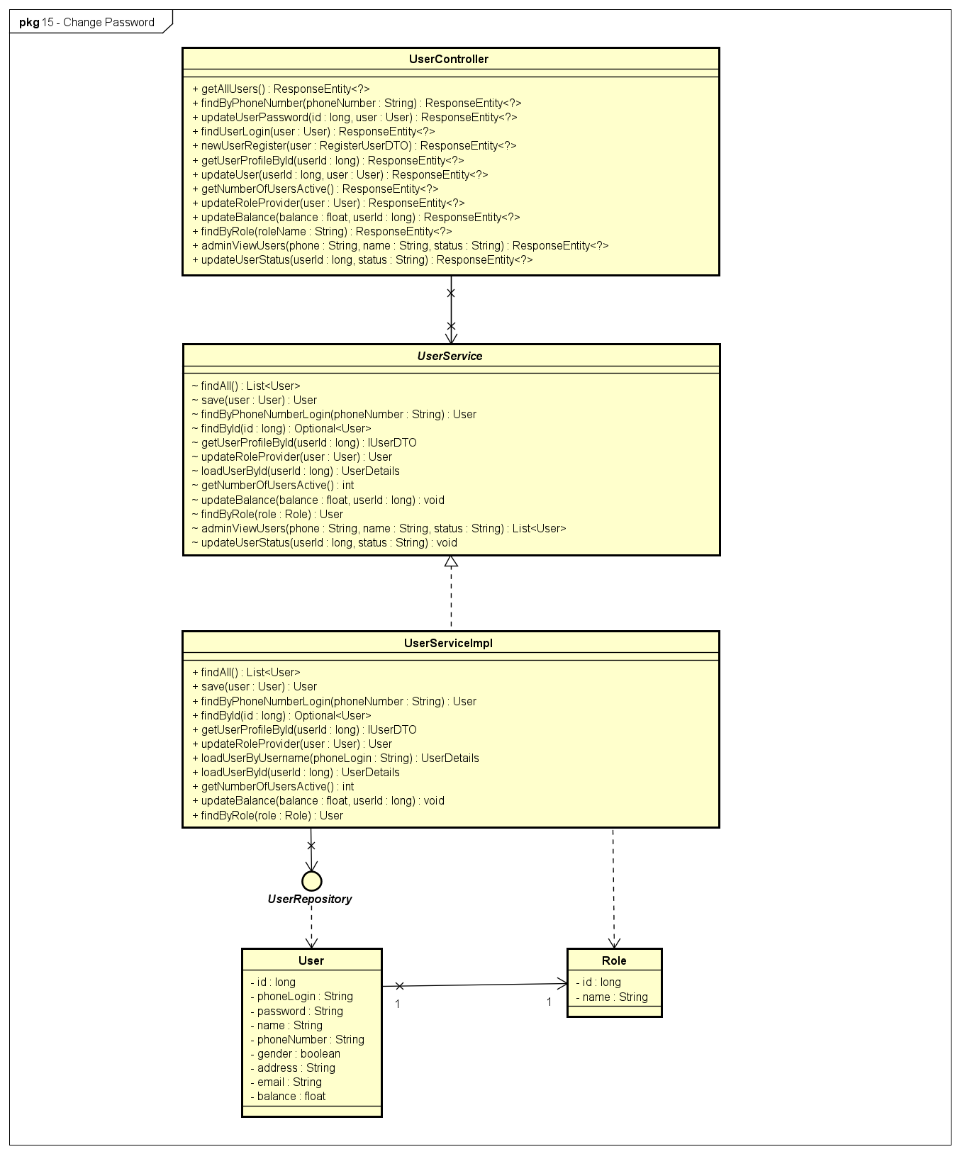

**Figure 4-49:** Change Password - Back-end Class Diagram

###### **4.2.5.2.2 Front End**

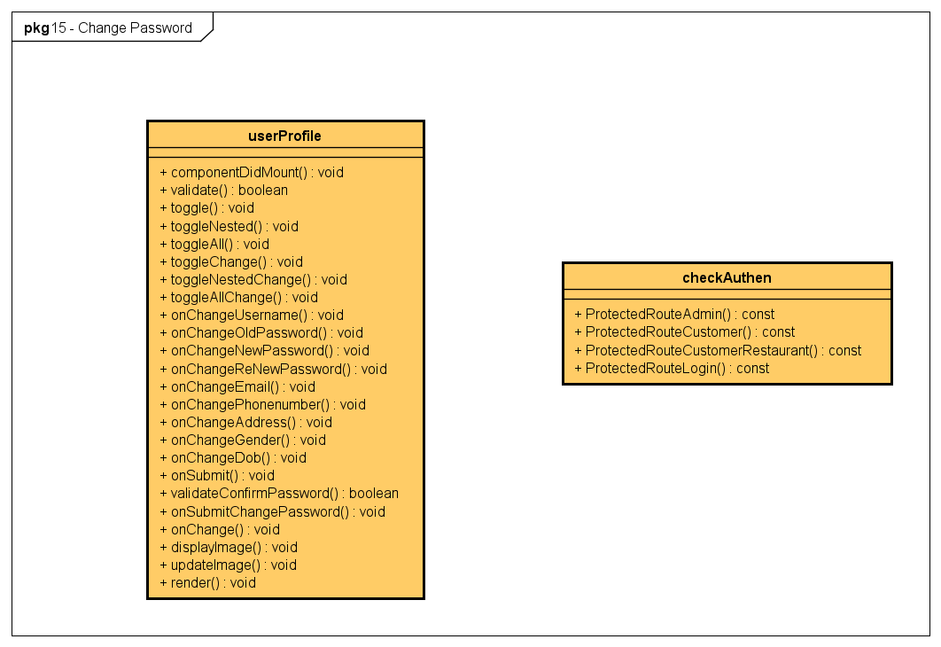

**Figure 4-50:** Change Password - Front-end Class Diagram

##### 4.2.5.3 Class Description

Reference to class description (4.2.3.3)

##### 4.2.5.4 Sequence Diagram

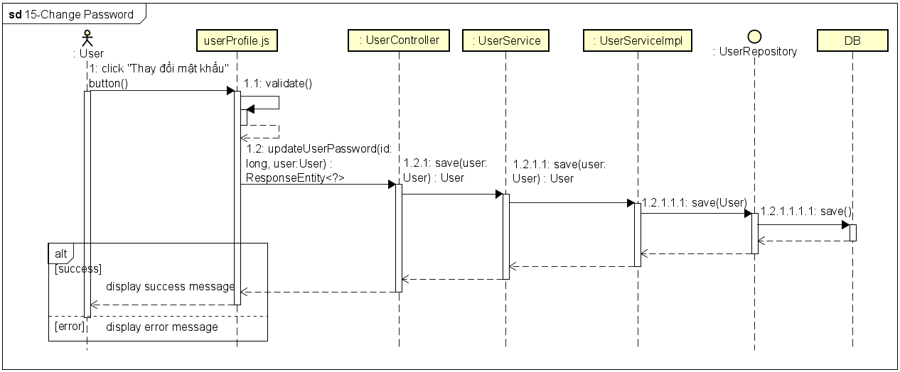

**Figure 4-51:** Change Password - Sequence Diagram

#### 4.2.6 UC-16 Charge Account

##### 4.2.6.1 Screen design

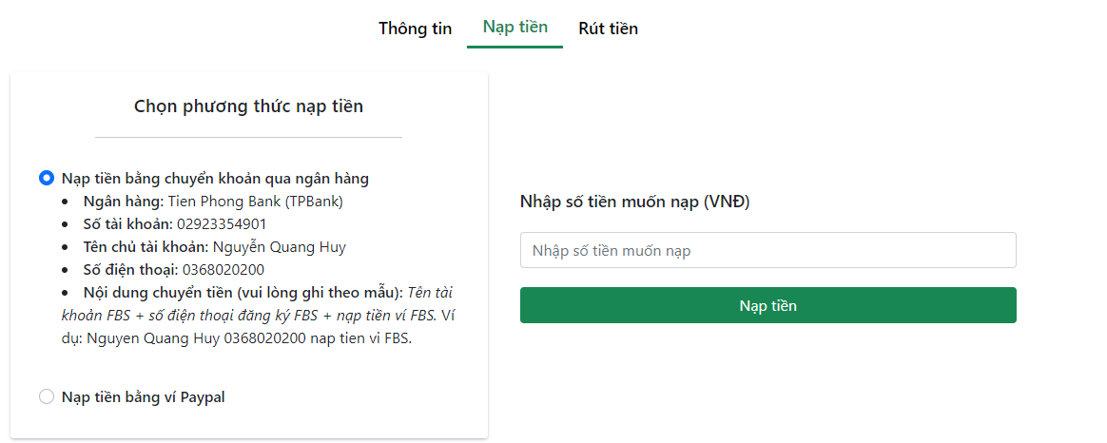

**Figure 4-52:** Charge Account

|  |  |  |  |  |  |
| --- | --- | --- | --- | --- | --- |
| **#** | **Object/Control Name** | **Type** | **Required** | **Length** | **Description** |
| **Menu bar** | | | | | |
| 1 | Thông tin | <NavLink >Thông tin</NavLink> |  |  | Link to Wallet Information screen |
| 2 | Nạp tiền | <NavLink>Nạp tiền</NavLink> |  |  | Link to Pay In screen |
| 3 | Rút tiền | <NavLink >Rút tiền</NavLink> |  |  | Link to Withdrawal screen |
| **Main** | | | | | |
| 1 | Title Chọn phương thức nạp tiền | <div >Chọn phương thức nạp tiền</div> |  |  |  |
| 2 | Nạp tiền bằng cách chuyển khoản qua ngân hàng | <span >Nạp tiền bằng chuyển khoản qua ngân hàng</span> |  |  | Top up by bank transfer to the system's account with the content as given by the system |
| 3 | Nạp tiền bằng ví PayPal | <span >Nạp tiền bằng ví Paypal</span> |  |  | Top up FBS wallet with PayPal wallet |
| 4 | Nhập số tiền muốn nạp | <Input type="number" min={10000} placeholder="Nhập số tiền muốn nạp" /> | Yes |  | Enter the amount to top up into the FBS wallet |
| 5 | Nạp tiền | <Button >Nạp tiền</Button> |  |  | Button to trigger Top-up function |

**Table 4-55:** Charge Account screen definition

##### 4.2.6.2 Class diagram

###### **4.2.6.2.1 Back End**

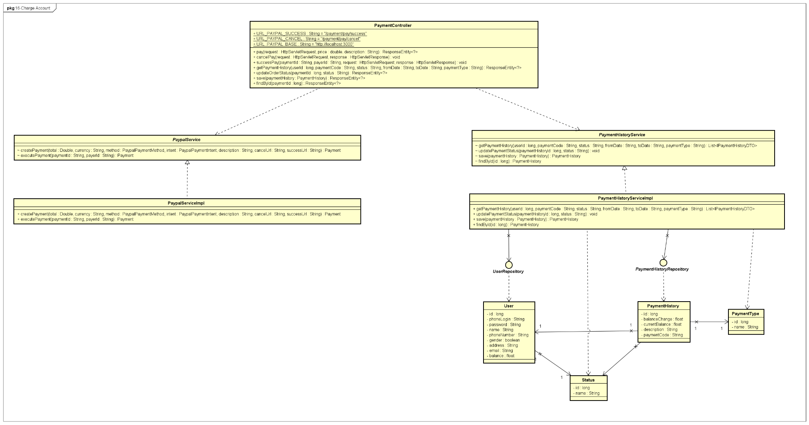

**Figure 4-52:** Charge Account - Back-end Class Diagram

###### **4.2.6.2.2 Front End**

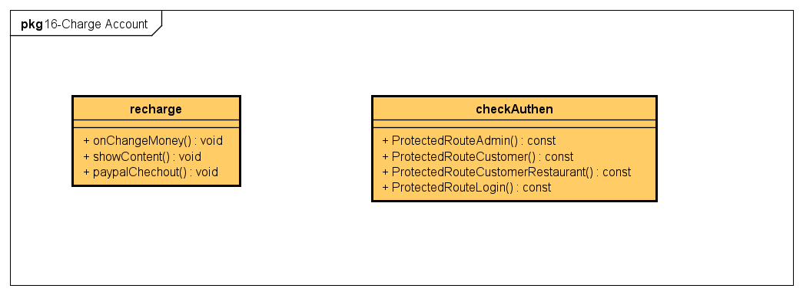

**Figure 4-53:** Charge Account - Back-end Class Diagram

##### 4.2.6.3 Class Description

###### **4.2.6.3.1 recharge**

|  |  |  |  |  |
| --- | --- | --- | --- | --- |
| **Class** | **recharge** | | | |
| **Description** | Define attributes and methods for these attributes in recharge front-end class | | | |
| **Base Class** |  | | | |
| **Constructor** |  | | | |
| **Prototype** |  | | | |
| **Source File** | ofbs-master\front-end\src\components\wallet\recharge.js | | | |
| **Namespace** |  | | | |
| **Attributes** | **Name** | **Type** | **Description** | |
|  |  |  | |
| **Methods** | **Name** | **Input** | **Output** | **Description** |
| onChangeMoney | e |  | use to set money value |
| showContent | type |  | use to display bank info |
| paypalChechout |  |  | use to handle checkout |

**Table 4-56**: recharge class description

###### **4.2.6.3.2 PaymentController**

|  |  |  |  |  |
| --- | --- | --- | --- | --- |
| **Class** | **PaymentController** | | | |
| **Description** | Responsible for controlling the way that a user interacts with payment | | | |
| **Base Class** |  | | | |
| **Constructor** |  | | | |
| **Prototype** |  | | | |
| **Source File** | ofbs-master\back-end\src\main\java\edu\fpt\ofbs\controllers\PaymentController.java | | | |
| **Namespace** |  | | | |
| **Attributes** | **Name** | **Type** | **Description** | |
| URL_PAYPAL_SUCCESS | String | URL PayPal payment is success | |
| URL_PAYPAL_CANCEL | String | URL Paypal payment is cancel | |
| URL_PAYPAL_BASE | String | URL PayPal base | |
| log | Logger | store error message | |
| **Methods** | **Name** | **Input** | **Output** | **Description** |
| pay | request  price  description | ResponseEntity | use to create payment |
| cancelPay | request  response |  | use to cancel payment |
| successPay | paymentId  payerId  request  response |  | use to approve payment |
| getPaymentHistory | userId  paymentCode  status  fromDate  toDate  paymentType | ResponseEntity | use to get payment history |
| updateOrderStatus | paymentId  status | ResponseEntity | use to update order status after payment |
| save | paymentHistory | ResponseEntity | use to save payment history |
| findById | paymentId | ResponseEntity | use to find payment by id |

**Table 4-57**: PaymentController class description

###### **4.2.6.3.3 PaypalServiceImpl**

|  |  |  |  |  |
| --- | --- | --- | --- | --- |
| **Class** | **PaypalServiceImpl** | | | |
| **Description** | provide functionality to handle user requests with PayPal | | | |
| **Base Class** |  | | | |
| **Constructor** |  | | | |
| **Prototype** |  | | | |
| **Source File** | ofbs-master\back-end\src\main\java\edu\fpt\ofbs\service\impl\PaypalServiceImpl.java | | | |
| **Namespace** |  | | | |
| **Attributes** | **Name** | **Type** | **Description** | |
|  |  |  | |
| **Methods** | **Name** | **Input** | **Output** | **Description** |
| createPayment | total  currency  method  intent  description  cancelUrl  successUrl | Payment |  |
| executePayment | paymentId  payerId | Payment |  |

**Table 4-58**: PaypalServiceImpl class description

###### **4.2.6.3.4 PaymentHistoryServiceImpl**

|  |  |  |  |  |
| --- | --- | --- | --- | --- |
| **Class** | **PaymentHistoryServiceImpl** | | | |
| **Description** | provide functionality to handle patent history | | | |
| **Base Class** |  | | | |
| **Constructor** |  | | | |
| **Prototype** |  | | | |
| **Source File** | ofbs-master\back-end\src\main\java\edu\fpt\ofbs\service\impl\PaymentHistoryServiceImpl.java | | | |
| **Namespace** |  | | | |
| **Attributes** | **Name** | **Type** | **Description** | |
|  |  |  | |
| **Methods** | **Name** | **Input** | **Output** | **Description** |
| getPaymentHistory | userId  paymentCode  status  fromDate  toDate  paymentType | List<IPaymentHistoryDTO> | use to get list payment history |
| updatePaymentStatus | paymentHistoryId  status |  | use to change payment status |
| save | paymentHistory | PaymentHistory | use to save payment history |
| findById | id | PaymentHistory | use to find payment history by id |

**Table 4-59**: PaymentHistoryServiceImpl class description

###### **4.2.6.3.5 PaymentHistoryRepository**

|  |  |  |  |  |
| --- | --- | --- | --- | --- |
| **Class** | **PaymentHistoryRepository** | | | |
| **Description** | manipulate the payment history table in the database. | | | |
| **Base Class** | JpaRepository<PaymentHistory, Long> | | | |
| **Constructor** |  | | | |
| **Prototype** |  | | | |
| **Source File** | ofbs-master\back-end\src\main\java\edu\fpt\ofbs\repositories\PaymentHistoryRepository.java | | | |
| **Namespace** |  | | | |
| **Attributes** | **Name** | **Type** | **Description** | |
|  |  |  | |
| **Methods** | **Name** | **Input** | **Output** | **Description** |
| getPaymentHistory | userId  paymentCode  status  fromDate  toDate  paymentType | List<IPaymentHistoryDTO> | use to get payment history |
| updatePaymentStatus | paymentHistoryId  status |  | use to update payment status |

**Table 4-60**: PaymentHistoryRepository class description

###### **4.2.6.3.6 PaymentHistory**

|  |  |  |  |  |
| --- | --- | --- | --- | --- |
| **Class** | **PaymentHistory** | | | |
| **Description** | Define attributes for PaymentHistory entity and set/get method for these attributes | | | |
| **Base Class** |  | | | |
| **Constructor** |  | | | |
| **Prototype** |  | | | |
| **Source File** | ofbs-master\back-end\src\main\java\edu\fpt\ofbs\entities\PaymentHistory.java | | | |
| **Namespace** |  | | | |
| **Attributes** | **Name** | **Type** | **Description** | |
| id | long | use to store payment history id | |
| balanceChange | float | use to store balance change | |
| currentBalance | float | use to store current balance | |
| description | String | use to store description of payment | |
| paymentCode | String | use to store payment code | |
| **Methods** | **Name** | **Input** | **Output** | **Description** |
|  |  |  |  |

**Table 4-61**: PaymentHistory class description

###### **4.2.6.3.7 PaymentType**

|  |  |  |  |  |
| --- | --- | --- | --- | --- |
| **Class** | **PaymentType** | | | |
| **Description** | Define attributes for PaymentType entity and set/get method for these attributes | | | |
| **Base Class** |  | | | |
| **Constructor** |  | | | |
| **Prototype** |  | | | |
| **Source File** | ofbs-master\back-end\src\main\java\edu\fpt\ofbs\entities\PaymentType.java | | | |
| **Namespace** |  | | | |
| **Attributes** | **Name** | **Type** | **Description** | |
| id | long | use to store id of payment type | |
| name | String | use to store name of payment type | |
| **Methods** | **Name** | **Input** | **Output** | **Description** |
|  |  |  |  |

**Table 4-62**: PaymentType class description

##### 4.2.6.4 Sequence Diagram

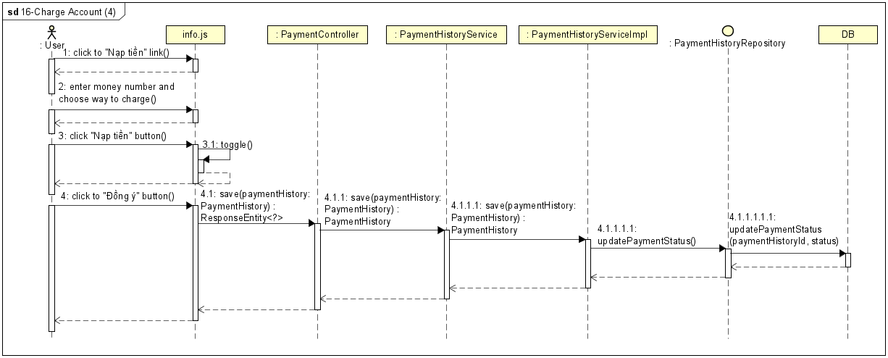

**Figure 4-54:** Charge Account - Sequence Diagram

#### 4.2.7 UC-17 View Transaction Infor

##### 4.2.7.1 Screen design

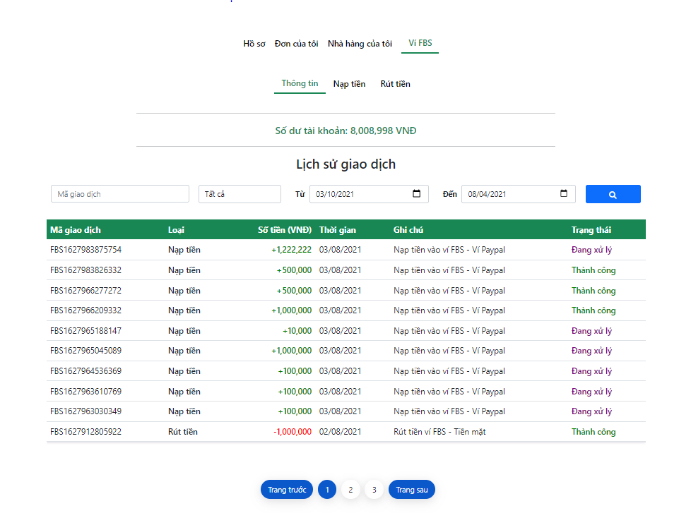

**Figure 4-55:** View Transaction Infor

|  |  |  |  |  |  |
| --- | --- | --- | --- | --- | --- |
| **#** | **Object/Control Name** | **Type** | **Required** | **Length** | **Description** |
| **Menu bar** (same as menu bar of Charge Account screen) | | | | | |
| **Main** | | | | | |
| 1 | Số dư tài khoản | <div >Số dư tài khoản:</div> |  |  | Current balance |
| 2 | Title Lịch sử giao dịch | <h3></h3> |  |  |  |
| 3 | Mã giao dịch | <Input type="text" placeholder="Mã giao dịch" /> |  |  | Enter transaction code to search |
| 4 | Trạng thái | <Input type="select"> |  |  | Filter transaction by status of transactions  Value: Tất cả - All, Thành công - Successful, Đang xử lý - Processing, Thất bại - Failure |
| 5 | Từ | <Input type="select"> |  |  | Search transaction history from what date |
| 6 | Đến | <Input type="date"/> |  |  | Search transaction history to what date |
| 7 | Search Icon | <Button ><FaSearch /></Button> |  |  | Button to trigger Search function |
| 8 | Mã giao dịch | <th>Mã giao dịch</th> |  |  | Transaction code |
| 9 | Loại | <th>Loại</th> |  |  | Type of transaction |
| 10 | Số tiền (VNĐ) | <th>Số tiền (VNĐ)</th> |  |  | Transaction amount |
| 11 | Thời gian | <th>Thời gian</th> |  |  | Transaction date |
| 12 | Ghi chú | <th>Ghi chú</th> |  |  | Note of transaction |
| 13 | Trạng thái | <th>Trạng thái</th> |  |  | Status of transaction |
| **Footer** (same as Search Restaurant screen) | | | | | |

**Table 4.-63:** View Transaction Info screen Definition

##### 4.2.7.2 Class diagram

###### **4.2.7.2.1 Back End**

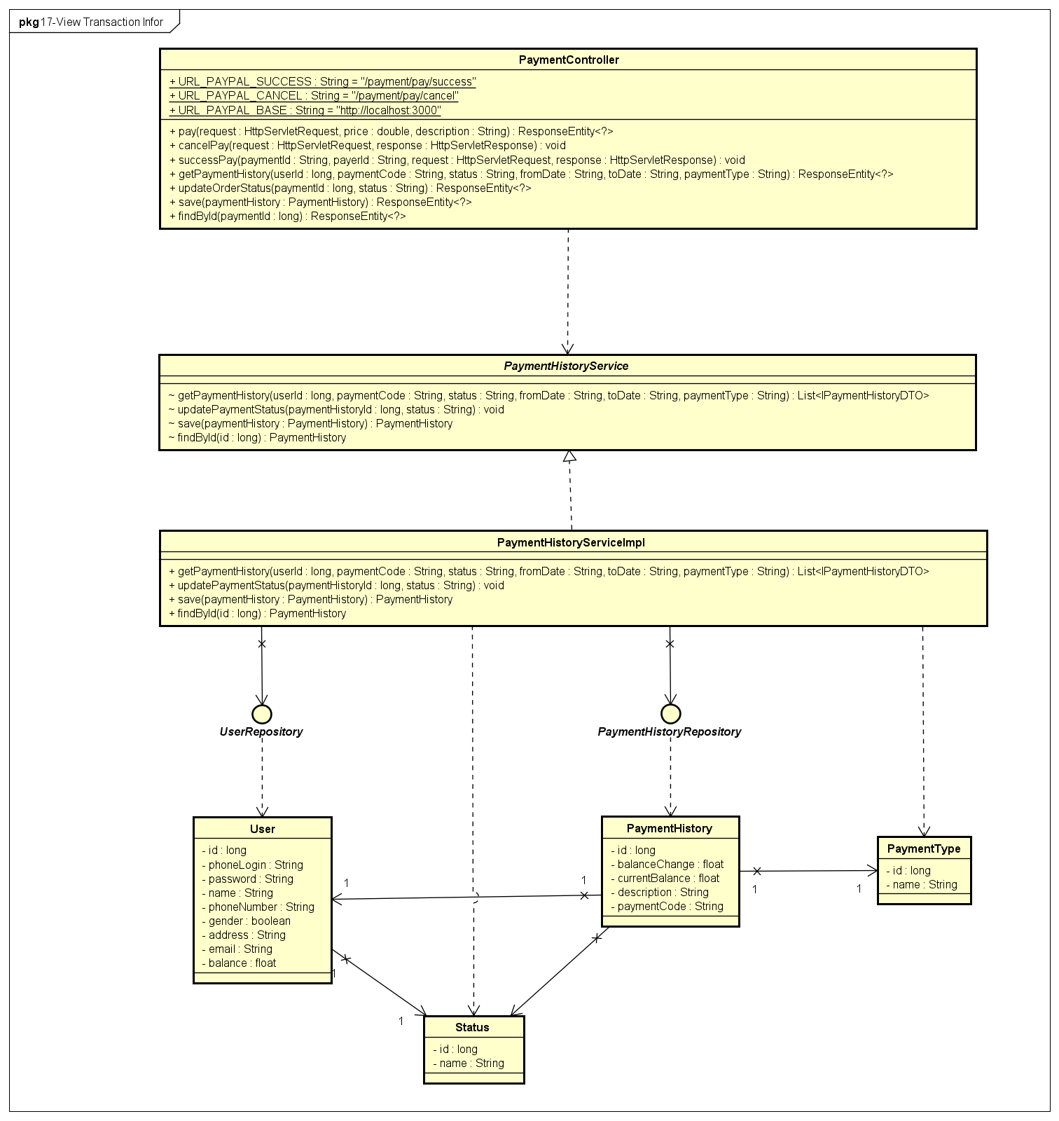

**Figure 4-56:** View Transaction Infor - Back-end Class Diagram

###### **4.2.7.2.2 Front End**

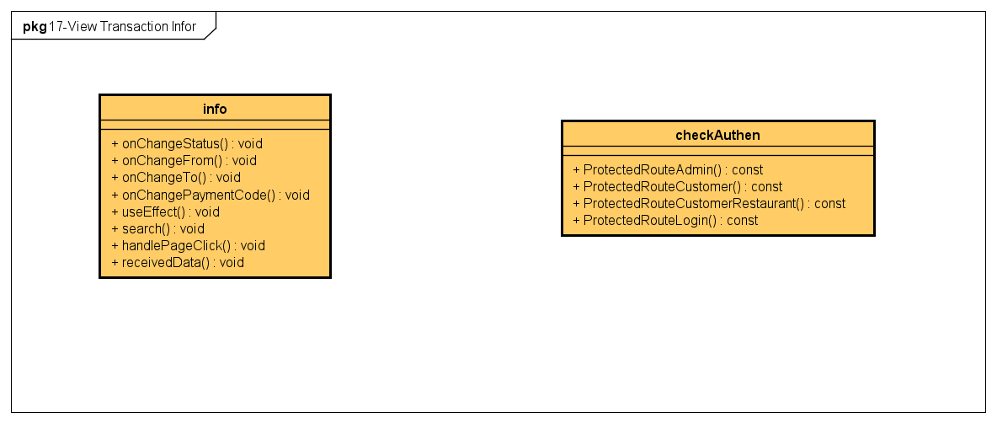

**Figure 4-57:** View Transaction Infor - Front-end Class Diagram

##### 4.2.7.3 Class Description

###### **4.2.7.3.1 info**

|  |  |  |  |  |
| --- | --- | --- | --- | --- |
| **Class** | **info** | | | |
| **Description** | Define attributes and methods for these attributes in info front-end class | | | |
| **Base Class** |  | | | |
| **Constructor** |  | | | |
| **Prototype** |  | | | |
| **Source File** |  | | | |
| **Namespace** |  | | | |
| **Attributes** | **Name** | **Type** | **Description** | |
|  |  |  | |
| **Methods** | **Name** | **Input** | **Output** | **Description** |
| onChangeStatus | e |  | use to set status value |
| onChangeFrom | e |  | use to set from date value |
| onChangeTo | e |  | use to set to date value |
| onChangePaymentCode | e |  | use to set payment code value |
| useEffect |  |  | use to use effect |
| search |  |  | use to search payment |
| handlePageClick | e |  | use to handle paging |
| receivedData |  |  | use to get data by API |

**Table 4-64:** info class description

##### 4.2.7.4 Sequence Diagram

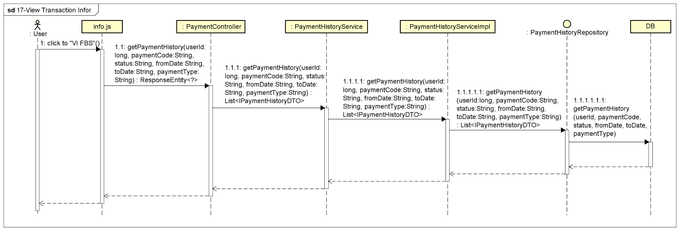

**Figure 4-57:** View Transaction Infor - Sequence Diagram

#### 4.2.8 UC-18 Withdraw

##### 4.2.8.1 Screen design

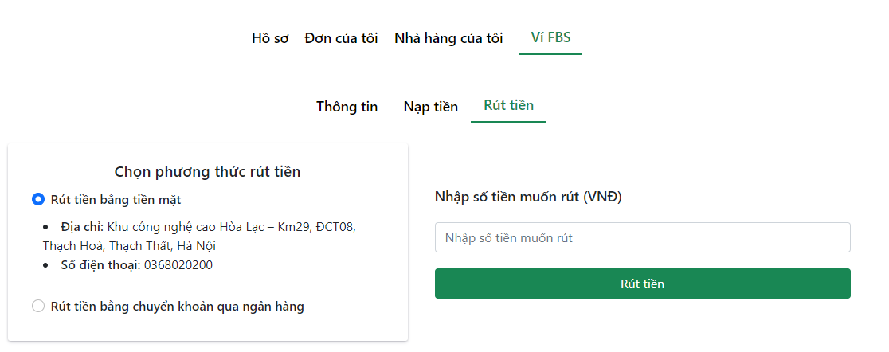

**Figure 4-58:** Withdraw

|  |  |  |  |  |  |
| --- | --- | --- | --- | --- | --- |
| **#** | **Object/Control Name** | **Type** | **Required** | **Length** | **Description** |
| **Menu bar** (same as menu bar of Charge Account screen) | | | | | |
| **Main** | | | | | |
| 1 | Title Chọn phương thức rút tiền | <div >Chọn phương thức rút tiền</div> |  |  |  |
| 2 | Rút tiền bằng tiền mặt | <span >Rút tiền bằng tiền mặt</span> |  |  | Withdraw cash directly at the specific address of the system |
| 3 | Rút tiền bằng chuyển khoản qua ngân hàng | <span >Rút tiền bằng chuyển khoản qua ngân hàng</span> |  |  | Withdraw by bank transfer to the user's account with the content as given by the system |
| 4 | Nhập số tiền muốn rút | <Label></Label> |  |  |  |
| 5 | Nhập số tiền muốn rút | <Input type="number" min={10000} placeholder="Nhập số tiền muốn rút" /> | Yes |  | Enter the amount to withdraw into the FBS wallet |
| 6 | Rút tiền | <Button >Rút tiền</Button> |  |  | Button to trigger Withdraw function |

**Table 4-65:** Withdraw Screen Definition

##### 4.2.8.2 Class diagram

###### **4.2.8.2.1 Back End**

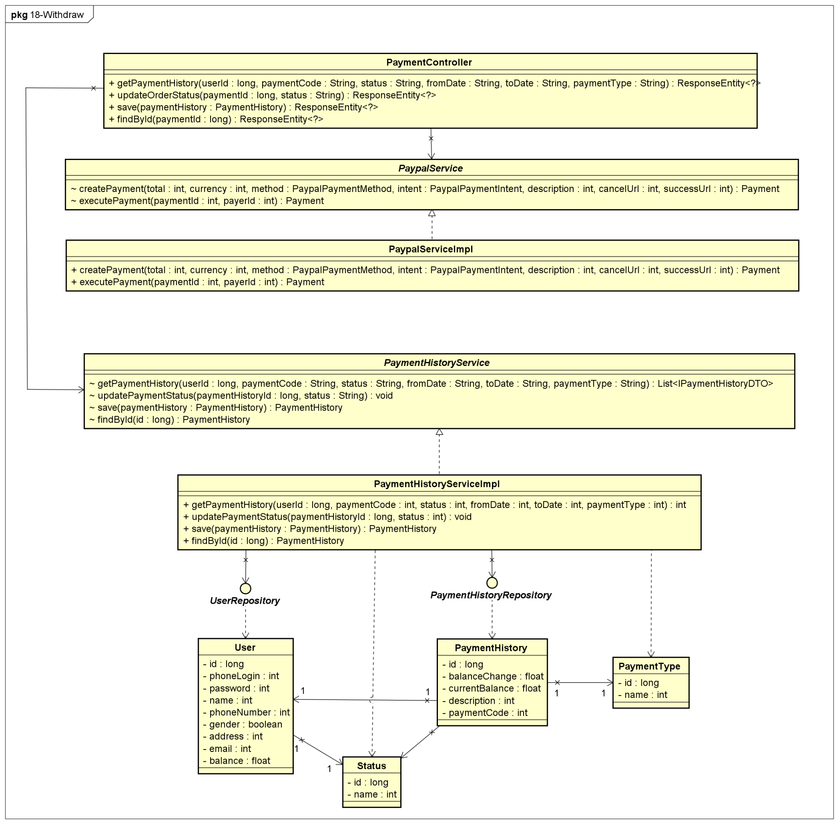

**Figure 4-58:** Withdraw - Back-end Class Diagram

###### **4.2.8.2.2 Front End**

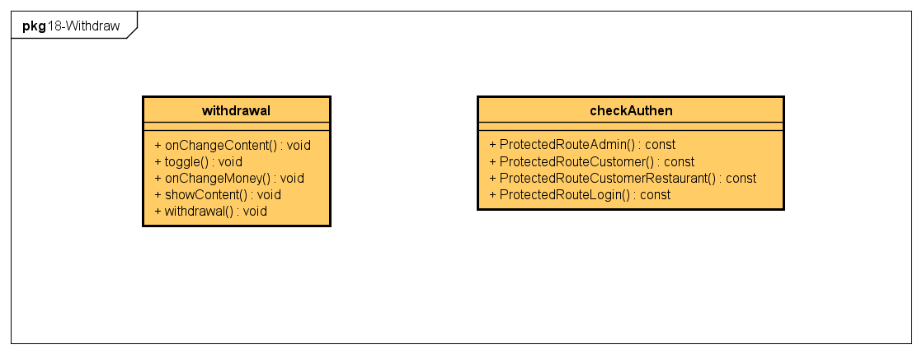

**Figure 4-59:** Withdraw - Front-end Class Diagram

##### 4.2.8.3 Class Description

###### **4.2.8.3.1 withdrawal**

|  |  |  |  |  |
| --- | --- | --- | --- | --- |
| **Class** | **withdrawal** | | | |
| **Description** | Define attributes and methods for these attributes in withdrawal front-end class | | | |
| **Base Class** |  | | | |
| **Constructor** |  | | | |
| **Prototype** |  | | | |
| **Source File** | ofbs-master\front-end\src\components\wallet\withdrawal.js | | | |
| **Namespace** |  | | | |
| **Attributes** | **Name** | **Type** | **Description** | |
|  |  |  | |
| **Methods** | **Name** | **Input** | **Output** | **Description** |
| onChangeContent | e |  | use to set content value |
| toggle |  |  | use to set modal status is true |
| onChangeMoney | e |  | use to set money value |
| showContent | type |  | use to display bank info and address value |
| withdrawal |  |  | use to handle withdraw |

**Table 4-66:** withdrawal class description

##### 4.2.8.4 Sequence Diagram

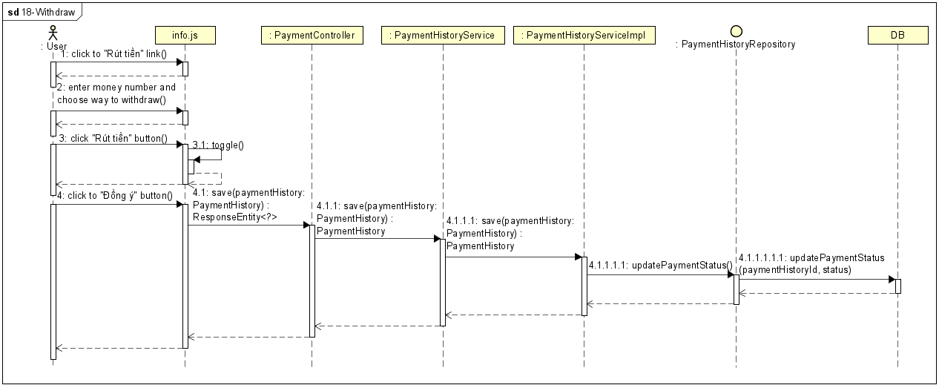

**Figure 4-60:** Withdraw - Sequence Diagram

#### 4.2.9 UC-19 Rate And Comment Restaurant

##### 4.2.9.1 Screen design

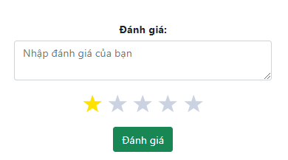

**Figure 4-61:** Rate And Comment Restaurant

|  |  |  |  |  |  |
| --- | --- | --- | --- | --- | --- |
| **#** | **Object/Control Name** | **Type** | **Required** | **Length** | **Description** |
| **Main** (described in View Restaurant Infor screen) | | | | | |

**Table 4-67:** Rate and Comment Restaurant Screen Definition

##### 4.2.9.2 Class diagram

###### **4.2.9.2.1 Back End**

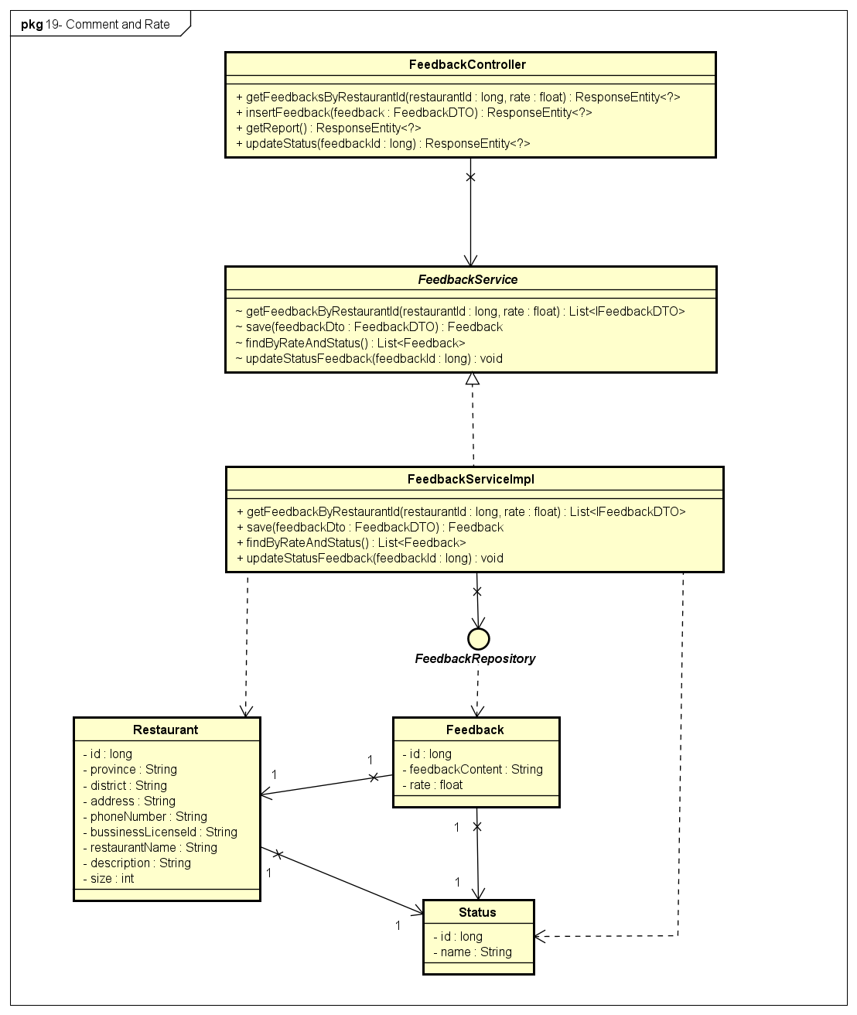

**Figure 4-62:** Rate And Comment Restaurant - Back-end Class Diagram

###### **4.2.9.2.2 Front End**

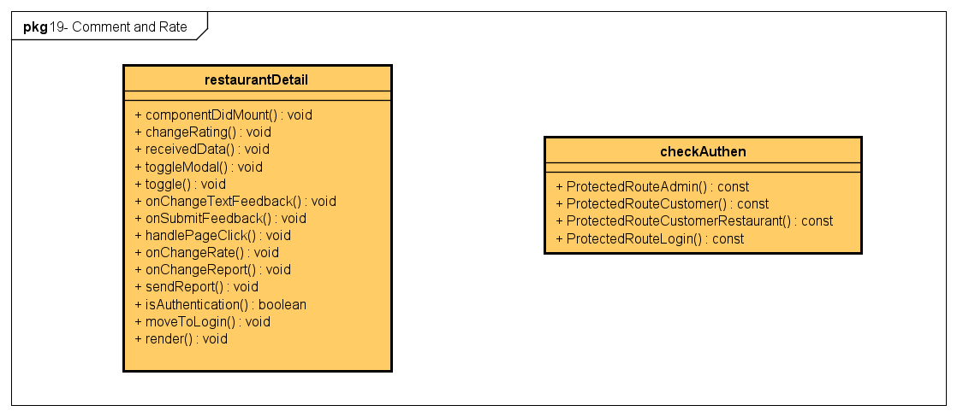

**Figure 4-63:** Rate And Comment Restaurant - Front-end Class Diagram

##### 4.2.9.3 Class Description

###### **4.2.9.3.1 FeedbackController**

|  |  |  |  |  |
| --- | --- | --- | --- | --- |
| **Class** | **FeedbackController** | | | |
| **Description** | Responsible for controlling the way that a user interacts with feedback and rate | | | |
| **Base Class** |  | | | |
| **Constructor** |  | | | |
| **Prototype** |  | | | |
| **Source File** | ofbs-master\back-end\src\main\java\edu\fpt\ofbs\controllers\FeedbackController.java | | | |
| **Namespace** |  | | | |
| **Attributes** | **Name** | **Type** | **Description** | |
|  |  |  | |
| **Methods** | **Name** | **Input** | **Output** | **Description** |
| getFeedbacksByRestaurantId | restaurantId  rate | ResponseEntity | use to get list feedback and rate of a restaurant |
| insertFeedback | feedback | ResponseEntity | use to create a feedback |
| getReport |  | ResponseEntity | use to get list report |
| updateStatus | feedbackId | ResponseEntity | use to update status of a feedback |

**Table 4-68:** FeedbackController class description

###### **4.2.9.3.2 FeedbackServiceImpl**

|  |  |  |  |  |
| --- | --- | --- | --- | --- |
| **Class** | **FeedbackServiceImpl** | | | |
| **Description** | provide functionality to handle user requests with rate & feedback | | | |
| **Base Class** | FeedbackService | | | |
| **Constructor** |  | | | |
| **Prototype** |  | | | |
| **Source File** | ofbs-master\back-end\src\main\java\edu\fpt\ofbs\service\impl\FeedbackServiceImpl.java | | | |
| **Namespace** |  | | | |
| **Attributes** | **Name** | **Type** | **Description** | |
|  |  |  | |
| **Methods** | **Name** | **Input** | **Output** | **Description** |
| getFeedbackByRestaurantId | restaurantId  rate | List<IFeedbackDTO> | use to get list feedback and rate of a restaurant |
| save | feedbackDto | Feedback | use to save a feedback |
| findByRateAndStatus |  | List<Feedback> | use to find feedback by rate and status |
| updateStatusFeedback | feedbackId |  | use to update status of a feedback |

**Table 4-69:** FeedbackServiceImpl class description

###### **4.2.9.3.3 FeedbackRepository**

|  |  |  |  |  |
| --- | --- | --- | --- | --- |
| **Class** | **FeedbackRepository** | | | |
| **Description** | manipulate the feedback table in the database. | | | |
| **Base Class** | JpaRepository<Feedback, Long> | | | |
| **Constructor** |  | | | |
| **Prototype** |  | | | |
| **Source File** | ofbs-master\back-end\src\main\java\edu\fpt\ofbs\repositories\FeedbackRepository.java | | | |
| **Namespace** |  | | | |
| **Attributes** | **Name** | **Type** | **Description** | |
|  |  |  | |
| **Methods** | **Name** | **Input** | **Output** | **Description** |
| getFeedbackByRestaurantId | restaurantId  rate | List<IFeedbackDTO> | use to get list feedback and rate of a restaurant |
| findByRateAndStatus | rate  status | List<Feedback> | use to find feedback by rate and status |
| updateStatusFeedback | feedbackId |  | use to update status of a feedback |

**Table 4-70:** FeedbackRepository class description

###### **4.2.9.3.4 Feedback**

|  |  |  |  |  |
| --- | --- | --- | --- | --- |
| **Class** | **Feedback** | | | |
| **Description** | Define attributes for Feedback entity and set/get method for these attributes | | | |
| **Base Class** |  | | | |
| **Constructor** |  | | | |
| **Prototype** |  | | | |
| **Source File** | ofbs-master\back-end\src\main\java\edu\fpt\ofbs\entities\Feedback.java | | | |
| **Namespace** |  | | | |
| **Attributes** | **Name** | **Type** | **Description** | |
| id | long | id of feedback | |
| feedbackContent | String | use to store feedback content value | |
| rate | float | use to store rate value | |
| **Methods** | **Name** | **Input** | **Output** | **Description** |
|  |  |  |  |

**Table 4-71:** Feedback class description

##### 4.2.9.4 Sequence Diagram

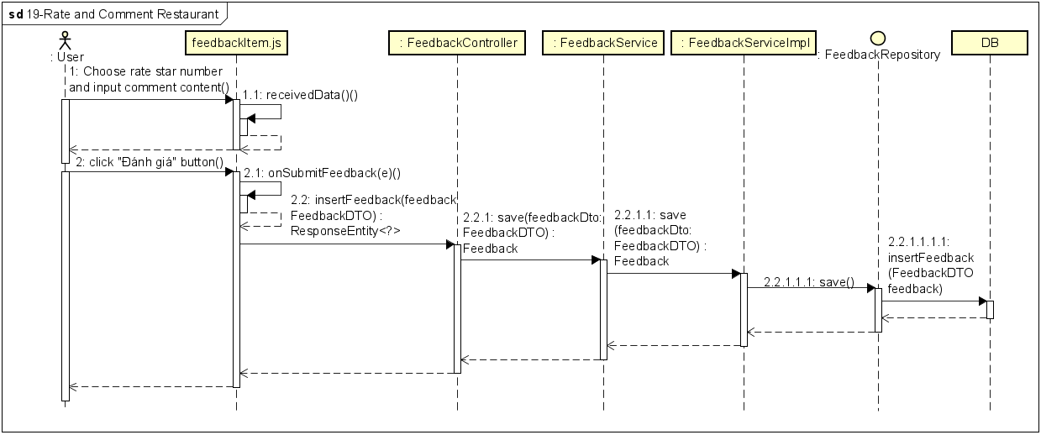

**Figure 4-64:** Rate And Comment Restaurant - Sequence Diagram

#### 4.2.10 UC-20 Report Restaurant

##### 4.2.10.1 Screen design

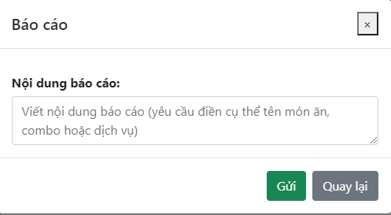

**Figure 4-65:** Report Restaurant

|  |  |  |  |  |  |
| --- | --- | --- | --- | --- | --- |
| **#** | **Object/Control Name** | **Type** | **Required** | **Length** | **Description** |
| **Main** | | | | | |
| 1 | Title Báo cáo | <ModalHeader >Báo cáo</ModalHeader> |  |  |  |
|  | Nội dung báo cáo | <Label ><b>Nội dung báo cáo: </b></Label> |  |  |  |
| 2 | Viết nội dung báo cáo | <Input type="textarea" placeholder="Viết nội dung báo cáo (yêu cầu điền cụ thể tên món ăn, combo hoặc dịch vụ) " /> | Yes | 250 | Enter report content |
| 3 | Gửi | <Button >Gửi</Button>{' '} |  |  | Button to send report |
| 4 | Quay lại | <Button >Quay lại</Button> |  |  | Button to back Restaurant Detail screen |

**Table 4-72:** Report Restaurant Screen Definition

##### 4.2.10.2 Class diagram

###### **4.2.10.2.1 Back End**



**Figure 4-66:** Report Restaurant - Back-end Class Diagram

###### **4.2.10.2.2 Front End**



**Figure 4-67:** Report Restaurant - Back-end Class Diagram

##### 4.2.10.3 Class Description

Reference to 4.1.1.3 & 4.1.2.3

##### 4.2.10.4 Sequence Diagram

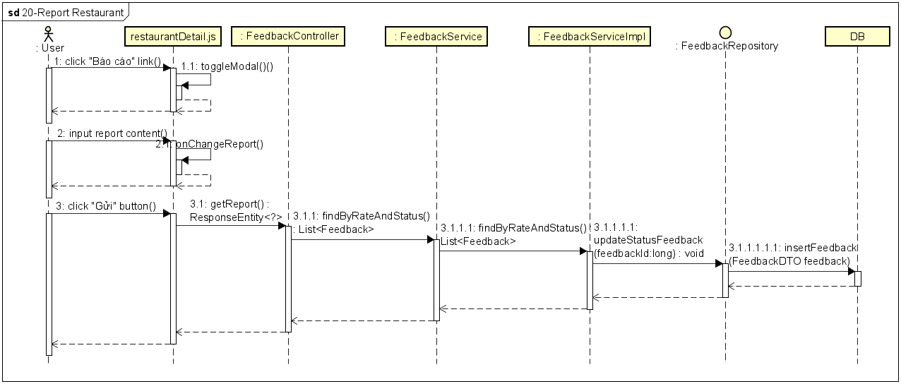

**Figure 4-68:** Report Restaurant - Sequence Diagram

#### 4.2.11 UC-21 Create Feast Order

##### 4.2.11.1 Screen design

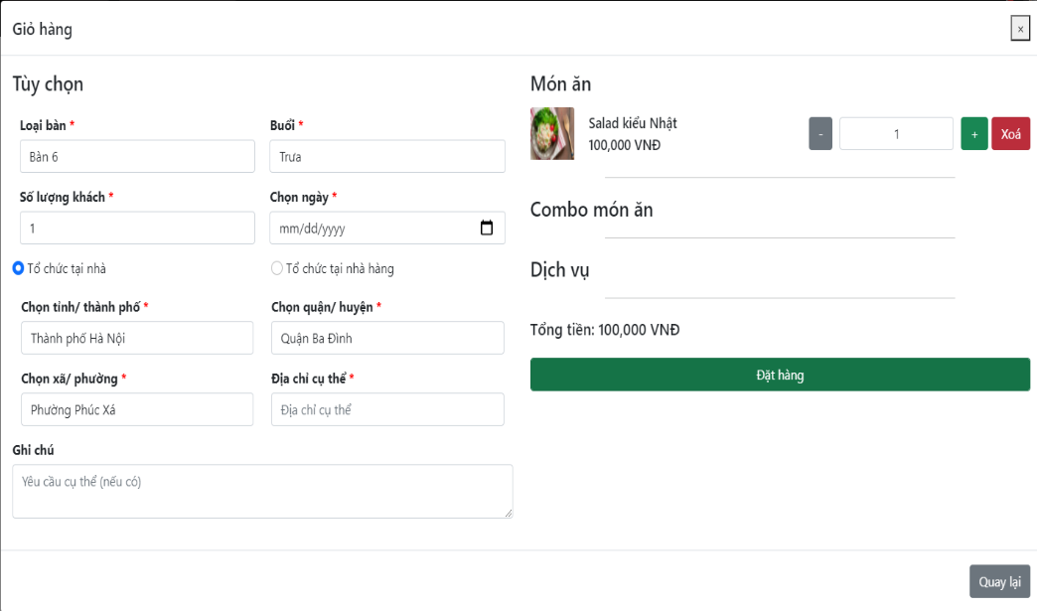

**Figure 4-69:** Create Feast Order

|  |  |  |  |  |  |
| --- | --- | --- | --- | --- | --- |
| **#** | **Object/Control Name** | **Type** | **Required** | **Length** | **Description** |
| **Main** | | | | | |
| 1 | Title Giỏ hàng | <ModalHeader >Giỏ hàng</ModalHeader> |  |  |  |
| 2 | Close | <span >×</span> |  |  | Button to close Cart screen |
| 3 | Loại bàn | <Input type="select" required="required" > <option value={6}>Bàn 6</option> <option value={8}>Bàn 8</option> </Input> | Yes |  | Select table type  Value: Bàn 6 – Type 6 people, Bàn 8 – Type 8 people |
| 4 | Buổi | <Input type="select" required="required"> | Yes |  | Select session to organize feast  Value: Trưa – noon, Tối – evening |
| 5 | Số lượng khách | <Input type="number" required="required"/> | Yes | 10 | Enter the number of guests |
| 6 | Chọn ngày | <Input type="date" required="required" /> | Yes |  | Select feast date |
| 7 | Tổ chức tại nhà | <span >Tổ chức tại nhà</span> |  |  | Select type “Event at home” service of restaurant |
| 8 | Tổ chức tại nhà hàng | <span >Tổ chức tại nhà hàng</span> |  |  | Select type “Event at restaurant” service of restaurant |
| 9 | Chọn tỉnh/ thành phố | <Input type="select"> | Yes |  | Select province/city |
| 10 | Chọn quận/ huyện | <Input type="select"> | Yes |  | Select district |
| 11 | Chọn xã/ phường | <Input type="select"> | Yes |  | Select commune / ward |
| 12 | Địa chỉ cụ thể | <Input type="text" placeholder="Địa chỉ cụ thể" required="required" /> | Yes |  | Enter specific address |
| 13 | Ghi chú | <Input type="textarea" placeholder="Yêu cầu cụ thể (nếu có)" /> | No | 2000 | Note for restaurant |
| 14 | Title Món ăn | <h4>Món ăn</h4> |  |  |  |
| 15 | Category Title | <h4>Combo món ăn</h4> |  |  | Category of items  Value: Thực đơn – Menu, Combo món ăn – Combo, Dịch vụ - Service |
| 16 | Item Name | <CartServiceItem /> |  |  | Name of selected item |
| 17 | Item Price | <CartServiceItem /> |  |  | Sale price of selected item |
| 18 | Subtract item | <button type="button" >-</button> |  |  | Subtraction item |
| 19 | Item Quantity | <input min="0" type="number" value="1"> |  | 5 | Quantity of selected item |
| 20 | Add item | <button type="button" >+</button> |  |  | Addition item |
| 21 | Xóa | <button type="button" >Xoá</button> |  |  | Button to remove item |
| 22 | Tổng tiền | <div >Tổng tiền: </div> |  |  | Total amount of feast order |
| 23 | Đặt hàng | <input type="submit" value="Đặt hàng"> |  |  | Button to book feast order |
| 24 | Quay lại | <button type="button" >Quay lại</button> |  |  | Button to back Restaurant Detail screen |

**Table 4-73:** Create Feast Order Screen Definition

##### 4.2.11.2 Class diagram

###### **4.2.11.2.1 Back End**

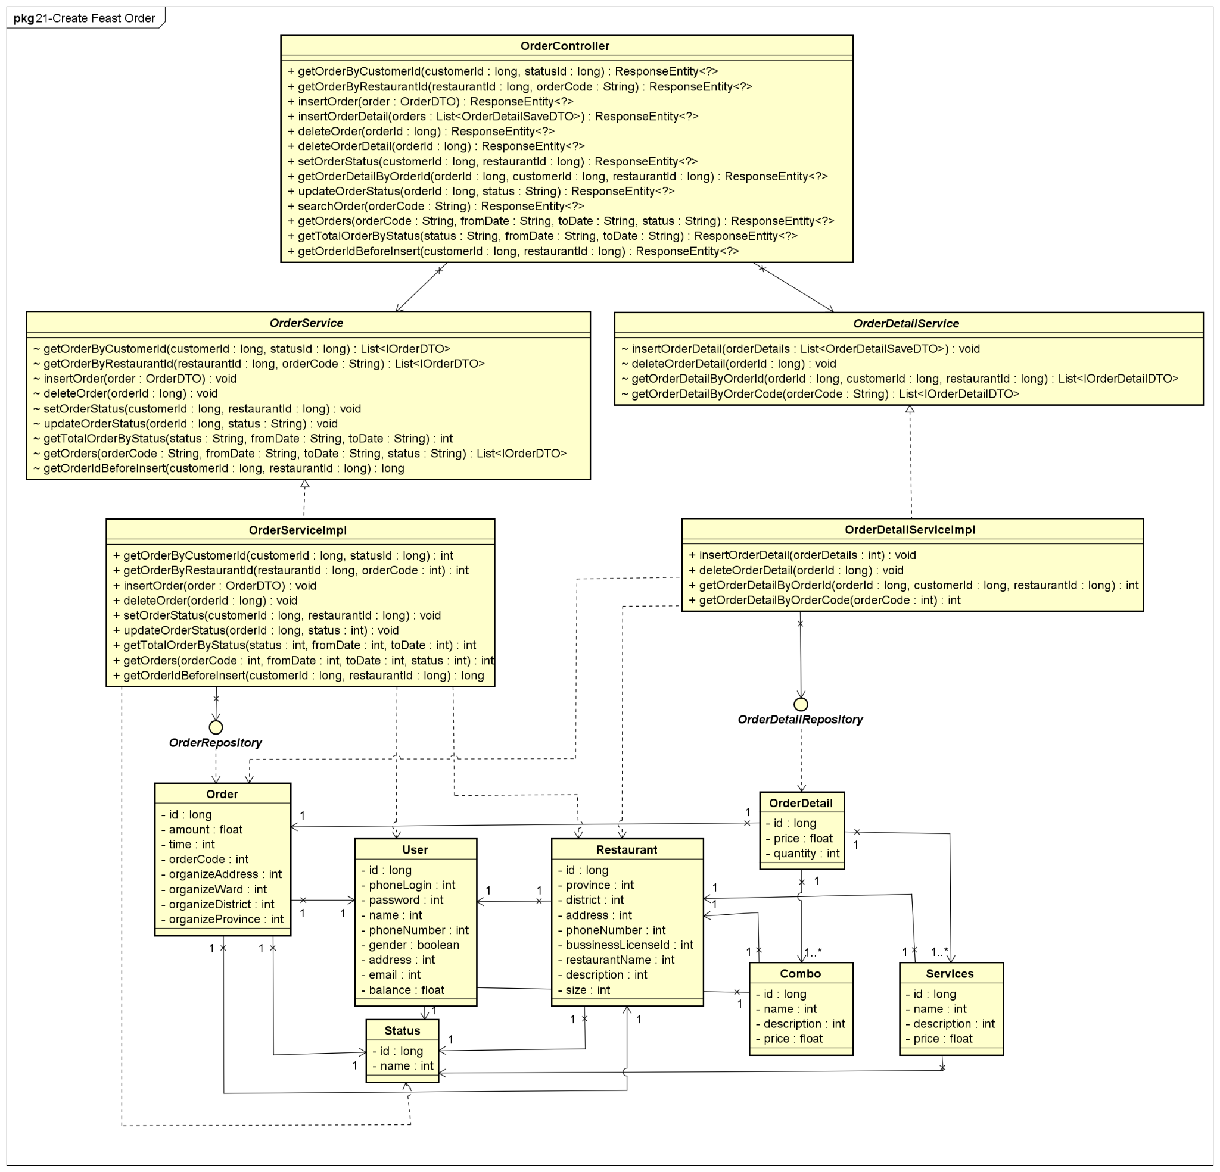

**Figure 4-70:** Create Feast Order - Back-end Class Diagram

###### **4.2.11.2.2 Front End**

##### 

**Figure 4-71:** Create Feast Order - Front-end Class Diagram

##### 4.2.11.3 Class Description

###### **4.2.11.3.1 Cart**

|  |  |  |  |  |
| --- | --- | --- | --- | --- |
| **Class** | **Cart** | | | |
| **Description** | Define attributes and methods for these attributes in cart front-end class | | | |
| **Base Class** |  | | | |
| **Constructor** |  | | | |
| **Prototype** |  | | | |
| **Source File** | ofbs-master\front-end\src\components\restaurant\cart.js | | | |
| **Namespace** |  | | | |
| **Attributes** | **Name** | **Type** | **Description** | |
|  |  |  | |
| **Methods** | **Name** | **Input** | **Output** | **Description** |
| toggle |  |  | use to set modal status is true and set customer quantity value |
| toggleConfirm |  |  | use to get restaurant id from API |
| onchangeTypeTable | e |  | use to set table type value |
| calNumTable | numCustomer  typeTable |  | use to get number of tables |
| onChangeCustomerQuantity | e |  | use to set customer quantity value |
| onchangePeriod | e |  | use to set period value |
| onChangeTime | e |  | use to set time value |
| onChangeNote | e |  | use to set note value |
| onChangeOrganizeAddress | e |  | use to set organize address value |
| onProvinceClick | event |  | use to set province information |
| onDistrictClick | event |  | use to set district information |
| onWardClick | event |  | use to set ward information |
| validateCart |  | true/false | use to validate in cart |
| payment |  |  | use to call API to handle payment |
| onSubmitCart |  |  | use to submit handle a cart |

**Table 4-74:** Cart class description

###### **4.2.11.3.2 OrderController**

|  |  |  |  |  |
| --- | --- | --- | --- | --- |
| **Class** | **OrderController** | | | |
| **Description** | Responsible for controlling the way that a user interacts with order | | | |
| **Base Class** |  | | | |
| **Constructor** |  | | | |
| **Prototype** |  | | | |
| **Source File** | ofbs-master\back-end\src\main\java\edu\fpt\ofbs\controllers\OrderController.java | | | |
| **Namespace** |  | | | |
| **Attributes** | **Name** | **Type** | **Description** | |
|  |  |  | |
| **Methods** | **Name** | **Input** | **Output** | **Description** |
| getOrderByCustomerId | customerId  statusId | ResponseEntity | use to get list order of a customer by customer-id |
| getOrderByRestaurantId | restaurantId  orderCode | ResponseEntity | use to get list order of a restaurant by restaurant id |
| insertOrder | order | ResponseEntity | use to insert an order |
| insertOrderDetail | orders | ResponseEntity | use to insert an order detail |
| deleteOrder | orderId | ResponseEntity | use to delete an order |
| deleteOrderDetail | orderId | ResponseEntity | use to delete an order detail |
| setOrderStatus | customerId  restaurantId | ResponseEntity | use to set status of an order |
| getOrderDetailByOrderId | orderId  customerId  restaurantId | ResponseEntity | use to get order detail of a order by order id |
| updateOrderStatus | orderId  status | ResponseEntity | use to update status of an order |
| searchOrder | orderCode | ResponseEntity | use to get order by order code |
| getOrders | orderCode  fromDate  toDate  status | ResponseEntity | use to get the list orders |
| getTotalOrderByStatus | status  fromDate  toDate | ResponseEntity | use to get the list order by status |
| getOrderIdBeforeInsert | customerId  restaurantId | ResponseEntity | use to get order before insert |

**Table 4-75:** OrderController class description

###### **4.2.11.3.3 OrderServiceImpl**

|  |  |  |  |  |
| --- | --- | --- | --- | --- |
| **Class** | **OrderServiceImpl** | | | |
| **Description** | provide functionality to handle user requests with order | | | |
| **Base Class** | OrderService | | | |
| **Constructor** |  | | | |
| **Prototype** |  | | | |
| **Source File** | ofbs-master\back-end\src\main\java\edu\fpt\ofbs\service\impl\OrderServiceImpl.java | | | |
| **Namespace** |  | | | |
| **Attributes** | **Name** | **Type** | **Description** | |
|  |  |  | |
| **Methods** | **Name** | **Input** | **Output** | **Description** |
| getOrderByCustomerId | customerId  statusId | List<IOrderDTO> | use to get list order by customer id |
| getOrderByRestaurantId | restaurantId  orderCode | List<IOrderDTO> | use to get list order by restaurant id |
| insertOrder | order |  | use to insert an order |
| deleteOrder | orderId |  | use to delete order |
| setOrderStatus | customerId  restaurantId |  | use to set order status |
| updateOrderStatus | orderId  status |  | use to update order status |
| getTotalOrderByStatus | status  fromDate  toDate | int | use to get total orders by status |
| getOrders | orderCode  fromDate  toDate  status | List<IOrderDTO> | use to get list orders |
| getOrderIdBeforeInsert | customerId  restaurantId | long | use to get list orders |

**Table 4-76:** OrderServiceImpl class description

###### **4.2.11.3.4 OrderRepository**

|  |  |  |  |  |
| --- | --- | --- | --- | --- |
| **Class** | **OrderRepository** | | | |
| **Description** | manipulate the order table in the database. | | | |
| **Base Class** | JpaRepository<Order, Long> | | | |
| **Constructor** |  | | | |
| **Prototype** |  | | | |
| **Source File** | ofbs-master\back-end\src\main\java\edu\fpt\ofbs\repositories\OrderRepository.java | | | |
| **Namespace** |  | | | |
| **Attributes** | **Name** | **Type** | **Description** | |
|  |  |  | |
| **Methods** | **Name** | **Input** | **Output** | **Description** |
| getOrderByCustomerId | customerId  statusId | List<IOrderDTO> | use to get list order by customer id |
| getOrderByRestaurantId | restaurantId  orderCode | List<IOrderDTO> | use to get list order by restaurant id |
| insertOrder | order |  | use to insert an order |
| setOrderStatus | customerId  restaurantId |  | use to set order status |
| updateOrderStatus | orderId  status |  | use to update order status |
| getTotalOrderByStatus | status  fromDate  toDate | int | use to get total orders by status |
| getOrders | orderCode  fromDate  toDate  status | List<IOrderDTO> | use to get list orders |
| getOrderIdBeforeInsert | customerId  restaurantId | long | use to get list orders |

**Table 4-77:** OrderRepository class description

###### **4.2.11.3.5 OrderDetailServiceImpl**

|  |  |  |  |  |
| --- | --- | --- | --- | --- |
| **Class** | **OrderDetailServiceImpl** | | | |
| **Description** | provide functionality to handle user requests with order detail | | | |
| **Base Class** | OrderDetailService | | | |
| **Constructor** |  | | | |
| **Prototype** |  | | | |
| **Source File** | ofbs-master\back-end\src\main\java\edu\fpt\ofbs\service\impl\OrderDetailServiceImpl.java | | | |
| **Namespace** |  | | | |
| **Attributes** | **Name** | **Type** | **Description** | |
|  |  |  | |
| **Methods** | **Name** | **Input** | **Output** | **Description** |
| insertOrderDetail | orderDetails |  | use to insert order detail |
| deleteOrderDetail | orderId |  | use to delete order detail |
| getOrderDetailByOrderId | orderId  customerId  restaurantId | List<IOrderDetailDTO> | use to get order detail of an order by id |
| getOrderDetailByOrderCode | orderCode | List<IOrderDetailDTO> | use to get order detail of an order by code |

**Table 4-78:** OrderDetailServiceImpl class description

###### **4.2.11.3.6 OrderDetailRepository**

|  |  |  |  |  |
| --- | --- | --- | --- | --- |
| **Class** | **OrderDetailRepository** | | | |
| **Description** | manipulate the order detail table in the database. | | | |
| **Base Class** | JpaRepository<OrderDetail, Long> | | | |
| **Constructor** |  | | | |
| **Prototype** |  | | | |
| **Source File** | ofbs-master\back-end\src\main\java\edu\fpt\ofbs\repositories\OrderDetailRepository.java | | | |
| **Namespace** |  | | | |
| **Attributes** | **Name** | **Type** | **Description** | |
|  |  |  | |
| **Methods** | **Name** | **Input** | **Output** | **Description** |
| insertOrderDetail | quantity  dishId  comboId  serviceId  customerId  restaurantId |  | use to insert an order detail |
| deleteOrderDetail | orderId |  | use to delete order detail |
| getOrderDetailByOrderId | orderId  customerId  restaurantId | List<IOrderDetailDTO> | use to get order detail by order id |
| getOrderDetailByOrderCode | orderCode | List<IOrderDetailDTO> | use to get order detail by order code |

**Table 4-79:** OrderDetailRepository class description

###### **4.2.11.3.7 Order**

|  |  |  |  |  |
| --- | --- | --- | --- | --- |
| **Class** | **Order** | | | |
| **Description** | Define attributes for Order entity and set/get method for these attributes | | | |
| **Base Class** |  | | | |
| **Constructor** |  | | | |
| **Prototype** |  | | | |
| **Source File** | ofbs-master\back-end\src\main\java\edu\fpt\ofbs\entities\Order.java | | | |
| **Namespace** |  | | | |
| **Attributes** | **Name** | **Type** | **Description** | |
| id | long | use to store order id | |
| amount | float | use to store amount order | |
| time | String | use to store time of order | |
| orderCode | String | use to store order code | |
| organizeAddress | String | use to store organize address | |
| organizeWard | String | use to store organize ward | |
| organizeDistrict | String | use to store organize district | |
| organizeProvince | String | use to store organize province | |
| **Methods** | **Name** | **Input** | **Output** | **Description** |
|  |  |  |  |

**Table 4-80:** Order class description

###### **4.2.11.3.8 OrderDetail**

|  |  |  |  |  |
| --- | --- | --- | --- | --- |
| **Class** | **OrderDetail** | | | |
| **Description** | Define attributes for OrderDetail entity and set/get method for these attributes | | | |
| **Base Class** |  | | | |
| **Constructor** |  | | | |
| **Prototype** |  | | | |
| **Source File** | ofbs-master\back-end\src\main\java\edu\fpt\ofbs\entities\OrderDetail.java | | | |
| **Namespace** |  | | | |
| **Attributes** | **Name** | **Type** | **Description** | |
| id | long | use to store order detail id | |
| price | float | use to store order detail price | |
| quantity | int | use to store order detail quantity | |
| **Methods** | **Name** | **Input** | **Output** | **Description** |
|  |  |  |  |

**Table 4-81:** OrderDetail class description

##### 4.2.11.4 Sequence Diagram

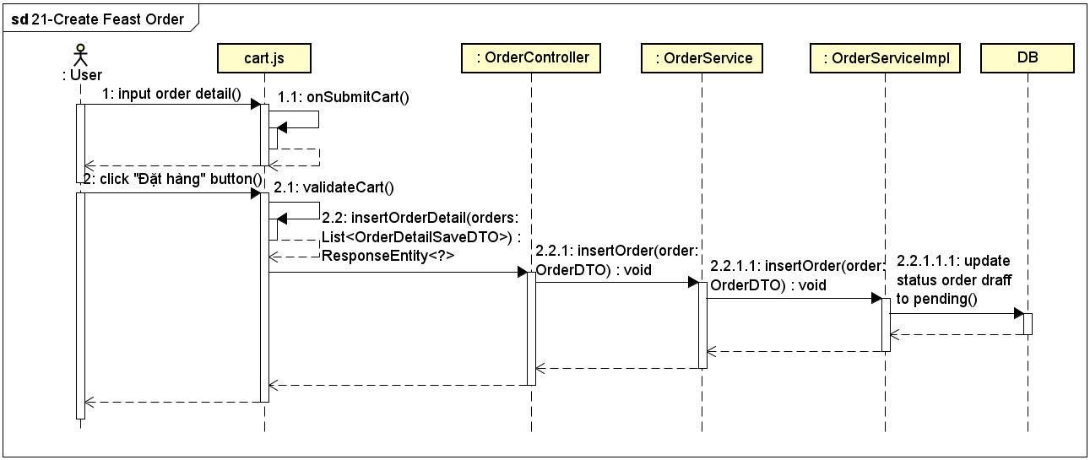

**Figure 4-72:** Create Feast Order - Sequence Diagram

#### 4.2.12 UC-22 View Order History

##### 4.2.12.1 Screen design

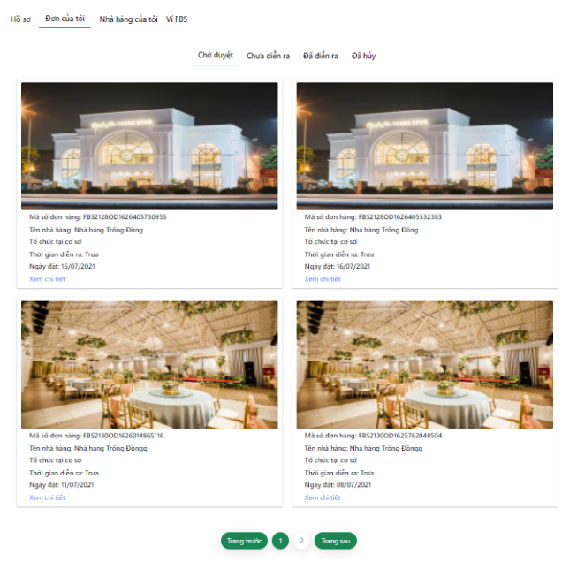

**Figure 4-73:** View order history

|  |  |  |  |  |  |
| --- | --- | --- | --- | --- | --- |
| **#** | **Object/Control Name** | **Type** | **Required** | **Length** | **Description** |
| **Sidebar** (same as User Profile screen) | | | | | |
| **Main** | | | | | |
| 1 | Status Of The Order | <a>Chờ duyệt</a> |  |  | Menu for the user to select the order status they want to see |
| 2 | Order Card | <div ></div> |  |  | Display some key information of order |
| 3 | Restaurant Image | <CardImg /> |  |  | Avatar of restaurant |
| 4 | Mã số đơn hàng | <div >Mã số đơn hàng: </div> |  |  | Order code |
| 5 | Tên nhà hàng | <div >Tên nhà hàng: </div> |  |  | Name of restaurant |
| 6 | Ngày đặt | <div >Ngày đặt:{formatDate(order.order_date)}</div> |  |  | Order date |
| 7 | Tiệc cưới tại nhà hàng/Tiệc cưới lưu động | <div >Tổ chức tại cơ sở</div> |  |  | Type of organization:  Value: Feast at restaurant / Feast at home |
| 8 | Thời gian diễn ra | <div >Thời gian diễn ra: </div> |  |  | Value: Trưa/ Tối |
| 9 | Xem chi tiết | <Link >Xem chi tiết</Link> |  |  | Button to view order detail |
| 10 | Order Pagination | Hyperlink |  |  | This hyperlink links to page of orders |

**Table 4-82:** View Order History Screen Definition

##### 4.2.12.2 Class diagram

###### **4.2.12.2.1 Back End**

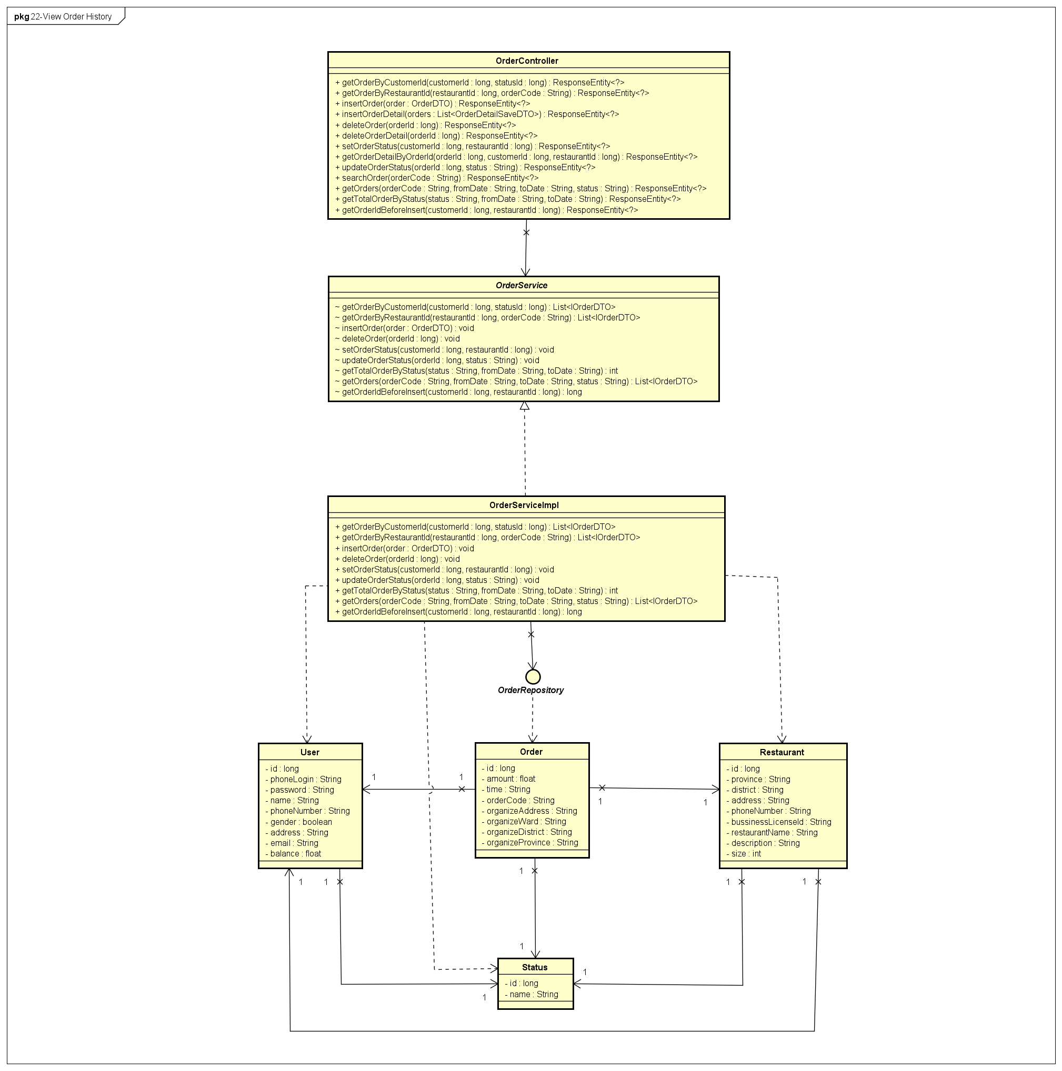

**Figure 4-74:** View order history - Back-end Class Diagram

###### **4.2.12.2.1 Front End**

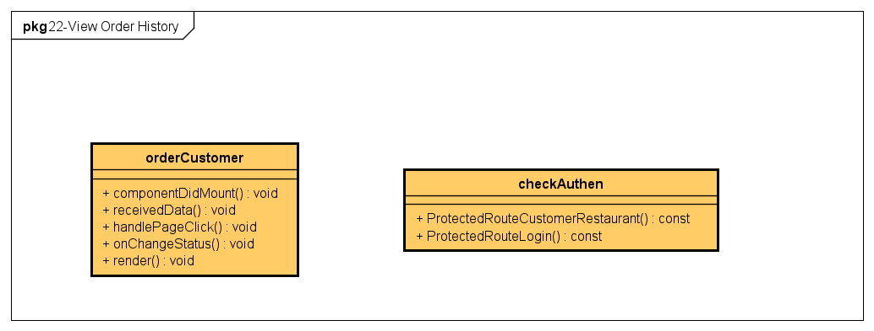

**Figure 4-75:** View order history - Back-end Class Diagram

##### 4.2.12.3 Class Description

###### **4.2.12.3.1 orderCustomer**

|  |  |  |  |  |
| --- | --- | --- | --- | --- |
| **Class** | **orderCustomer** | | | |
| **Description** | Define attributes and methods for these attributes in orderCustomer front-end class | | | |
| **Base Class** | Component | | | |
| **Constructor** |  | | | |
| **Prototype** |  | | | |
| **Source File** | ofbs-master\front-end\src\screens\user\orderCustomer.js | | | |
| **Namespace** |  | | | |
| **Attributes** | **Name** | **Type** | **Description** | |
|  |  |  | |
| **Methods** | **Name** | **Input** | **Output** | **Description** |
| componentDidMount |  |  | use to local store user id |
| receivedData |  |  | use to store order temp data received |
| handlePageClick | e |  | use to handle paging |
| onChangeStatus | status |  | use to set status value |
| render |  |  | render view |

**Table 4-83:** orderCustomer class description

##### 4.2.12.4 Sequence Diagram

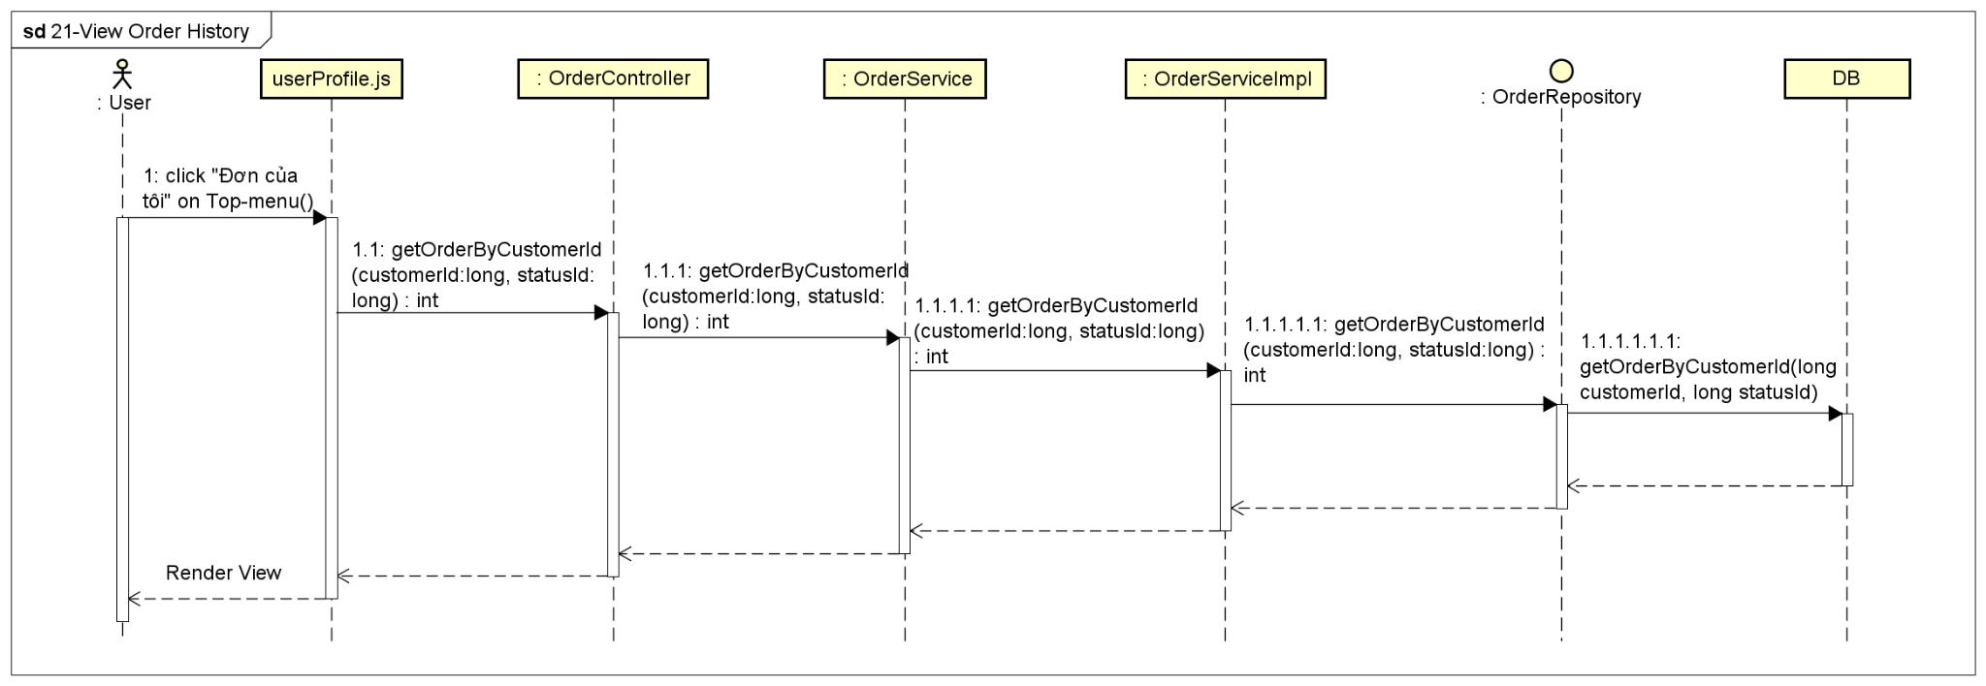

**Figure 4-76:** View order history - Sequence Diagram

#### 4.2.13 UC-23 View Order Detail

##### 4.2.13.1 Screen design

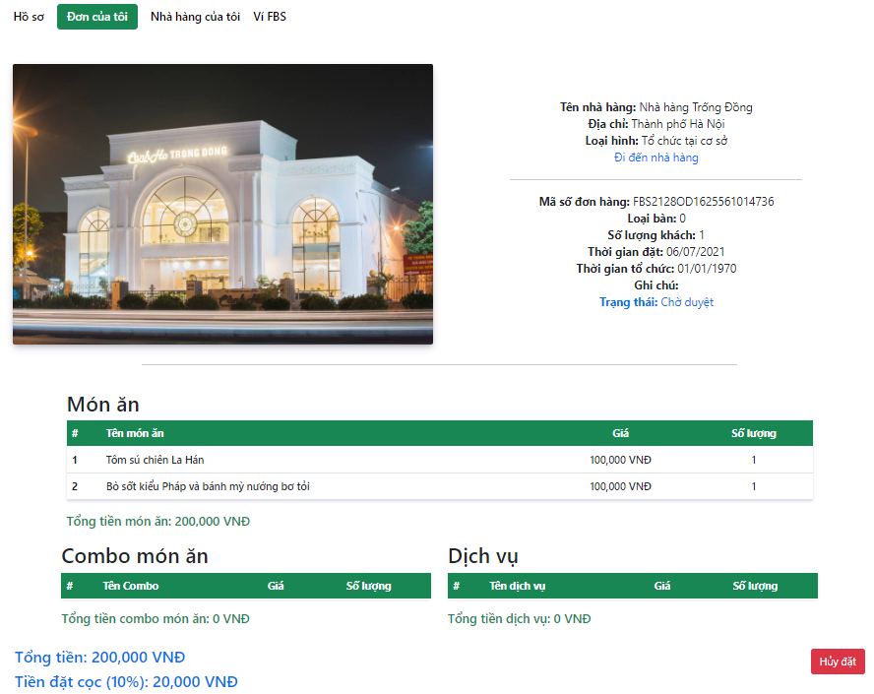

**Figure 4-77:** View Order Detail

|  |  |  |  |  |  |
| --- | --- | --- | --- | --- | --- |
| **#** | **Object/Control Name** | **Type** | **Required** | **Length** | **Description** |
| **Sidebar** (same as User Profile screen) | | | | | |
| **Main** | | | | | |
| 1 | Image | <CardImg /> |  |  | Restaurant avatar |
| 2 | Tên nhà hàng | <div ><b>Tên nhà hàng: </b></div> |  |  | Name of restaurant |
| 3 | Địa chỉ | <div ><b>Địa chỉ: </b></div> |  |  | Province of restaurant |
| 4 | Loại hình | <div ><b>Loại hình: </b></div> |  |  | Type of organization  Value: Tại cơ sở - Feast at restaurant, Lưu động - Feast at home |
| 5 | Đi đến nhà hàng | <Link >Đi đến nhà hàng</Link> |  |  | View restaurant detail screen |
| 6 | Mã số đơn hàng | <div ><b>Mã số đơn hàng: </b></div> |  |  | Order code |
| 7 | Loại bàn | <div ><b>Loại bàn: </b></div> |  |  | Type of table |
| 8 | Số lượng khách | <div ><b>Số lượng khách: </b></div> |  |  | Number of guests |
| 9 | Thời gian đặt | <div ><b>Thời gian đặt: </b></div> |  |  | Order date |
| 10 | Thời gian tổ chức | <b>Thời gian tổ chức: </b> |  |  | Feast session and date |
| 11 | Địa điểm tổ chức | <div ><b>Địa điểm tổ chức: </b></div> |  |  | Organization address |
| 12 | Ghi chú | <div ><b>Ghi chú: </b></div> |  |  | Note for restaurant |
| 13 | Trạng thái | <div ><b>Trạng thái: </b></div> |  |  | Status of order |
| 14 | Table Items | <Col></Col> |  |  | Include name, sale price, quantity of selected items |
| 15 | Tổng tiền item | <div >Tổng tiền món ăn: 0 VNĐ</div> |  |  | Total amount of each type: Menu, Combo, Service |
| 16 | Tổng tiền | <h5>Tổng tiền:</h5> |  |  | Total amount of order |
| 17 | Tiền đặt cọc | <h5 >Tiền đặt cọc (10%):</h5> |  |  | Deposits of order |
| 18 | Hủy đặt | <Button >Hủy đặt</Button> |  |  | Button to cancel the order |
| **Footer** (same as Search Restaurant screen) | | | | | |

**Table 4-84:** View Order Detail Screen Definition

##### 4.2.13.2 Class diagram

###### **4.2.13.2.1 Back End**

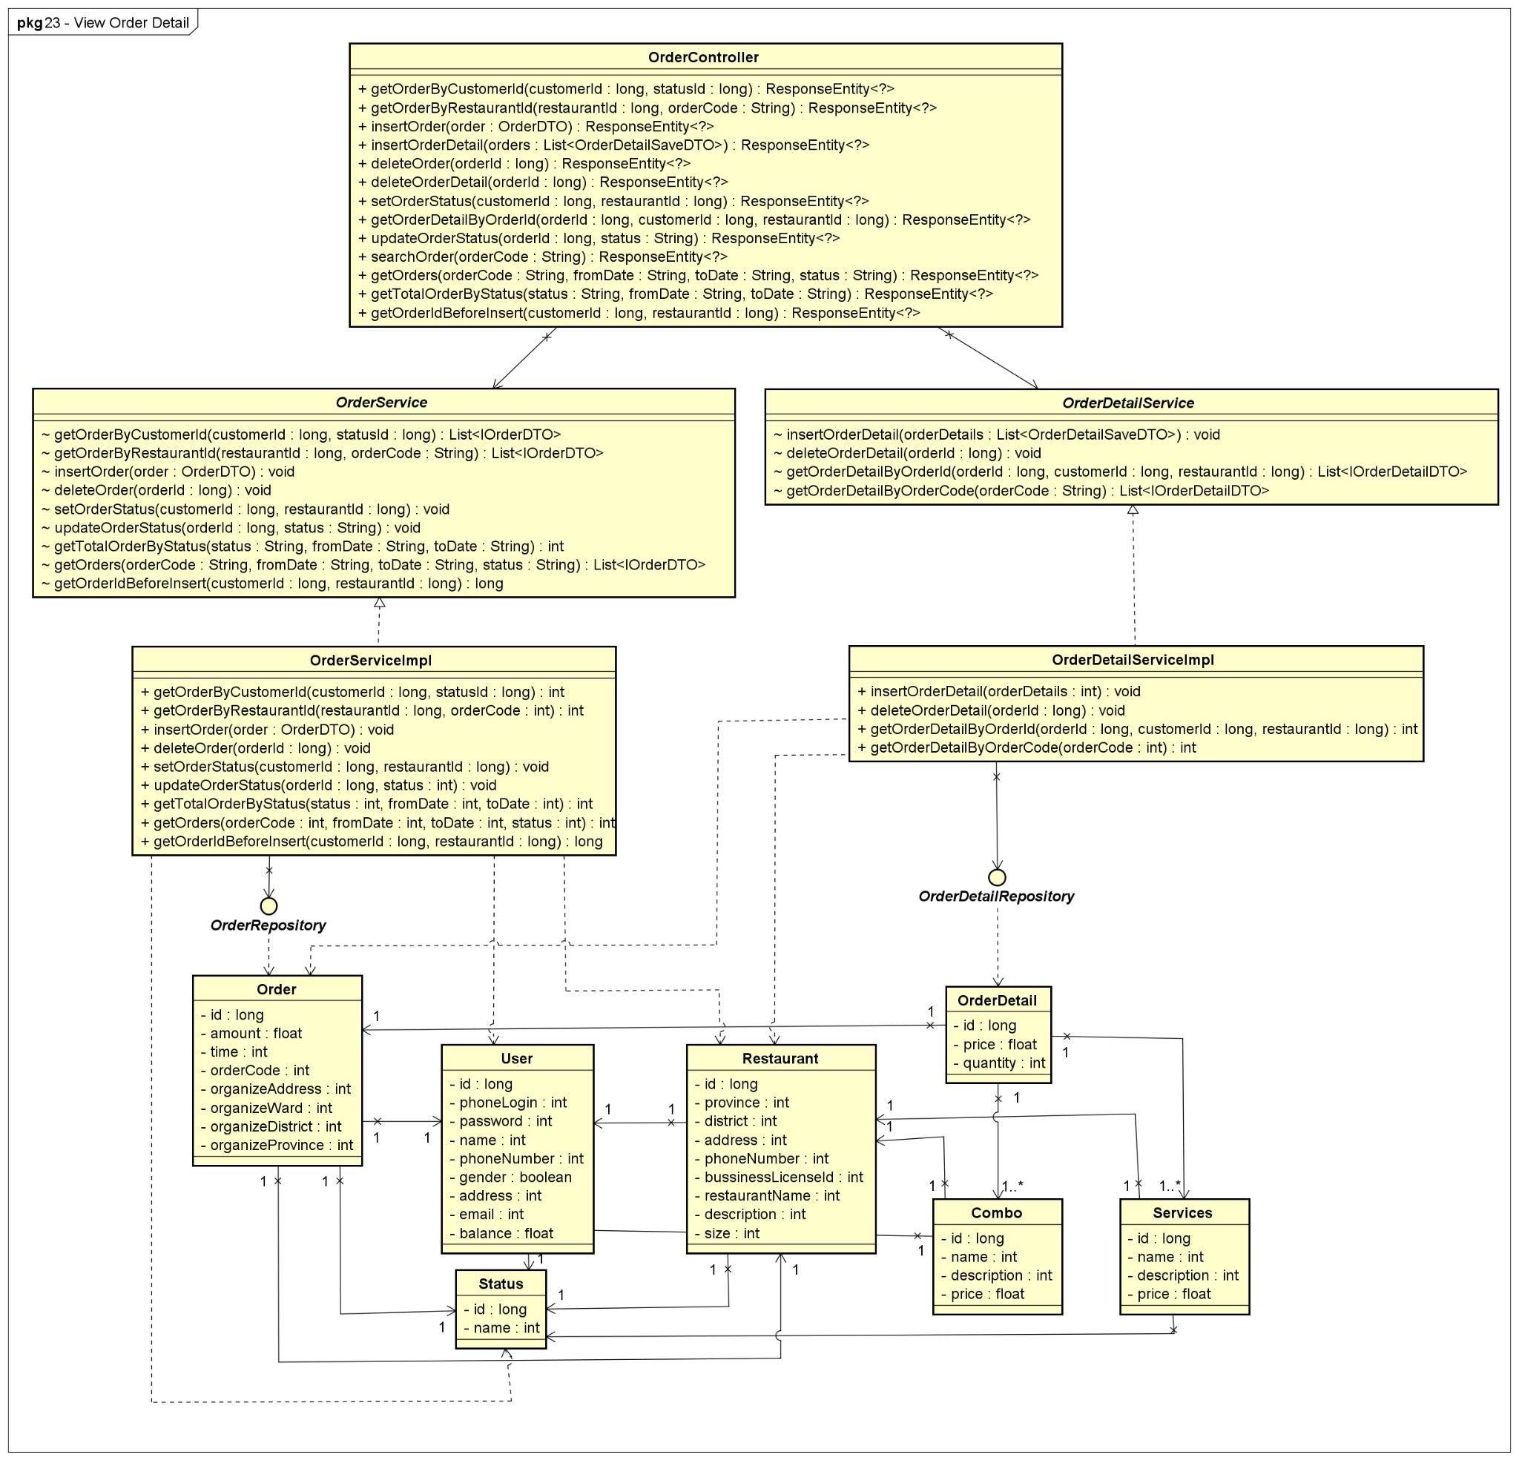

**Figure 4-78:** View Order Detail - Back-end Class Diagram

###### **4.2.13.2.2 Front End**

##### 

##### 

**Figure 4-79:** View Order Detail - Front-end Class Diagram

##### 4.2.13.3 Class Description

###### **4.2.13.3.1 orderCustomerDetail**

|  |  |  |  |  |
| --- | --- | --- | --- | --- |
| **Class** | **orderCustomerDetail** | | | |
| **Description** | Define attributes and methods for these attributes in orderCustomerDetail front-end class | | | |
| **Base Class** | Component | | | |
| **Constructor** | state  cancelOrder  toggle  onChangePassword | | | |
| **Prototype** |  | | | |
| **Source File** | ofbs-master\front-end\src\screens\user\orderCustomerDetail.js | | | |
| **Namespace** |  | | | |
| **Attributes** | **Name** | **Type** | **Description** | |
|  |  |  | |
| **Methods** | **Name** | **Input** | **Output** | **Description** |
| componentDidMount |  |  | order detail component did mount |
| toggle |  |  | use to set state modal |
| onChangePassword |  |  | use to set state password value |
| checkCancelOrder | organizeDate  status | percent | check percent when canceling the order |
| cancelOrder |  |  | use to cancel order |
| render |  |  | render view |

**Table 4-85:** orderCustomerDetail class description

##### 4.2.13.4 Sequence Diagram

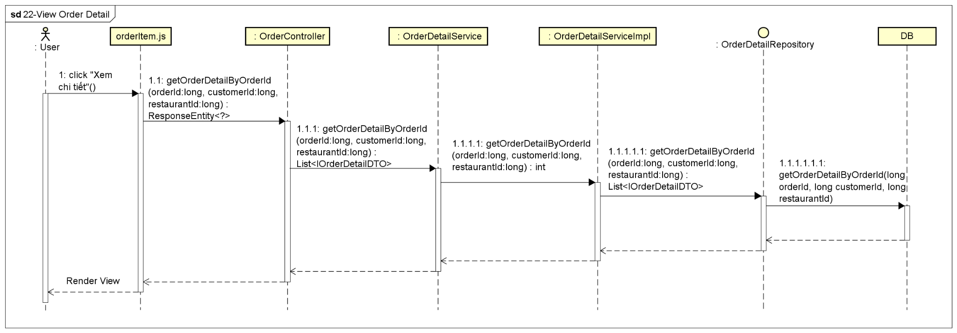

**Figure 4-80:** View Order Detail - Sequence Diagram

#### 4.2.14 UC-24 Cancel Feast Order

##### 4.2.14.1 Screen design

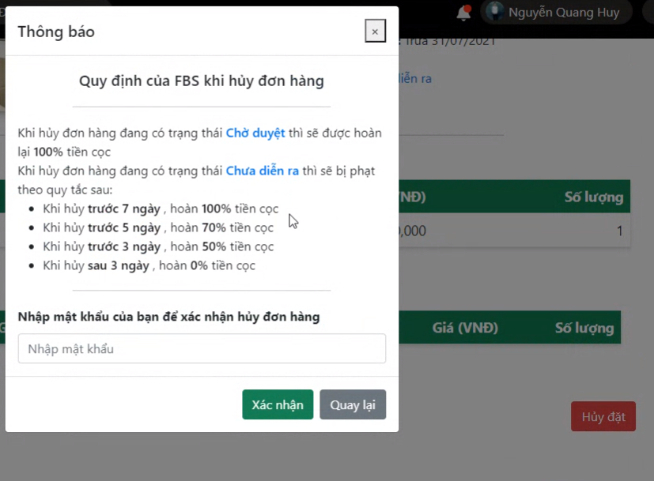

**Figure 4-81:** Cancel Feast Order

|  |  |  |  |  |  |
| --- | --- | --- | --- | --- | --- |
| **#** | **Object/Control Name** | **Type** | **Required** | **Length** | **Description** |
| **Confirm Dialog** | | | | | |
| 1 | Title Thông báo | <ModalHeader >Thông báo</ModalHeader> |  |  |  |
| 2 | Close | <span >×</span> |  |  | Button to close confirm dialog |
| 3 | Nhập mật khẩu của bạn để xác nhận hủy đơn hàng | <Input type="password" placeholder="Nhập mật khẩu" /> | Yes | 32 | Enter password |
| 4 | Xác nhận | <Button >Xác nhận</Button> |  |  | Button to accept to cancel the order |
| 5 | Quay lại | <Button >Quay lại</Button> |  |  | Button to back to User Profile Order Detail screen |

**Table 4-86:** Cancel Feast Order Screen Definition

##### 4.2.14.2 Class diagram

###### **4.2.14.2.1 Back End**

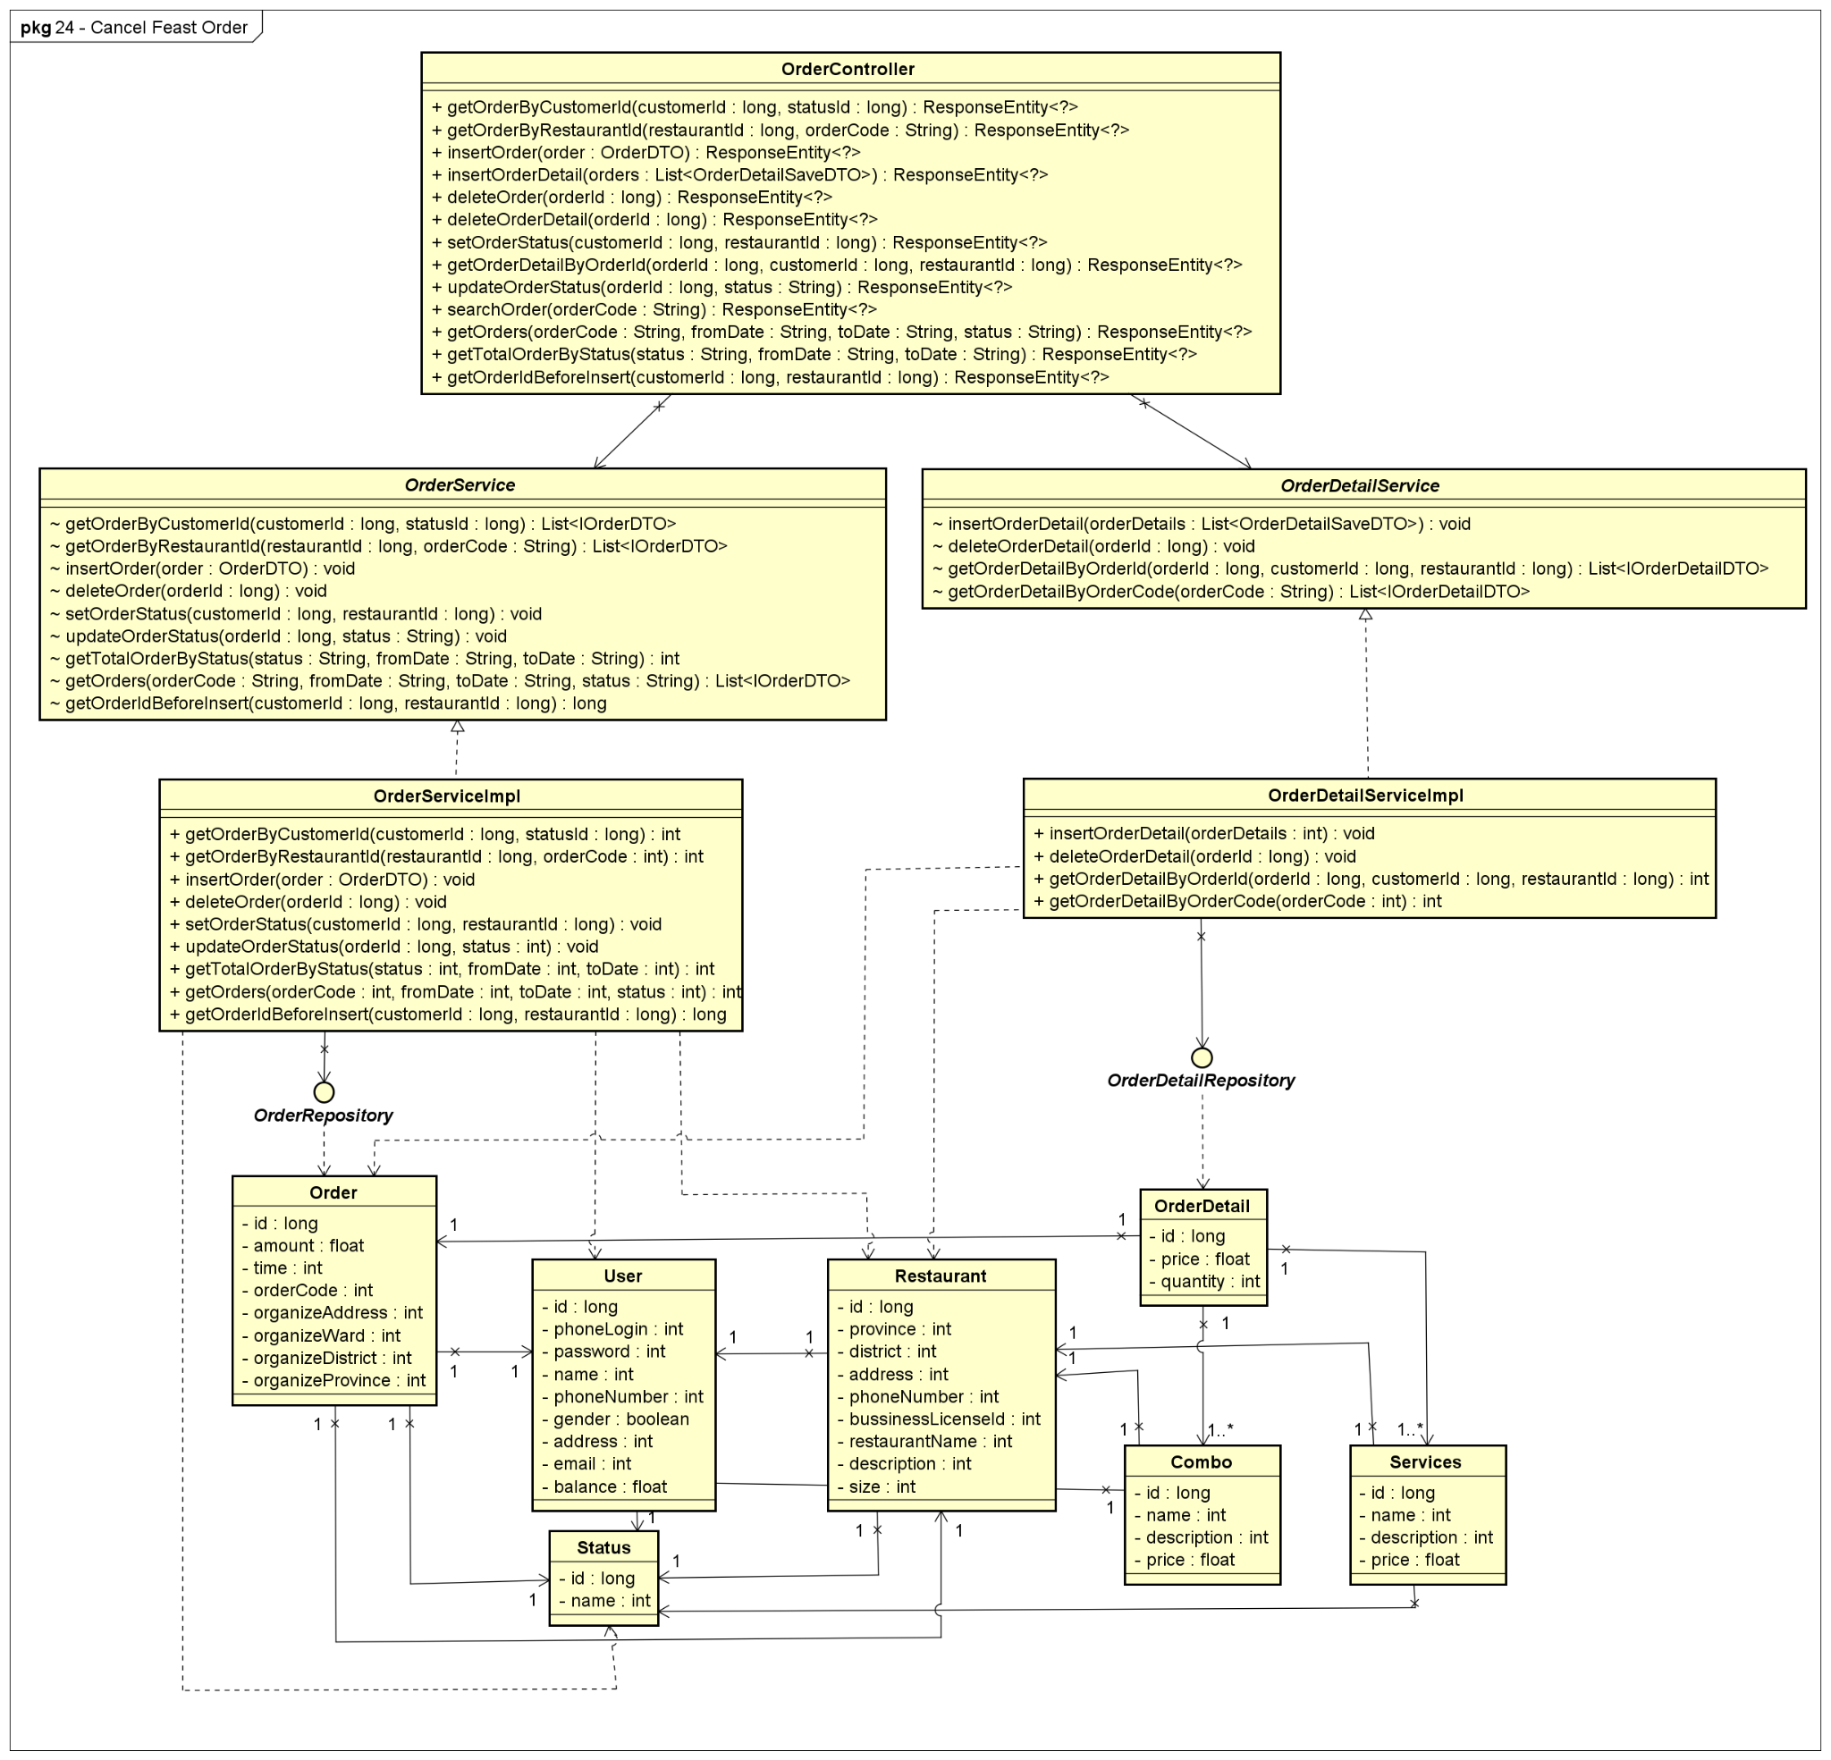

**Figure 4-82:** Cancel Feast Order - Back-end Class Diagram

###### **4.2.14.2.2 Front End**

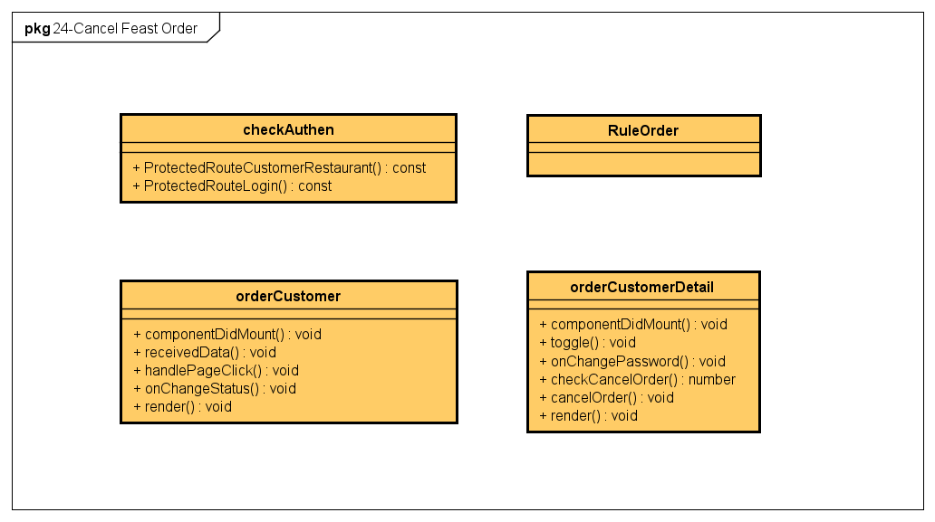

**Figure 4-83:** Cancel Feast Order - Front-end Class Diagram

##### 4.2.14.3 Class Description

###### **4.2.14.3.1 RuleOrder**

|  |  |  |  |  |
| --- | --- | --- | --- | --- |
| **Class** | **RuleOrder** | | | |
| **Description** | Define attributes and methods for these attributes in RuleOrder front-end class | | | |
| **Base Class** |  | | | |
| **Constructor** |  | | | |
| **Prototype** |  | | | |
| **Source File** | ofbs-master\front-end\src\components\common\ruleOrder.js | | | |
| **Namespace** |  | | | |
| **Attributes** | **Name** | **Type** | **Description** | |
|  |  |  | |
| **Methods** | **Name** | **Input** | **Output** | **Description** |
|  |  |  |  |

**Table 4-87:** RuleOrder Class Description

##### 4.2.14.4 Sequence Diagram

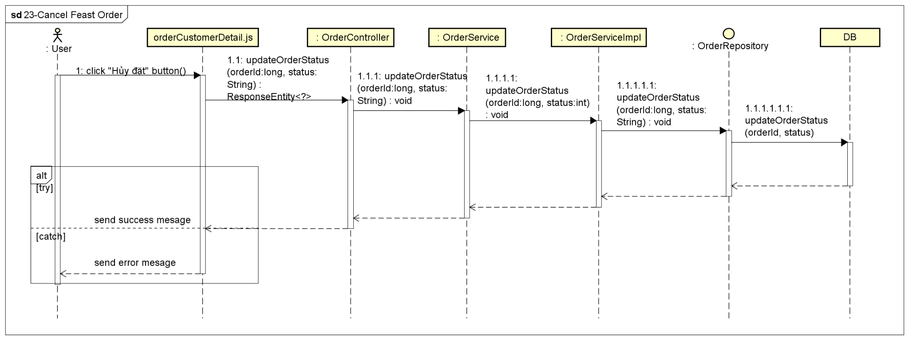

**Figure 4-84:** Cancel Feast Order - Sequence Diagram

#### 4.2.15 UC-25 Add Restaurant

##### 4.2.15.1 Screen design

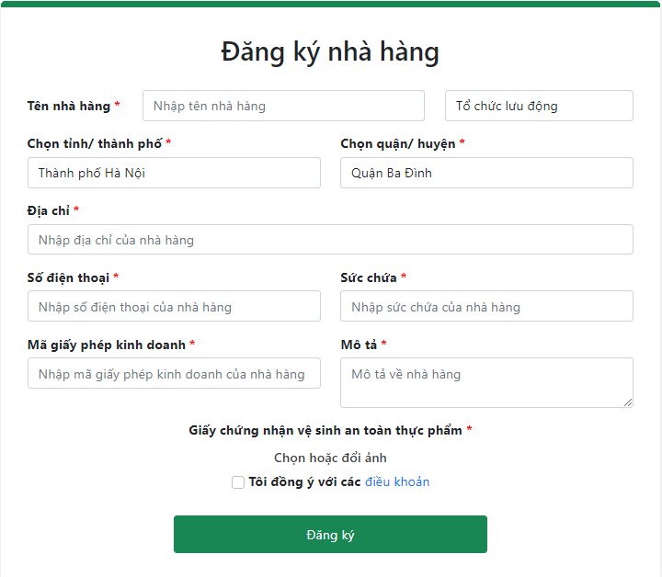

**Figure 4-85:** Add Restaurant

|  |  |  |  |  |  |
| --- | --- | --- | --- | --- | --- |
| **#** | **Object/Control Name** | **Type** | **Required** | **Length** | **Description** |
| **Main** | | | | | |
| 1 | Title Đăng ký nhà hàng | <h2 >Đăng ký nhà hàng</h2> |  |  |  |
| 2 | Tên nhà hàng | <Input type="text" placeholder="Nhập tên nhà hàng" /> | Yes | 100 | Name of restaurant |
| 3 | Loại hình | <Input type="select"> | Yes |  | Type of restaurant  Value: Tổ chức sự kiện lưu động - Organizing a roving feast, Tổ chức sự kiện tại cơ sở - Organizing a restaurant feast, Cả hai - Both |
| 4 | Tỉnh/Thành phố | <Input type="select"> | Yes |  | Province/City of restaurant |
| 5 | Quận/Huyện | <Input type="select" > | Yes |  | District of restaurant |
| 6 | Địa chỉ | <Input type="text" placeholder="Nhập địa chỉ của nhà hàng" /> | Yes | 100 | Specific address of the restaurant |
| 7 | Số điện thoại | <Input type="tel" placeholder="Nhập số điện thoại của nhà hàng" /> | Yes | 10 | Phone number to contact of restaurant |
| 8 | Sức chứa | <Input type="number" min={1} placeholder="Nhập sức chứa của nhà hàng" /> | Yes | 10 | The number of guests the restaurant can accommodate |
| 9 | Mã giấy phép kinh doanh | <Input type="text" placeholder="Nhập mã giấy phép kinh doanh của nhà hàng" /> | Yes | 100 | The business license number of the restaurant |
| 10 | Mô tả | <Input type="textarea" placeholder="Mô tả về nhà hàng" /> | Yes | 2000 | Detailed description about restaurant |
| 11 | Giấy chứng nhận vệ sinh an toàn thực phẩm | <ImageUploading > | Yes |  | Button to open popup to select Images of food hygiene and safety for catering of the restaurant |
| 12 | Tôi đồng ý với các điều khoản | <Input type="checkbox" /> | Yes |  | Checkbox to accept with terms of system |
| 13 | điều khoản | <a target="_blank" href="https://drive.google.com/file/d/1cDyuko1YEeiRQ5ui5D-rBMZrjkRsUcpE/view?usp=sharing" rel="noreferrer">điều khoản</a> |  |  | Link to Terms of system |
| 14 | Đăng ký | <button type="button" >Đăng ký</button> |  |  | Button to add a new restaurant |

**Table 4-88:** Add Restaurant Screen Definition

##### 4.2.15.2 Class diagram

###### **4.2.15.2.1 Back End**

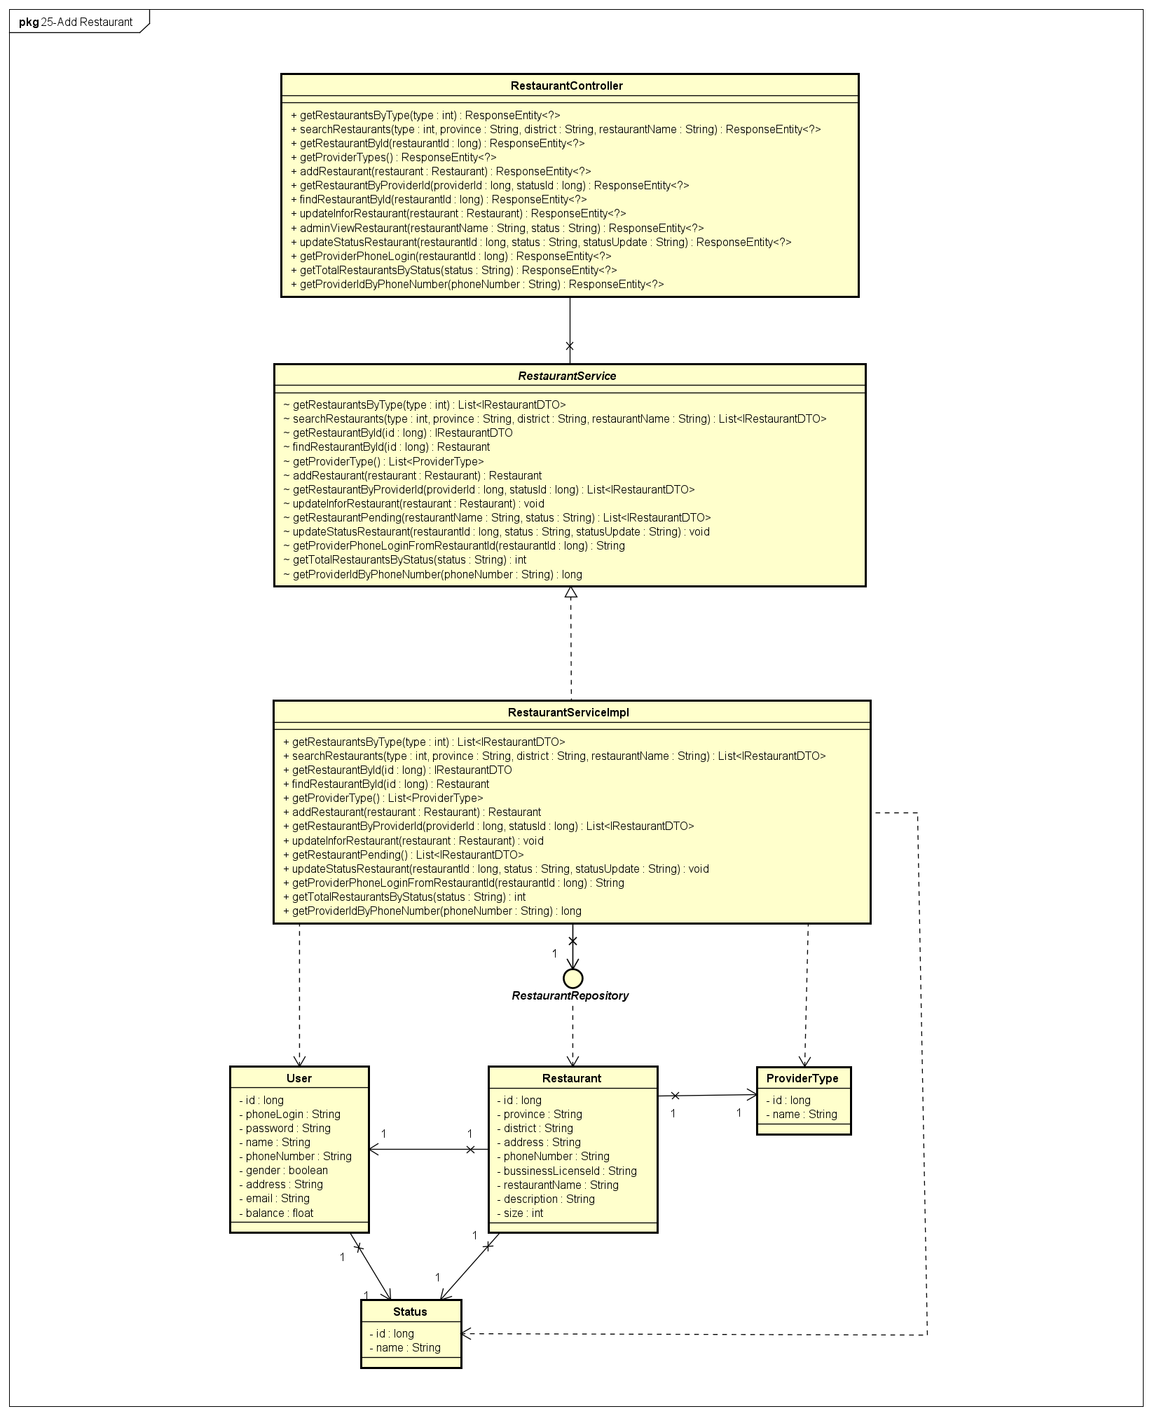

**Figure 4-86:** Add Restaurant - Back-end Class Diagram

###### **4.2.15.2.2 Front End**

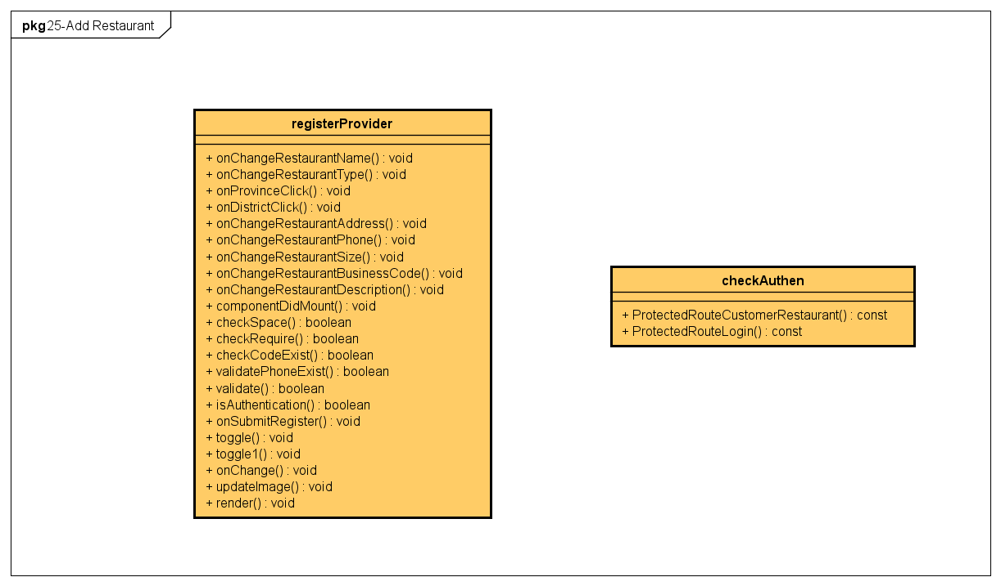

**Figure 4-87:** Add Restaurant - Front-end Class Diagram

##### 4.2.15.3 Class Description

###### **4.2.15.3.1 registerProvider**

|  |  |  |  |  |
| --- | --- | --- | --- | --- |
| **Class** | **registerProvider** | | | |
| **Description** | Define attributes and methods for these attributes in registerProvider front-end class | | | |
| **Base Class** | Component | | | |
| **Constructor** | state  onProvinceClick  onDistrictClick  onChangeRestaurantName  onChangeRestaurantType  onChangeRestaurantAddress  onChangeRestaurantPhone  onChangeRestaurantSize  onChangeRestaurantBusinessCode  onChangeRestaurantDescription  onSubmitRegister  toggle  toggle1  onChange  updateImage  validate  checkRequire  checkCodeExist  validatePhoneExist | | | |
| **Prototype** |  | | | |
| **Source File** | ofbs-master\front-end\src\screens\provider\registerProvider.js | | | |
| **Namespace** |  | | | |
| **Attributes** | **Name** | **Type** | **Description** | |
|  |  |  | |
| **Methods** | **Name** | **Input** | **Output** | **Description** |
| onChangeRestaurantName | e |  | use to set restaurant name value |
| onChangeRestaurantType |  |  | use to set restaurant type value |
| onProvinceClick | event |  | use to set province information |
| onDistrictClick | event |  | use to set district information |
| onChangeRestaurantAddress | e |  | use to set restaurant address |
| onChangeRestaurantPhone | e |  | use to set restaurant phone value |
| onChangeRestaurantSize | e |  | use to set restaurant size value |
| onChangeRestaurantBusinessCode | e |  | use to set restaurant Business Code value |
| onChangeRestaurantDescription | e |  | use to use to set restaurant Description value |
| componentDidMount |  |  | use to call API to get restaurant data |
| checkSpace | text | true/false | use to check space |
| checkRequire |  | true/false | use to check require of restaurant info |
| checkCodeExist |  | true/false | use to check restaurant code exist |
| validatePhoneExist |  | true/false | use to check restaurant phone exist |
| validate |  | true/false | use to validate restaurant info |
| isAuthentication |  | true/false | use to check current user |
| onSubmitRegister | e |  | use to submit register |
| toggle |  |  | use to set state modal |
| toggle1 |  |  | use to set state modal1 |
| onChange |  |  | use to set state for image list |
| updateImage |  |  | use to update image |
| render |  |  | render view |

**Table 4-89:** registerProvider class description

##### 4.2.15.4 Sequence Diagram

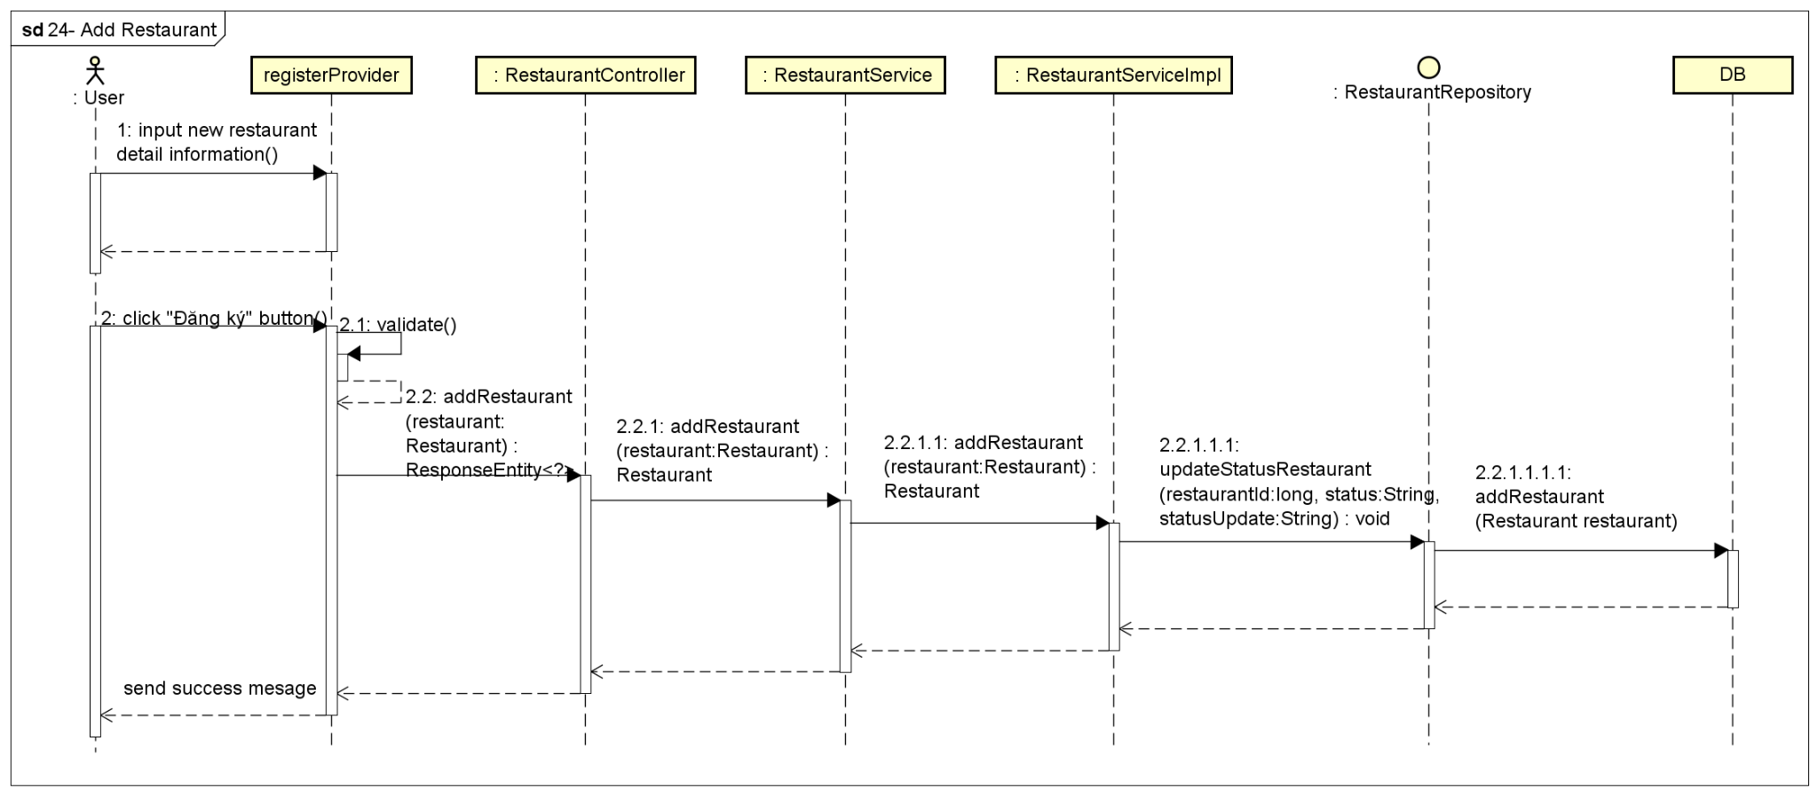

**Figure 4-88:** Add Restaurant - Sequence Diagram

#### 4.2.16 UC-26 View Notifications

##### 4.2.16.1 Screen design

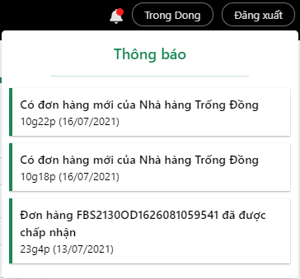

**Figure 4-89:** View Notifications

|  |  |  |  |  |  |
| --- | --- | --- | --- | --- | --- |
| **#** | **Object/Control Name** | **Type** | **Required** | **Length** | **Description** |
| **Notification** | | | | | |
| 1 | Title Thông báo | <h5 >Thông báo</h5> |  |  |  |
| 2 | Notifications List | <div ></div> |  |  | List of notification |
| 3 | Notification Content | <NotificationItem /> | Yes |  | Content of notification |

**Table 4-90:** View Notifications Screen Definition

##### 4.2.16.2 Class diagram

###### **4.2.16.2.1 Back End**

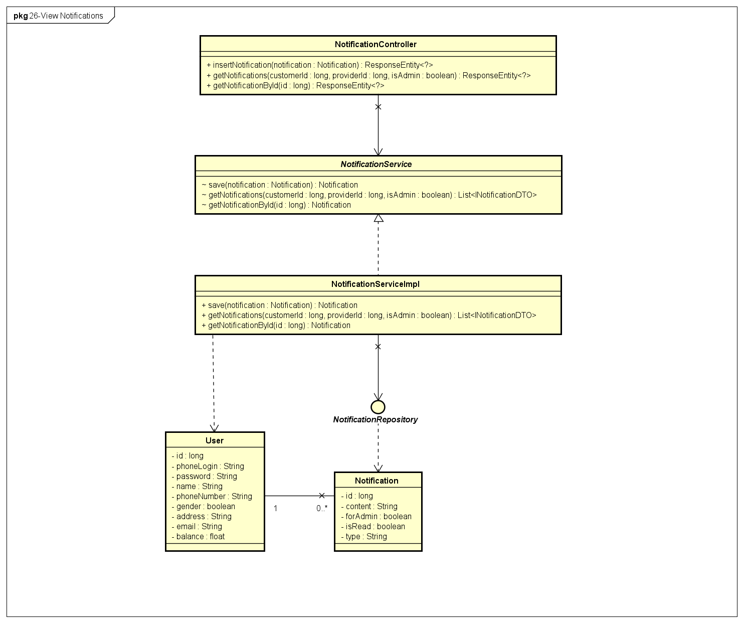

**Figure 4-90:** View Notifications - Back-end Class Diagram

###### **4.2.16.2.2 Front End**

##### 

**Figure 4-91:** View Notifications - Front-end Class Diagram

##### 4.2.16.3 Class Description

###### **4.2.16.3.1 Notification**

|  |  |  |  |  |
| --- | --- | --- | --- | --- |
| **Class** | **Notification** | | | |
| **Description** | Define attributes and methods for these attributes in Notification front-end class | | | |
| **Base Class** |  | | | |
| **Constructor** |  | | | |
| **Prototype** |  | | | |
| **Source File** | ofbs-master\front-end\src\components\admin\Notification.js | | | |
| **Namespace** |  | | | |
| **Attributes** | **Name** | **Type** | **Description** | |
|  |  |  | |
| **Methods** | **Name** | **Input** | **Output** | **Description** |
| loadData |  |  | use to load notification data |
| displayNotify |  |  | use to display notification |

**Table 4-91:** Notification class description

###### **4.2.16.3.2 NotificationController**

|  |  |  |  |  |
| --- | --- | --- | --- | --- |
| **Class** | **NotificationController** | | | |
| **Description** | Responsible for controlling the way that a user interacts with notification | | | |
| **Base Class** |  | | | |
| **Constructor** |  | | | |
| **Prototype** |  | | | |
| **Source File** | ofbs-master\front-end\src\components\admin\Notification.js | | | |
| **Namespace** |  | | | |
| **Attributes** | **Name** | **Type** | **Description** | |
|  |  |  | |
| **Methods** | **Name** | **Input** | **Output** | **Description** |
| insertNotification | notification | ResponseEntity | use to response insert notification |
| getNotifications | customerId  providerId  isAdmin | ResponseEntity | use to response get list notifications |
| getNotificationById | id | ResponseEntity | use to response get notification by id |

**Table 4-92:** NotificationController class description

###### **4.2.16.3.3 NotificationServiceImpl**

|  |  |  |  |  |
| --- | --- | --- | --- | --- |
| **Class** | **NotificationServiceImpl** | | | |
| **Description** | Provide functionality to handle user requests with notification | | | |
| **Base Class** |  | | | |
| **Constructor** |  | | | |
| **Prototype** |  | | | |
| **Source File** | ofbs-master\back-end\src\main\java\edu\fpt\ofbs\service\impl\NotificationServiceImpl.java | | | |
| **Namespace** |  | | | |
| **Attributes** | **Name** | **Type** | **Description** | |
|  |  |  | |
| **Methods** | **Name** | **Input** | **Output** | **Description** |
| save | notification | Notification | use to save a notification |
| getNotifications | customerId  providerId  isAdmin | List<INotificationDTO> | use to get list notifications |
| getNotificationById | id | Notification | use to get notification by id |

**Table 4-93:** NotificationServiceImpl class description

###### **4.2.16.3.4 NotificationRepository**

|  |  |  |  |  |
| --- | --- | --- | --- | --- |
| **Class** | **NotificationRepository** | | | |
| **Description** | manipulate the notification table in the database. | | | |
| **Base Class** | JpaRepository<Notification, Long> | | | |
| **Constructor** |  | | | |
| **Prototype** |  | | | |
| **Source File** | ofbs-master\back-end\src\main\java\edu\fpt\ofbs\repositories\NotificationRepository.java | | | |
| **Namespace** |  | | | |
| **Attributes** | **Name** | **Type** | **Description** | |
|  |  |  | |
| **Methods** | **Name** | **Input** | **Output** | **Description** |
| getNotifications | customerId  providerId  isAdmin | List<INotificationDTO> | use to get list notifications |

**Table 4-94:** NotificationRepository class description

###### **4.2.16.3.5 Notification**

|  |  |  |  |  |
| --- | --- | --- | --- | --- |
| **Class** | **Notification** | | | |
| **Description** | Define attributes for Notification Entity and set/get method for these attributes | | | |
| **Base Class** |  | | | |
| **Constructor** |  | | | |
| **Prototype** |  | | | |
| **Source File** | ofbs-master\back-end\src\main\java\edu\fpt\ofbs\entities\Notification.java | | | |
| **Namespace** |  | | | |
| **Attributes** | **Name** | **Type** | **Description** | |
| id | long | use to store notification id | |
| content | String | use to store notification content | |
| forAdmin | boolean | use to store type status is admin or not | |
| isRead | boolean | use to store status read notification yet | |
| type | String | use to store type of notification | |
| **Methods** | **Name** | **Input** | **Output** | **Description** |

**Table 4-95:** Notification class description

##### 4.2.16.4 Sequence Diagram

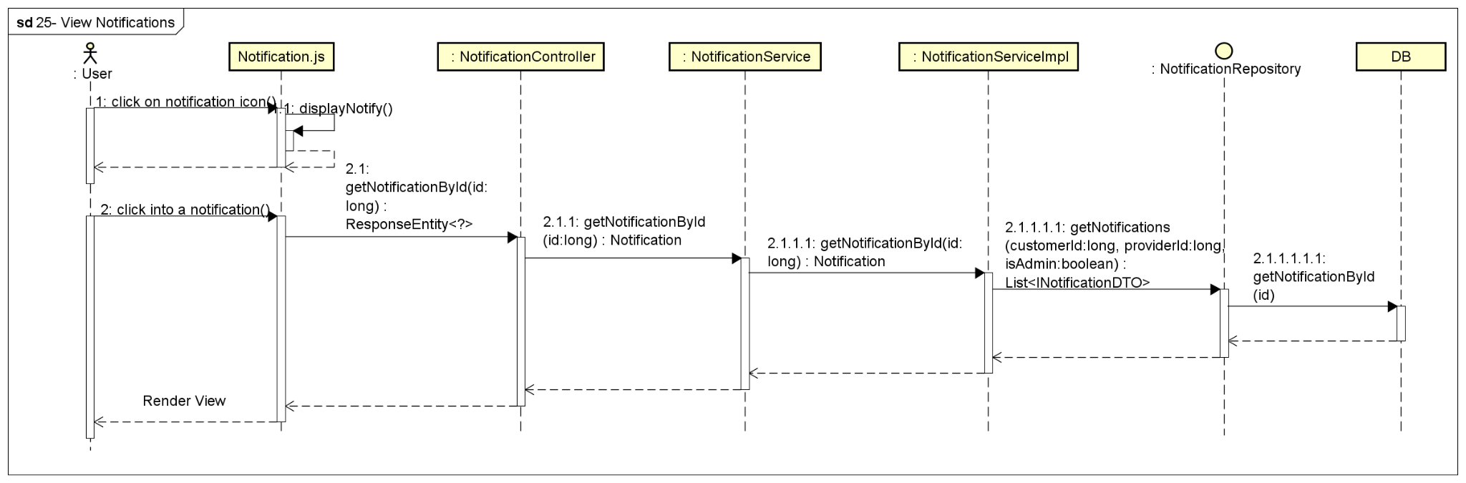

**Figure 4-92:** View Notifications - Sequence Diagram

#### 4.2.17 UC-27 Sign Out

##### 4.2.17.1 Screen design

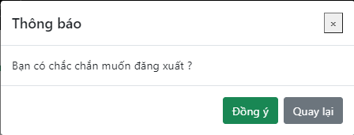

**Figure 4-93:** Sign Out

##### 4.2.17.2 Class diagram

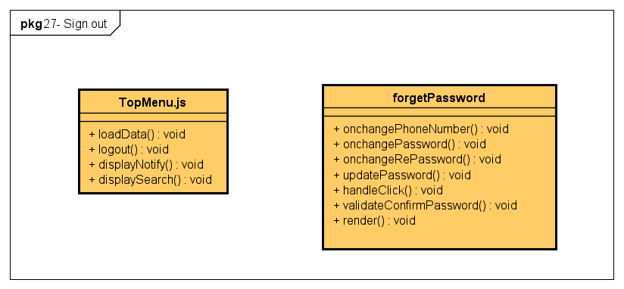

**Figure 4-94:** Sign Out - Front-end Class Diagram

##### 4.2.17.3 Class Description

reference to 4.2.1.3.1

##### 4.2.17.4 Sequence Diagram

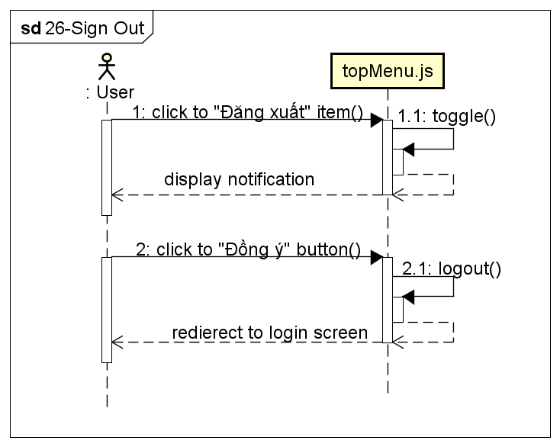

**Figure 4-95:** Sign Out - Sequence Diagram

## 5. Database Design

### 5.1 Database Design Diagram

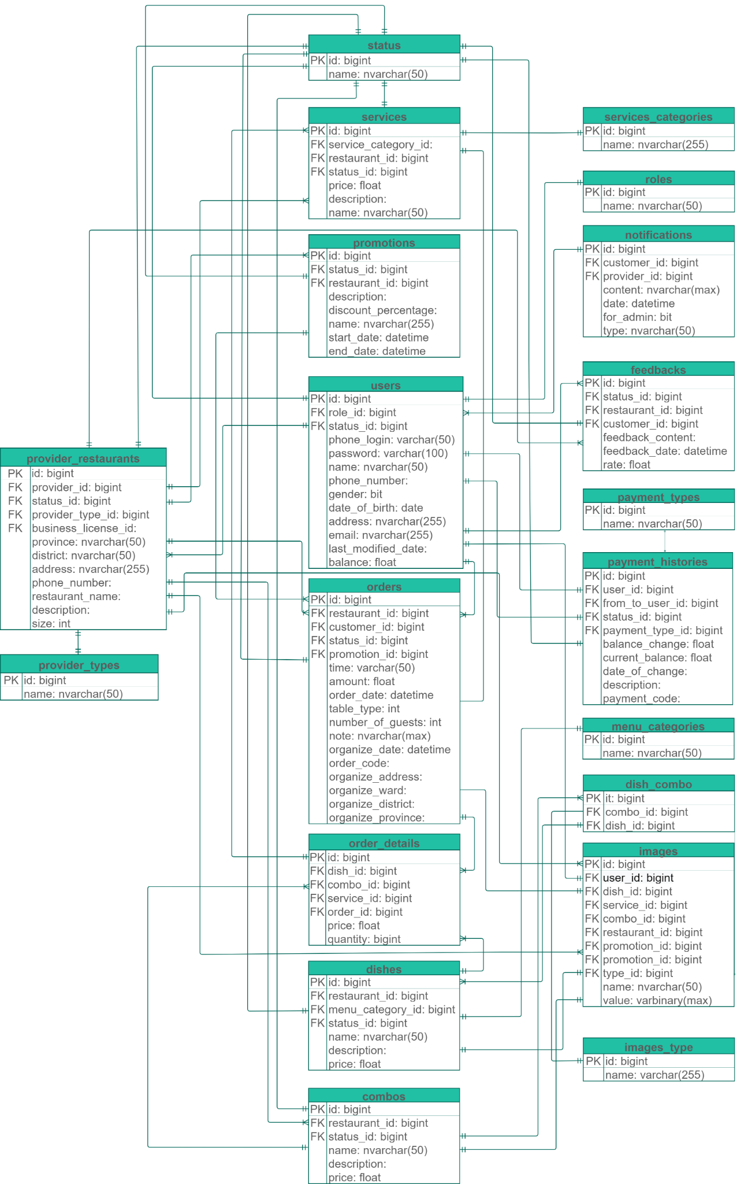

**Figure 5-1:** Database design diagram

### 5.2 Table Description

#### 5.2.1 combo

|  |  |  |  |  |  |  |  |
| --- | --- | --- | --- | --- | --- | --- | --- |
| **#** | **Field name** | **Type** | **Size** | **Unique** | **Not Null** | **PK/FK** | **Notes** |
| 1 | id | bigint |  | **X** | X | PK |  |
| 2 | name | nvarchar | 50 |  | X |  |  |
| 3 | description | nvarchar |  |  | X |  |  |
| 4 | price | float |  |  | X |  |  |
| 5 | restaurant_id | bigint |  |  | X | FK |  |
| 6 | status_id | bigint |  |  | X | FK |  |

**Table 5-1:** Combo table description

#### 5.2.2 dish_combo

|  |  |  |  |  |  |  |  |
| --- | --- | --- | --- | --- | --- | --- | --- |
| **#** | **Field name** | **Type** | **Size** | **Unique** | **Not Null** | **PK/FK** | **Notes** |
| 1 | id | bigint |  | **X** | X | PK |  |
| 2 | combo_id | bigint |  |  | X | FK |  |
| 3 | dish_id | bigint |  |  | X | FK |  |

**Table 5-2:** Dish_combo table description

#### 5.2.3 dishes

|  |  |  |  |  |  |  |  |
| --- | --- | --- | --- | --- | --- | --- | --- |
| **#** | **Field name** | **Type** | **Size** | **Unique** | **Not Null** | **PK/FK** | **Notes** |
| 1 | id | bigint |  | **X** | X | PK |  |
| 2 | name | nvarchar(50) | 50 |  | X |  |  |
| 3 | description | nvarchar(MAX) |  |  | X |  |  |
| 4 | price | float |  |  | X |  |  |
| 5 | restaurant_id | bigint |  |  | X |  |  |
| 6 | menu_category_id | bigint |  |  | X | FK |  |
| 7 | status_id | bigint |  |  | X | FK |  |

**Table 5-3:** Dish table description

#### 5.2.4 feedbacks

|  |  |  |  |  |  |  |  |
| --- | --- | --- | --- | --- | --- | --- | --- |
| **#** | **Field name** | **Type** | **Size** | **Unique** | **Not Null** | **PK/FK** | **Notes** |
| 1 | id | bigint |  | **X** | X | PK |  |
| 2 | feedback_content | nvarchar(MAX) |  |  | X |  |  |
| 3 | feedback_date | datetime |  |  | X |  |  |
| 4 | rate | float |  |  | X |  |  |
| 5 | customer_id | bigint |  |  | X | FK |  |
| 6 | restaurant_id | bigint |  |  | X | FK |  |
| 7 | status_id | bigint |  |  | X | FK |  |

**Table 5-4:** Feedback table description

#### 5.2.5 image_types

|  |  |  |  |  |  |  |  |
| --- | --- | --- | --- | --- | --- | --- | --- |
| **#** | **Field name** | **Type** | **Size** | **Unique** | **Not Null** | **PK/FK** | **Notes** |
| 1 | id | bigint |  | **X** | X | PK |  |
| 2 | image_type | varchar(255) | 255 |  | X |  |  |

**Table 5-5:** Image_type table description

#### 5.2.6 images

|  |  |  |  |  |  |  |  |
| --- | --- | --- | --- | --- | --- | --- | --- |
| **#** | **Field name** | **Type** | **Size** | **Unique** | **Not Null** | **PK/FK** | **Notes** |
| 1 | id | varchar(255) | 255 | **X** | X | PK |  |
| 2 | name | nvarchar(50) | 50 |  | X |  |  |
| 3 | value | varbinary(MAX) |  |  | X |  |  |
| 4 | user_id | bigint |  |  | X | FK |  |
| 5 | dish_id | bigint |  |  | X | FK |  |
| 6 | service_id | bigint |  |  | X | FK |  |
| 7 | combo_id | bigint |  |  | X | FK |  |
| 8 | restaurant_id | bigint |  |  | X | FK |  |
| 9 | promotion_id | bigint |  |  | X | FK |  |
| 10 | type_id | bigint |  |  | X | FK |  |

**Table 5-6:** Image table description

#### 5.2.7 menu_categories

|  |  |  |  |  |  |  |  |
| --- | --- | --- | --- | --- | --- | --- | --- |
| **#** | **Field name** | **Type** | **Size** | **Unique** | **Not Null** | **PK/FK** | **Notes** |
| 1 | id | bigint |  | **X** | X | PK |  |
| 2 | name | nvarchar(50) | 50 |  | X |  |  |

**Table 5-7:** Menu_categories table description

#### 5.2.8 notifications

|  |  |  |  |  |  |  |  |
| --- | --- | --- | --- | --- | --- | --- | --- |
| **#** | **Field name** | **Type** | **Size** | **Unique** | **Not Null** | **PK/FK** | **Notes** |
| 1 | id | bigint |  | **X** | X | PK |  |
| 2 | [content] | nvarchar(MAX) |  |  | X |  |  |
| 3 | customer_id | bigint |  |  |  | FK |  |
| 4 | provider_id | bigint |  |  |  | FK |  |
| 5 | date | datetime |  |  | X |  |  |
| 6 | for_admin | bit |  |  | X |  |  |
| 7 | is_read | bit |  |  | X |  |  |
| 8 | type | nvarchar(50) |  |  | X |  |  |

**Table 5-8:** Notifications table description

#### 5.2.9 order_details

|  |  |  |  |  |  |  |  |
| --- | --- | --- | --- | --- | --- | --- | --- |
| **#** | **Field name** | **Type** | **Size** | **Unique** | **Not Null** | **PK/FK** | **Notes** |
| 1 | id | bigint |  | **X** | X | PK |  |
| 2 | price | float |  |  | X |  |  |
| 3 | quantity | bigint |  |  | X |  |  |
| 4 | dish_id | bigint |  |  |  | FK |  |
| 5 | combo_id | bigint |  |  |  | FK |  |
| 6 | service_id | bigint |  |  |  | FK |  |
| 7 | order_id | bigint |  |  | X | FK |  |

**Table 5-9:** Order_details table description

#### 5.2.10 orders

|  |  |  |  |  |  |  |  |
| --- | --- | --- | --- | --- | --- | --- | --- |
| **#** | **Field name** | **Type** | **Size** | **Unique** | **Not Null** | **PK/FK** | **Notes** |
| 1 | id | bigint |  | **X** | X | PK |  |
| 2 | amount | float |  |  |  |  |  |
| 3 | time | nvarchar(50) | 50 |  | X |  |  |
| 4 | order_date | datetime |  |  | X |  |  |
| 5 | status_id | bigint |  |  | X | FK |  |
| 6 | customer_id | bigint |  |  | X | FK |  |
| 7 | restaurant_id | bigint |  |  | X | FK |  |
| 8 | promotion_id | bigint |  |  |  | FK |  |
| 9 | table_type | int |  |  |  |  |  |
| 10 | number_of_guests | int |  |  |  |  |  |
| 11 | note | nvarchar(MAX) |  |  |  |  |  |
| 12 | organize_date | datetime |  |  |  |  |  |
| 13 | order_code | nvarchar(255) | 255 |  |  |  |  |
| 14 | organize_address | nvarchar(255) | 255 |  |  |  |  |
| 15 | organize_ward | nvarchar(255) | 255 |  |  |  |  |
| 16 | organize_district | nvarchar(255) | 255 |  |  |  |  |
| 17 | organize_province | nvarchar(255) | 255 |  |  |  |  |

**Table 5-10:** Orders table description

#### 5.2.11 promotions

#### 

|  |  |  |  |  |  |  |  |
| --- | --- | --- | --- | --- | --- | --- | --- |
| **#** | **Field name** | **Type** | **Size** | **Unique** | **Not Null** | **PK/FK** | **Notes** |
| 1 | id | bigint |  | **X** | X | PK |  |
| 2 | restaurant_id | bigint |  |  | X | FK |  |
| 3 | description | nvarchar(MAX) |  |  | X |  |  |
| 4 | discount_percentage | smallmoney |  |  | X |  |  |
| 5 | name | nvarchar(255) | 255 |  | X |  |  |
| 6 | start_date | datetime |  |  | X |  |  |
| 7 | end_date | datetime |  |  | X |  |  |
| 8 | status_id | bigint |  |  | X | FK |  |

**Table 5-11:** Promotions table description

#### 5.2.12 provider_restaurants

#### 

|  |  |  |  |  |  |  |  |
| --- | --- | --- | --- | --- | --- | --- | --- |
| **#** | **Field name** | **Type** | **Size** | **Unique** | **Not Null** | **PK/FK** | **Notes** |
| 1 | id | bigint |  | **X** | X | PK |  |
| 2 | provider_id | bigint |  |  | X | FK |  |
| 3 | province | nvarchar(50) | 50 |  | X |  |  |
| 4 | district | nvarchar(50) | 50 |  | X |  |  |
| 5 | address | nvarchar(255) | 255 |  | X |  |  |
| 6 | phone_number | varchar(50) | 50 |  | X |  |  |
| 7 | restaurant_name | nvarchar(255) | 255 |  | X |  |  |
| 8 | status_id | bigint |  |  | X | FK |  |
| 9 | description | nvarchar(MAX) |  |  |  |  |  |
| 10 | size | int |  |  |  |  |  |
| 11 | provider_type_id | bigint |  |  | X | FK |  |
| 12 | business_license_id | varchar(255) | 255 |  |  | FK |  |

**Table 5-12:** Provider_restaurants table description

#### 5.2.13 provider_types

|  |  |  |  |  |  |  |  |
| --- | --- | --- | --- | --- | --- | --- | --- |
| **#** | **Field name** | **Type** | **Size** | **Unique** | **Not Null** | **PK/FK** | **Notes** |
| 1 | id | bigint |  | **X** | X | PK |  |
| 2 | name | nvarchar(50) | 50 |  | X |  |  |

**Table 5-13:** Provider_types table description

#### 5.2.14 roles

|  |  |  |  |  |  |  |  |
| --- | --- | --- | --- | --- | --- | --- | --- |
| **#** | **Field name** | **Type** | **Size** | **Unique** | **Not Null** | **PK/FK** | **Notes** |
| 1 | id | bigint |  | **X** | X | PK |  |
| 2 | name | nvarchar(50) | 50 |  | X |  |  |

**Table 5-14:** Roles table description

#### 5.2.15 service_categories

|  |  |  |  |  |  |  |  |
| --- | --- | --- | --- | --- | --- | --- | --- |
| **#** | **Field name** | **Type** | **Size** | **Unique** | **Not Null** | **PK/FK** | **Notes** |
| 1 | id | bigint |  | **X** | X | PK |  |
| 2 | name | nvarchar(255) | 255 |  | X |  |  |

**Table 5-15:** Service_categories table description

#### 5.2.16 services

|  |  |  |  |  |  |  |  |
| --- | --- | --- | --- | --- | --- | --- | --- |
| **#** | **Field name** | **Type** | **Size** | **Unique** | **Not Null** | **PK/FK** | **Notes** |
| 1 | id | bigint |  | **X** | X | PK |  |
| 2 | name | nvarchar(50) | 50 |  | X |  |  |
| 3 | description | nvarchar(MAX) |  |  |  |  |  |
| 4 | status_id | bigint |  |  | X | FK |  |
| 5 | price | float |  |  | X |  |  |
| 6 | restauran_id | bigint |  |  | X | FK |  |
| 7 | service_category_id | bigint |  |  | X | FK |  |

**Table 5-16:** Services table description

#### 5.2.17 status

|  |  |  |  |  |  |  |  |
| --- | --- | --- | --- | --- | --- | --- | --- |
| **#** | **Field name** | **Type** | **Size** | **Unique** | **Not Null** | **PK/FK** | **Notes** |
| 1 | id | bigint |  | **X** | X | PK |  |
| 2 | name | nvarchar(50) | 50 |  | X |  |  |

**Table 5-17:** Status table description

#### 

#### 5.2.18 users

#### 

|  |  |  |  |  |  |  |  |
| --- | --- | --- | --- | --- | --- | --- | --- |
| **#** | **Field name** | **Type** | **Size** | **Unique** | **Not Null** | **PK/FK** | **Notes** |
| 1 | id | bigint |  | X | X | PK |  |
| 2 | phone_login | varchar(50) | 50 |  | X |  |  |
| 3 | password | varchar(100) | 100 |  | X |  |  |
| 4 | name | nvarchar(50) | 50 |  |  |  |  |
| 5 | phone_number | varchar(50) | 50 |  | X |  |  |
| 6 | gender | bit |  |  | X |  |  |
| 7 | date_of_birth | date |  |  |  |  |  |
| 8 | address | nvarchar(255) | 255 |  |  |  |  |
| 9 | email | nvarchar(255) | 255 |  |  |  |  |
| 10 | status_id | bigint |  |  | X | FK |  |
| 11 | role_id | bigint |  |  | X | FK |  |
| 12 | last_modified_date | datetime |  |  | X |  |  |
| 13 | balance | float |  |  | X |  |  |

**Table 5-18:** Users table description

#### 5.2.19 payment_types

|  |  |  |  |  |  |  |  |
| --- | --- | --- | --- | --- | --- | --- | --- |
| **#** | **Field name** | **Type** | **Size** | **Unique** | **Not Null** | **PK/FK** | **Notes** |
| 1 | id | bigint |  | **X** | X | PK |  |
| 2 | name | nvarchar(50) | 50 |  | X |  |  |

**Table 5-19:** Payment_types table description

#### 5.2.20 payment_histories

#### 

|  |  |  |  |  |  |  |  |
| --- | --- | --- | --- | --- | --- | --- | --- |
| **#** | **Field name** | **Type** | **Size** | **Unique** | **Not Null** | **PK/FK** | **Notes** |
| 1 | id | bigint |  | X | X | PK |  |
| 2 | user_id | bigint |  |  | X | FK |  |
| 3 | balance_change | float |  |  | X |  |  |
| 4 | from_to_user_id | bigint |  |  | X | FK |  |
| 5 | current_balance | float |  |  | X |  |  |
| 6 | date_of_change | datetime |  |  | X |  |  |
| 7 | description | nvarchar(MAX) |  |  |  |  |  |
| 8 | status_id | bigint |  |  | X | FK |  |
| 9 | payment_code | nvarchar(50) | 50 |  |  |  |  |
| 10 | payment_type_id | bigint |  |  | X | FK |  |

**Table 5-20:** Payment_histories table description